Projected Population Size and Births, Deaths, and Migration:

Year | Population | Numeric change since prior year | Percent change since prior year | Vital events |  | Natural increase (births – deaths) | Net international  migration¹
 |  |  |  | Births | Deaths
2016 | 323,128 | — | — | — | — | — | —
2017 | 325,511 | 2,384 | 0.74 | 4,054 | 2,667 | 1,387 | 997
2018 | 327,892 | 2,381 | 0.73 | 4,075 | 2,696 | 1,379 | 1,002
2019 | 330,269 | 2,377 | 0.72 | 4,095 | 2,724 | 1,371 | 1,006
2020 | 332,639 | 2,370 | 0.72 | 4,112 | 2,752 | 1,360 | 1,010
2021 | 334,998 | 2,359 | 0.71 | 4,126 | 2,781 | 1,345 | 1,014
2022 | 337,342 | 2,344 | 0.70 | 4,137 | 2,811 | 1,326 | 1,017
2023 | 339,665 | 2,323 | 0.69 | 4,146 | 2,844 | 1,302 | 1,021
2024 | 341,963 | 2,298 | 0.68 | 4,152 | 2,878 | 1,274 | 1,025
2025 | 344,234 | 2,271 | 0.66 | 4,156 | 2,915 | 1,241 | 1,030

A LifeLog view:
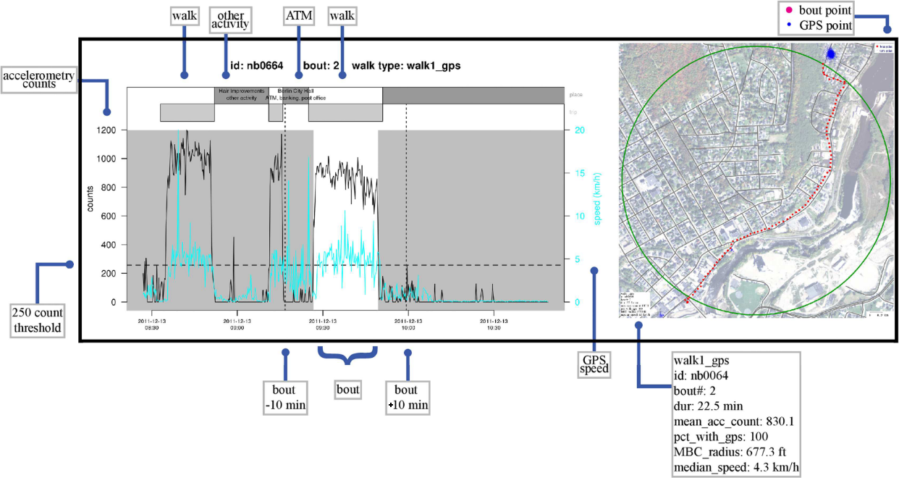

Geocoding:
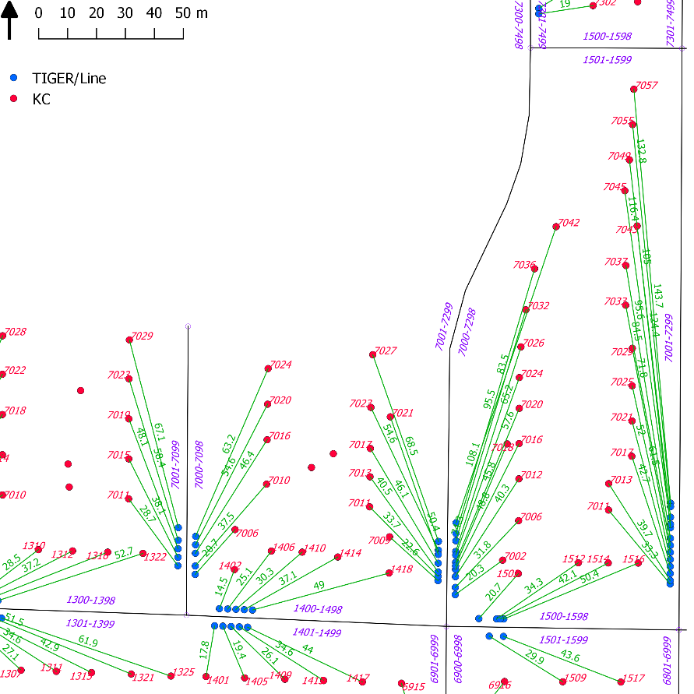

The binomial theorem:
$${\left(x+a\right)}^{n}=\sum_{k=0}^{n}{\left({n \atop k}\right)x^{k}a^{n-k}}$$

Taylor expansion:
$$e^{x}=1+\frac{x}{1!}+\frac{x^{2}}{2!}+\frac{x^{3}}{3!}+…, -∞<x<∞$$

