draft
DGH intranet development
Concept note
by Caroline Liou and Basia Otto
Based on the DGH Intranet Steering Committee (DISC) meeting discussion on Sept. 12, this document outlines a possible way forward to develop a DGH intranet. DISC discussed that the basic steps in developing the intranet are below. Preceding this would be a brief survey (both the one Dana previously conducted and another brief survey to complement):
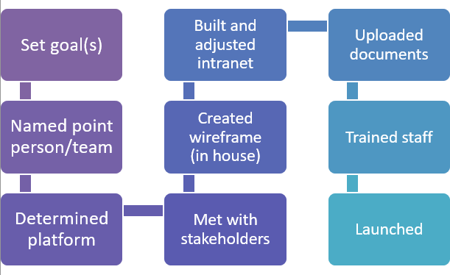
To identify the goals/objectives, DISC will consult DFOG and the Staff Leadership group (formerly Program Managers group). DISC would also like to identify a point person/team.

Estimated time commitment:
 | Point team member | Point team member | Intranet section leads (to be discussed with supervisors – HR, Finance, Program Mngt, etc)
Pre-development | 20% | 20% | 10%
Development | 20% | 30% | 10%
Pre-launch/launch | 20% | 30% | 5%
Post-launch | 5% | 20% | 5%

Proposed next steps:
Whom/what | Timeframe 2019
DGH leadership to approve point team and time allocation resources | Mid- Oct
Point team to develop workplan, milestones, and schedule | End Oct
Workplan approved by DFOG and DISC | Mid-Nov

