**Oregon Health Sciences University**

**Rehabilitation Services**

**Clinical Education Program**

Education is central to the mission of OHSU, the Rehabilitation Services Division places a high priority on preparation of professional students. Our aim is to provide an intensive, challenging learning experience for affiliates. This is a fast-paced and dynamic environment; and there are a number of benefits including the opportunity to participate with grand rounds and other offerings consistent with an academic medical center.

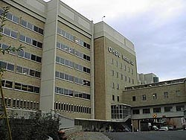

Oregon Health Science University (OHSU) is a Level I Trauma Center and diverse, multi-specialty academic medical center with core programs including neuroscience, orthopaedics, cardiology, oncology, organ transplant, and general medicine/surgery.

Outpatient care is provided at the OHSU Center for Health and Healing (CHH) and is connected to OHSU's main campus via an arial tram. Therapists collaborate with physicians and researchers in multidisciplinary teams such as Ortho/Sports, Spine, Neuroscience and Pain. In addition there are specialty programs in lymphedema, women’s health, high-intensity task training. The clinic employs equipment including a Balancemaster and a Locomat to support Neuroscience research and clinical care needs.

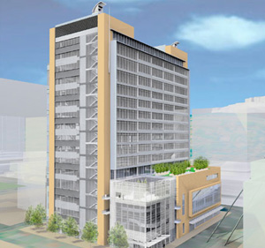

**Welcome to OHSU’s Rehabilitation program!**

*This is an excerpt from a handbook created for students by students.*

You have chosen one of the premiere research facilities in the nation to further your professional growth. Because OHSU is on the cutting edge of modern medicine, you will have the opportunity to see a wide variety of diagnoses. The staff at OHSU is accustomed to educating students of many health care disciples. This will help make your transition from student to therapist more comfortable. The rehabilitation department consists of physical therapy, occupational therapy and speech language pathology. The team approach is the foundation of treatment at OHSU. A full staff of OT, PT, and SLP all work together to create an environment of top quality care for the client. The staff is dedicated to the education process and hopes it will be a reciprocal process in which the both the intern and staff will learn from each other. Your clinical rotation experience will be balance of evaluation/assessment, goal setting, treatment and discharge planning, patient/family education and training, all of which will prepare you for a future as a rehabilitation therapist. We anticipate the challenge of the intense inpatient or outpatient rehabilitation setting will make you an efficient and knowledgeable entry-level therapist at the completion of your internship.

**ALL ABOUT PORTLAND**

Portland is the largest city in Oregon with a population over 500,000 and is ideal for those who enjoy the urban scene and those who enjoy the outdoors. Portland is unique and thrives with festivals, outdoors and dining scenes. Portland has the personality of a small community and the activities and vitality of a large city.

The night scene at Portland includes many restaurants, bars, cultural events and theaters. There are numerous Chinese and Japanese gardens, art and science museums, and parks to visit. Throughout the year, there are wine and beer tasting festivals at Pioneer Square in downtown Portland and at Willamette and Hood River Valley. Portland brings in prominent singers and bands ranging from the Oregon Symphony to rock bands to country singers at a variety of venues, including the Rose Quarter, Clark County Amphitheater and a few hours away at the Gorge Amphitheater.

Portland is located on the intersection of the Columbia and Willamette rivers with a view of the Cascade Mountains, Mt Hood, Mt Adams and Mt St Helens. Within a 60-minute drive of Portland, there is access to winter sports at Mt Hood, windsurfing at the internationally known Hood River, and strolling along the beaches of the Oregon and Washington Coast. In addition, camping, hiking, rafting, fishing and kayaking are available in many areas around Portland, especially in the Columbia Gorge.

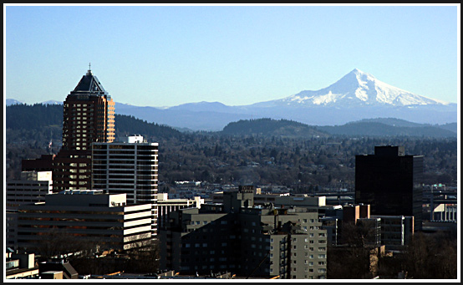

Portland is home to many sport teams including: professional basketball team Portland Trailblazers, hockey team Portland Winter Hawks, baseball team Portland Beavers, lacrosse team Portland LumberJax and soccer team Portland Timbers. Portland also has an international raceway and hosts car races throughout the year.

Make sure to visit Powell’s Used Books, which carries over a million books and McMenamins Restaurants, which stars homebrews and dinner theaters. All the opportunities in the Portland-metro area are easily accessible by a great bus transportation system, Tri-Met. Please research into the city of Portland and the Pacific Northwest to discover the fullness of what it can offer.

**HOUSING RESOURCES**

OHSU does not provide a formal housing program. However, the following two website links provide a wealth of information for living information in Portland, emphasizing information that would be useful to visitors, rehabilitation students or medical residents. In the past, rehabilitation students indicate that living on a bus line or near OHSU to avoid traffic and shorten commute time is very helpful.

Portland State University Housing Website: http://www.pdx.edu/housing

OHSU Website: <http://www.ohsu.edu/academic/acad/housing/apartment.html>

**Hospital Nursing Unit Organization**

University Hospital North

1NW Psychiatric Unit

2NW Psychiatric Unit

University Hospital South

4A Liver, Kidney Transplant, Plastics

5A Oncology

5C BMT

6C Operating Rooms

7A Trauma and EGS Intensive Care Unit

7CAO BMT

7CCS Neuro Care Unit

8CCM Cardiac Intensive Care Unit

10A Orthopedics

12A Neonatal Intensive Care Unit

12C Labor and Delivery

13A Trauma

13C/14C Women’s Health/Mother-Baby Unit

14A Abdominal surgery/ G-bypass

Peter Kohler Pavilion

10K Neurology, Neurosurgery, ENT

11K Cardiac, Vascular Surgery

12K Medical Intensive Care Unit

Veteran’s Administration Hospital

7CVA/8DVA General Medicine

**Outpatient Location: OHSU Center for Health and Healing**

The Center for Health & Healing (CHH) at OHSU is a new home for Oregon’s comprehensive group of physicians and other health professionals, including the outpatient rehabilitation team. It includes March Wellness fitness and spa center and is one of the most earth-friendly buildings built to-date in Oregon.

3303 SW Bond Avenue

Portland, OR 97239

(503) 494-3151

**TRANSPORTATION**

Directions/parking information is located at: <http://www.ohsu.edu/about/directions.shtml>. Parking is limited on Marquam Hill, most staff commute by bicycle, or public transportation.

**Tri-Met/ Streetcar/ MAX**

Portland’s transportation system consists of the Tri-Met bus system, streetcar and three light rails (MAX). The combination of the three provides service every 15 minutes to the Portland-metro area. OHSU currently offers free limited bus passes during your stay as student during your internship.

**The Arial Tram**

The tram provides rapid and reliable transportation that is necessary for OHSU's expansion into South Waterfront. The tram provides a three-minute ride every five minutes between OHSU's new hospital expansion on Marquam Hill; the clinical, research and educational facilities at the Center for Health & Healing at South Waterfront; the residential and commercial development in the South Waterfront Central District; and OHSU's eventual development at the Schnitzer Campus. The tram runs Monday- Friday from 6:00am to 10:00pm, Saturday 9:00 – 5:00 pm and will run on Sundays in the future.

The tram is free to ride for all OHSU employees and students with an OHSU ID Badge. The ID badge will provided on the first day of your internship.

**Bicycle**

Tri-met, streetcar and the tram all accommodate for commuters on bicycles. There are bike racks and bike lockers available at CHH and on the main hill with the facility.

Bicycle directions to OHSU: http://www.ohsu.edu/bike/routes.shtml

For further information:

Streetcar: http://www.portlandstreetcar.org/

Tri-Met: http://trimet.org/index.shtml

Tram: http://www.portlandtram.org/

**Library**

OHSU maintains Oregon’s largest medical library. The library is located in the BICC-Biomedical Information Communication Center. As a staff member of the University, the library is available to you at any time. To receive a library card you can complete an application at the library.

In addition to borrowing books and periodicals, the library is available for other traditional services. It is, of course, open for studying. We can request, for a nominal fee, “Med-Line Searches” to get a list of references on a defined topic. Copy machines, typewriters, computer hardware and computer software are also available in the library.

**Education Philosophy**

The goals and objectives of the department when working with students on affiliation from their schools include:

Challenging the student to synthesize his/her didactic information with clinical skills.

Providing experience for the student to evaluate and treat patients with problems within the specified and assigned service.

Serving as resources for students needing assistance with patient problems and situations.

Providing opportunities for students to interact with related departments in the hospital setting.

Providing feedback to the student on his/her clinical skills and abilities.

Providing an opportunity for the student to tailor the clinical experience to include areas of interest and/or need, within the limitations imposed by staffing and patient load

