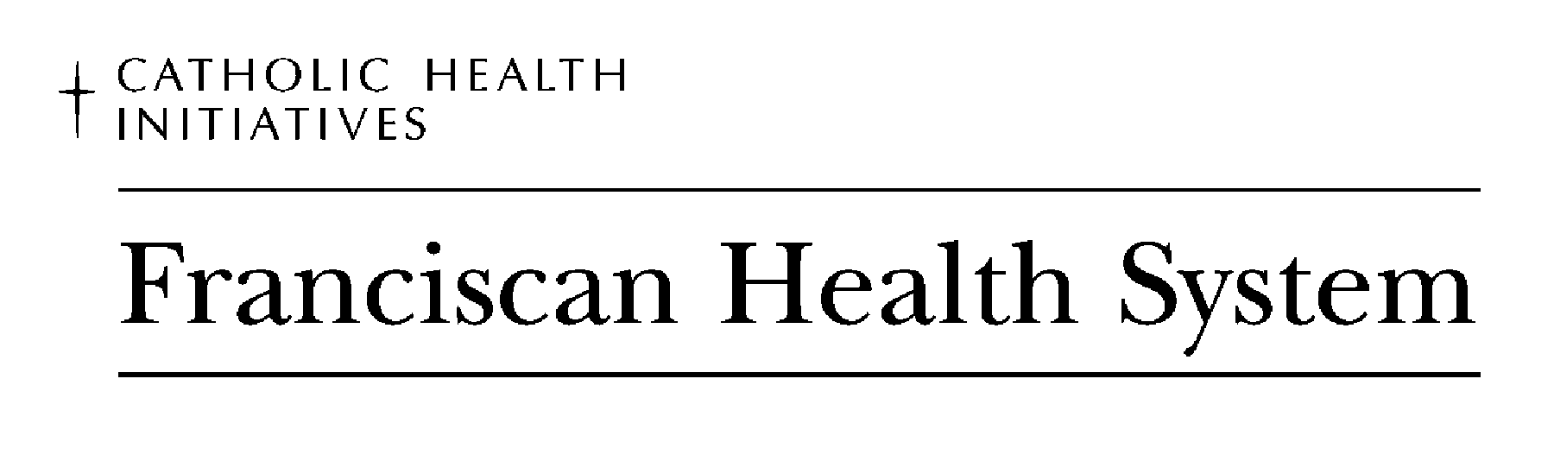
FRANCISCAN HEALTH SYSTEM

MINI ORIENTATION SELF- STUDY MODULE TEST

Name:__________________________ Date_______________________

1. T F The vision of Catholic Health Initiatives is to create integrated delivery networks and
new ministries that promote healthy communities, as well as showing special
concern for the poor.

2. Handwashing is the most effective means of preventing the spread of infection:

  - Between patient contact
  - After removing gloves
  - After using the restroom
  - All of the above

3.Basic Principals of Body Mechanics include:

A. Using equipment to assist you
- Using large muscles rather then small ones
C. Keeping the weight that you lift as close to you as possible
- All of the above

4.Dial 5555 to report a:

A. Code Red
- Code 4
- Code Orange
- All of the above.

5. T F It is important to focus on wellness, promote activities when addressing the
older adults needs.

6. T F Nose rings are acceptable as long as they match your clothes.

7. T F Visible body art (tattoo) that has a religious theme does not have to be
covered by the uniform.

