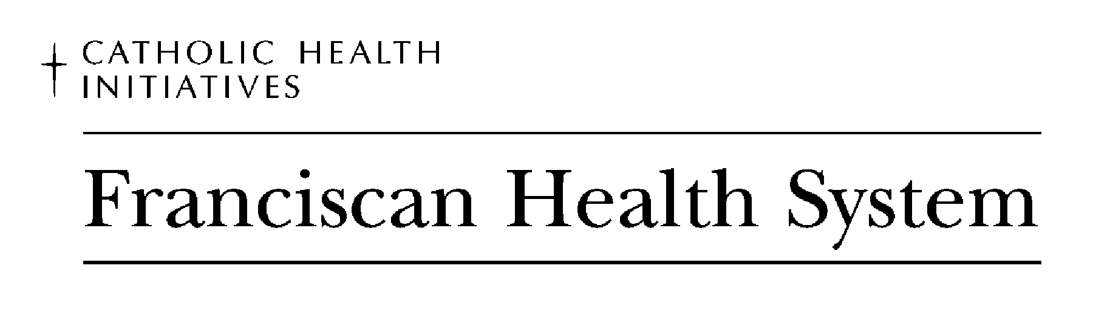
St. Anthony Hospital, Gig Harbor - St. Clare Hospital, Lakewood, - St. Francis Hospital, Federal Way - St. Joseph Medical Center, Tacoma

Student Placement Documentation Requirements

School ____________________ Preceptor Monitored Instructor led Page ______ of _______

1. Student Health & Safety Requirement Checklist 2. Confidentiality Statement 3. FHS mini- orientation post test

Last name | First name | Student type | Prior/ Present FHS employee?  If yes, facility? | Start & end date | Facility | Unit | Unit Contact Name  Mgr. or UBE or? | Shift & days of the week | Instructor | Total Hrs
Example: Doe | Jane | RN | No or Yes-facility? | 11/1 – 11/30 | SCH | ED |  | 8 hr days  M-Fri | Sue Smith | 50 hrs

