Pediatric Therapy: Occupational · Physical · Speech Adult Therapy: Hand & Upper Extremity
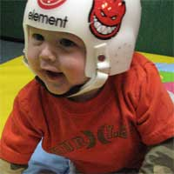

Home
About Us
Occupational Therapy
Physical Therapy
Speech Therapy
Hand Therapy
Registration Forms
Contact Us
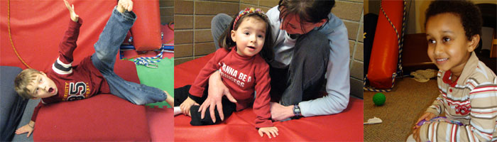

Visit Our New Clinics
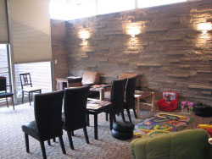

Bothell Clinic
Our Bothell clinic has moved to a new location. We are still conveniently located within downtown Bothell and look forward to greeting you at our new facility. Please find us at the following location:
18504 Bothell Way NE
Bothell, WA 98011
425-481-1933
Map Of New Clinic Location
Map From Previous Clinic Location

Marysville Clinic
We have opened a second clinic in Marysville to serve adult upper extremity rehabilitation and pediatric clients. Please find us at the following location:
1326 5th Street
Suite D1 and D2
Marysville, WA 98270
360-658-0207 or 1-888-658-0207
Map Of Clinic Location
For scheduling, please call: 425-481-1933

