Visual Recognition Memory/Visual Acuity Combination System Construction Details

10/16/09/F. Reitz, Ph.D.
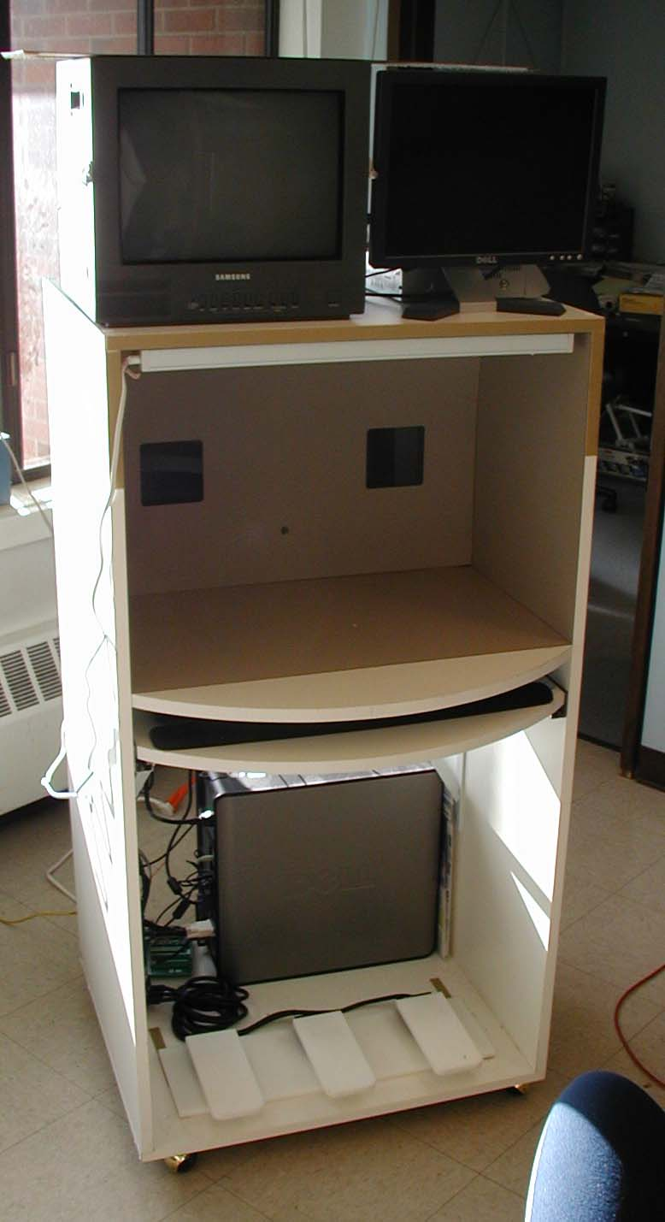
Cabinet

The cabinet is constructed of 3/4" melamine. The side pieces are 49.75" high, 23.625" deep. These rest on the base, which is 23.625" deep, 27.75" wide. The top caps the sides, and is also 23.625" deep, 27.75" wide. The floor of the stimulus chamber is 26.25" wide (i.e., narrower than the top and bottom pieces by the combined thickness of the side walls) and its top surface is 18.5" below the top piece's bottom surface. The floor of the stimulus chamber is 23.625" - 28.625" deep, even with the sides and protruding from the cabinet front plane in a circular arc extending 5" from the cabinet front at center. The top, bottom, and chamber floor are secured to the sides with pre-drilled, countersunk woodscrews, and the assembly is stabilized by 13" wide, 20" high shelf brackets, one for each sidewall, positioned 14.5" back from even with the cabinet front surface. A keyboard shelf is mounted with its top surface 2.5" below the bottom surface of the chamber floor, trimmed to accommodate the width of the drawer slides used (shelf width is 25.75" in our case), and 14.5" - 19.5" deep, matching the curve of the chamber floor when pushed in. The cabinet rides on 2.5" casters mounted with carriage bolts.

Stimulus chamber
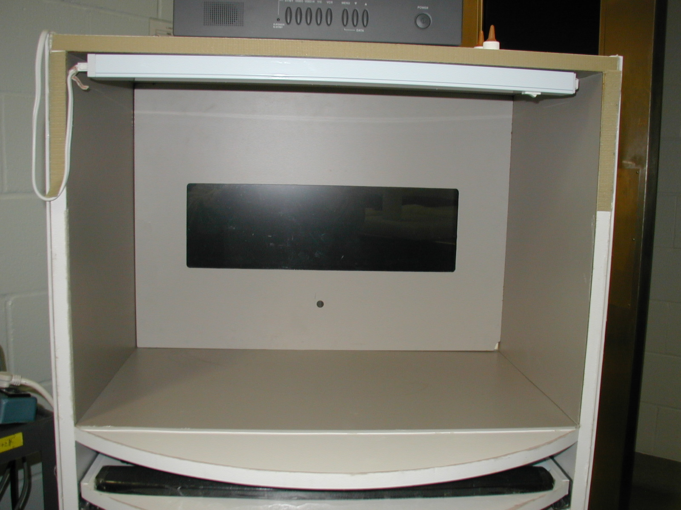
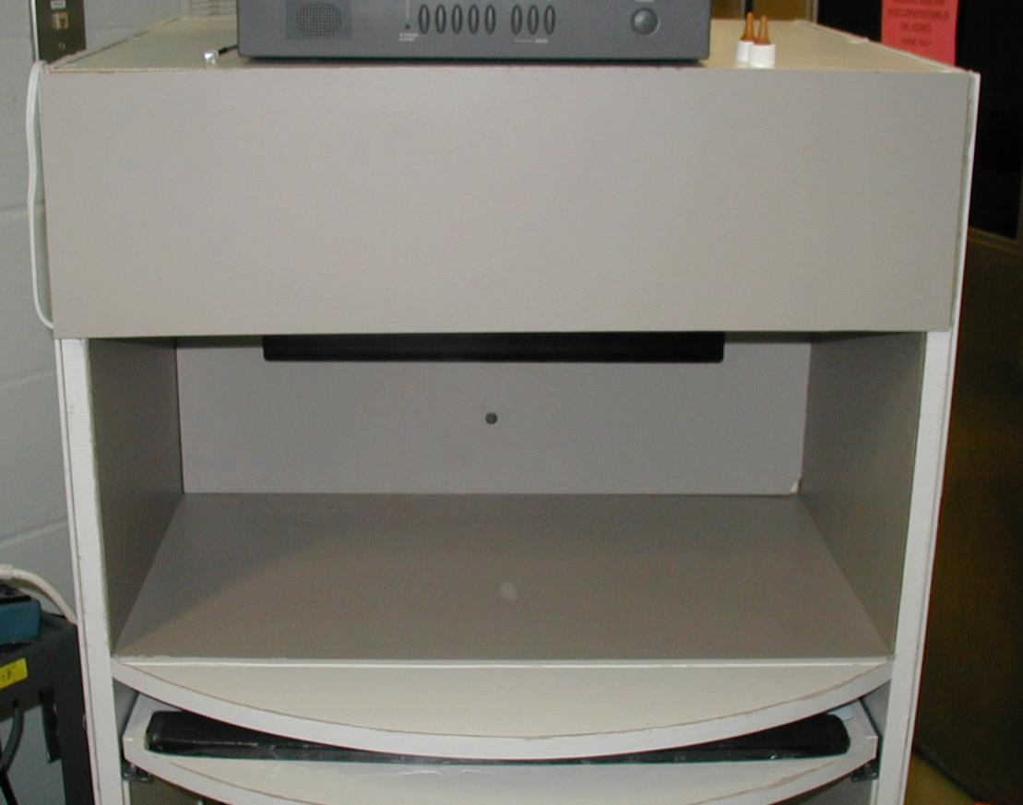
To provide a surface to mount stimulus masks and the stimulus monitor on, 1.5" aluminum angle is mounted all the way around the inner perimeter of the stimulus chamber with screws, and riveted to each other at the corners, 15" back from the cabinet front plane, with the flange of the aluminum pointed toward the back of the cabinet. These aluminum angles define the rear of the stimulus chamber, the inner sides, top and bottom of which are covered with grey ("pepperdust") formica. The formica is cut rectangular such that the rounded protrusion of the chamber floor remains white, delineating the front edge of the chamber, such that monkeys may be held on the shelf protrusion at a reproducible distance from the stimuli. A fluorescent light is mounted at top flush with the cabinet front plane. A 27.75" wide, 8" tall formica strip attaches with velcro to the top front of the chamber to block the experimenter's view of the stimuli when in use.

Stimulus monitor

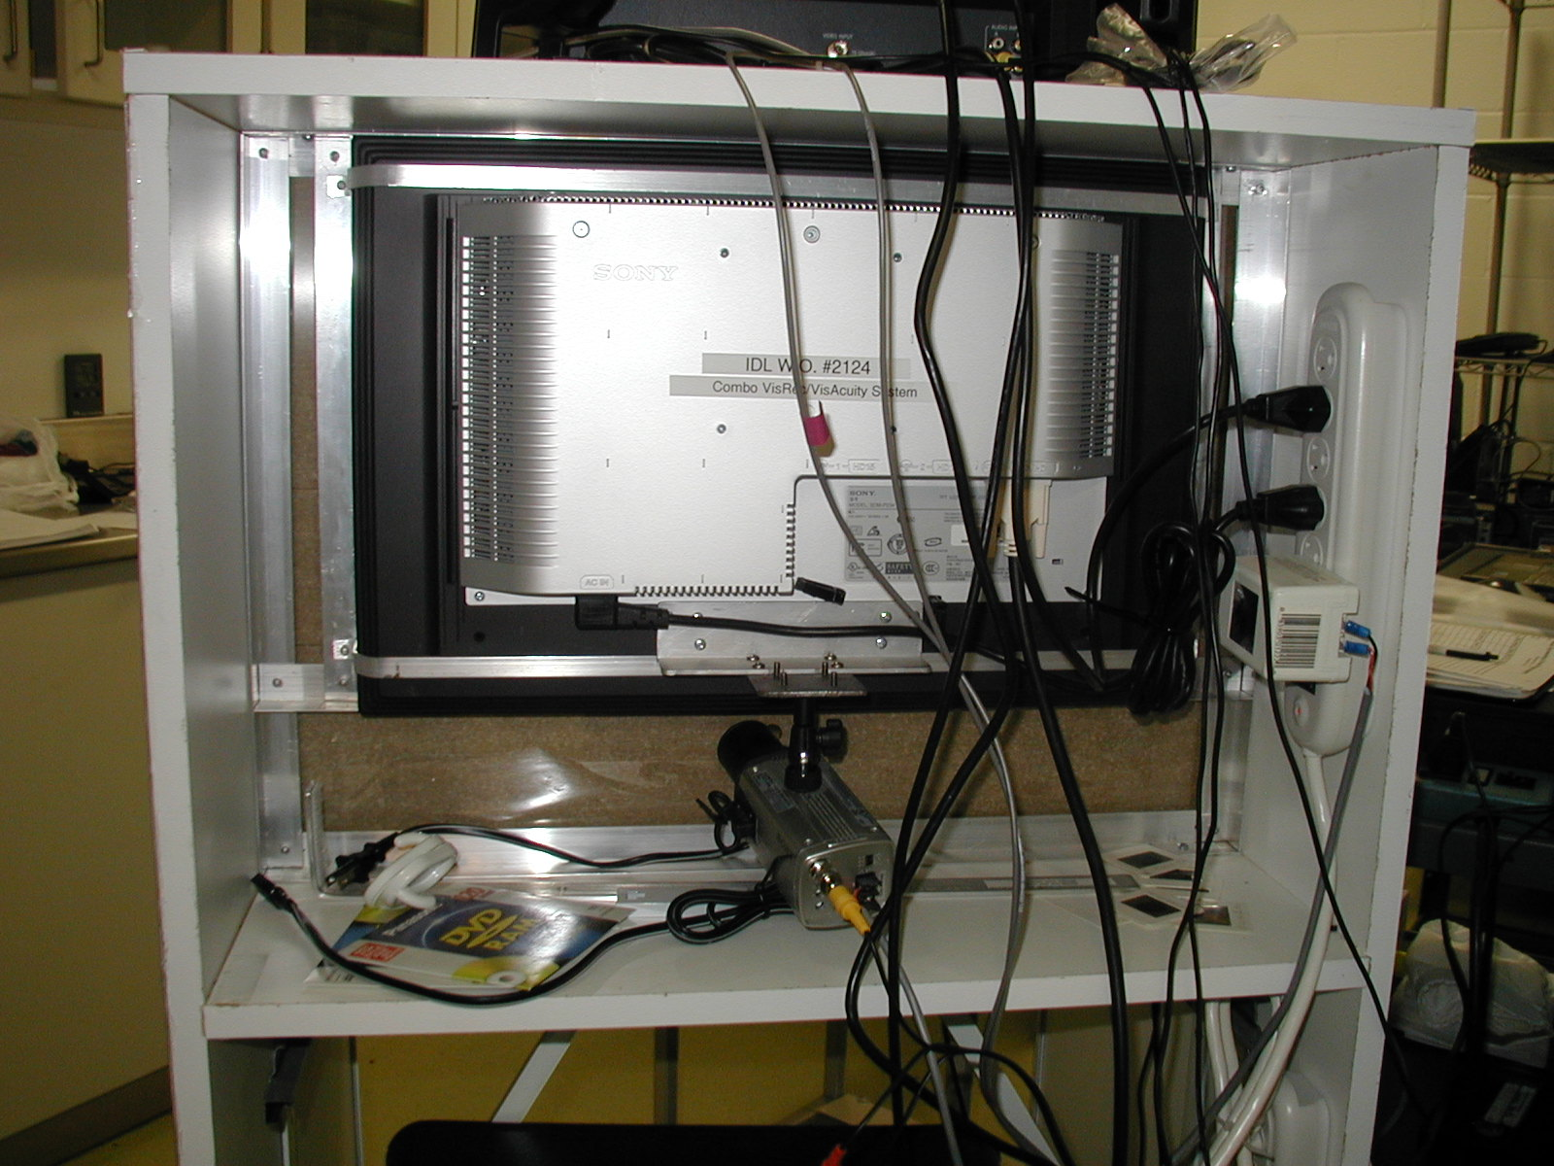
The stimulus monitor (an SDM P234 in our case) was selected for high spatial resolution (~ 100 lpi) such that Snellen values as low as ~ 20/50 could be tested for at 15", and wide width for adequate separation of left and right stimuli. The base of the monitor was removed, and the monitor pressed up into the upper aluminum angle framing the rear plane of the stimulus chamber. Another length of aluminum angle covers the bottom front edge of the monitor and is riveted behind the left and right vertically-mounted aluminum angle lengths (spanning the 13.9375" monitor height in our case). Two more lengths of aluminum angle are riveted with flanges outward to those running along the top and bottom of the monitor, snugly framing the monitor in place (inner faces 21.125" apart for this monitor). Two straps of 0.5" wide, 1/16" thick aluminum flat stock are riveted to these aluminum angle lengths that abut the monitor sides 3/4" from the chamber top and 1.25" from the monitor's bottom edge, holding the monitor forward snugly against the aluminum lengths running along its top front and bottom front edges. It was necessary to use a DVI connection to the monitor, and given the monitor's size, the data rate was higher than could be accommodated by conventional PCI video cards. An orion ADD2-N dual pad X16 PCI express card was used.

Camera

A further 1.5" aluminum angle piece mounts to the screw holes exposed upon removal of the monitor base, flange at bottom, such that a 2.5" wide, 3.5" deep piece of 1/8" steel plate may be mounted to the flange, and a 2.25" long swiveling camera mount suspended from this plate 1.25" in from the rear end and sides, such that the subject-monitoring camera hangs from the monitor. The camera used in our case was a SSC DC374 (hi-resolution color CCD video camera with 1/4" tapped mount on top). The camera image is shown on a monitor (Nuvico NVMC-140N in our case) atop the apparatus cabinet.

Feedback LEDs

An LED is mounted on either side of the subject-monitoring monitor to give the experimenter visual feedback of successful pedal presses. These LEDS have series 200 ohm resistors, and connect pins 49 and 52 of the CB68LP to pin 14, such that the LEDS light when the outer pedals are pressed.

Footpedals

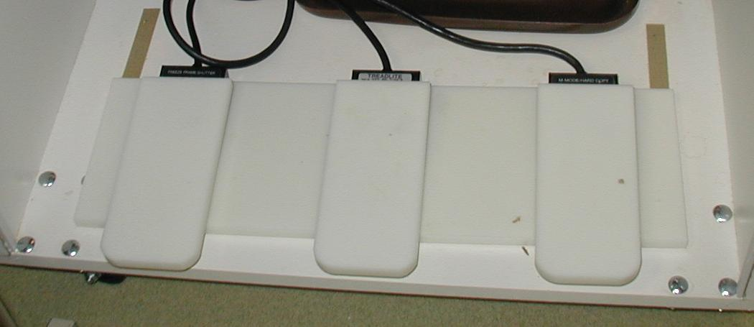
Scoring monkey behaviors is done with footpedals. 3 pedals are made from 1/2" thick polyethylene 3.5" wide and 8" long, each mounted to a rectangular Treadlite footswitch 1" from its back edge. The switches are in turn mounted to a 1/2" thick, 22" wide, 6.75" deep polyethylene slab, their back edges flush with that of the slab, with 4" of space between the polyethylene pedal extensions laterally. The switches have cables terminating in 1/4" phono plugs, which are plugged into a small project box, in which 1/4" phono jacks connect the switch signals to a length of telephone cable which runs to the computer's National Instruments CB68LP terminal board and NI PCI 6220 data acquisition card. The footswitches have 1100 ohm pull-up resistors to pins 49, 17, and 52 of the CB68LP, converting their signals to negative-logic CMOS-level signals.

Photometer
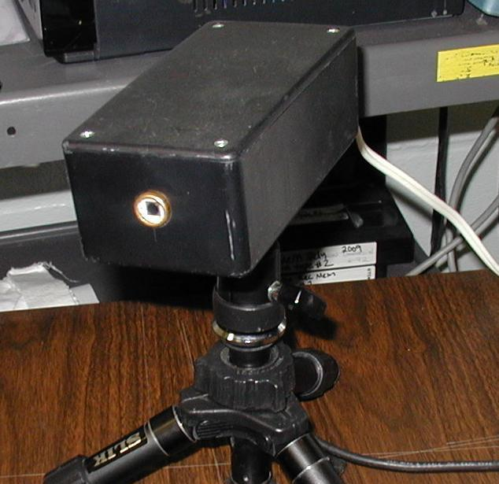
To avoid shading or coloration cues, the monitor must be linear (gamma set to 1), and exacting calibration of the monitor is critical. A UDT-020UV photodiode/amplifier was mounted in a project box on a small tripod with its signal connected to pins 67 & 68 of the CB68LP terminal board (differential analog in). With the photodiode placed in front of the left or right stimulus position, a calibration program automatically detects the photometer's location and begins exhaustively calibrating all 256 levels of the red, green, and blue channels of the monitor.

Masks

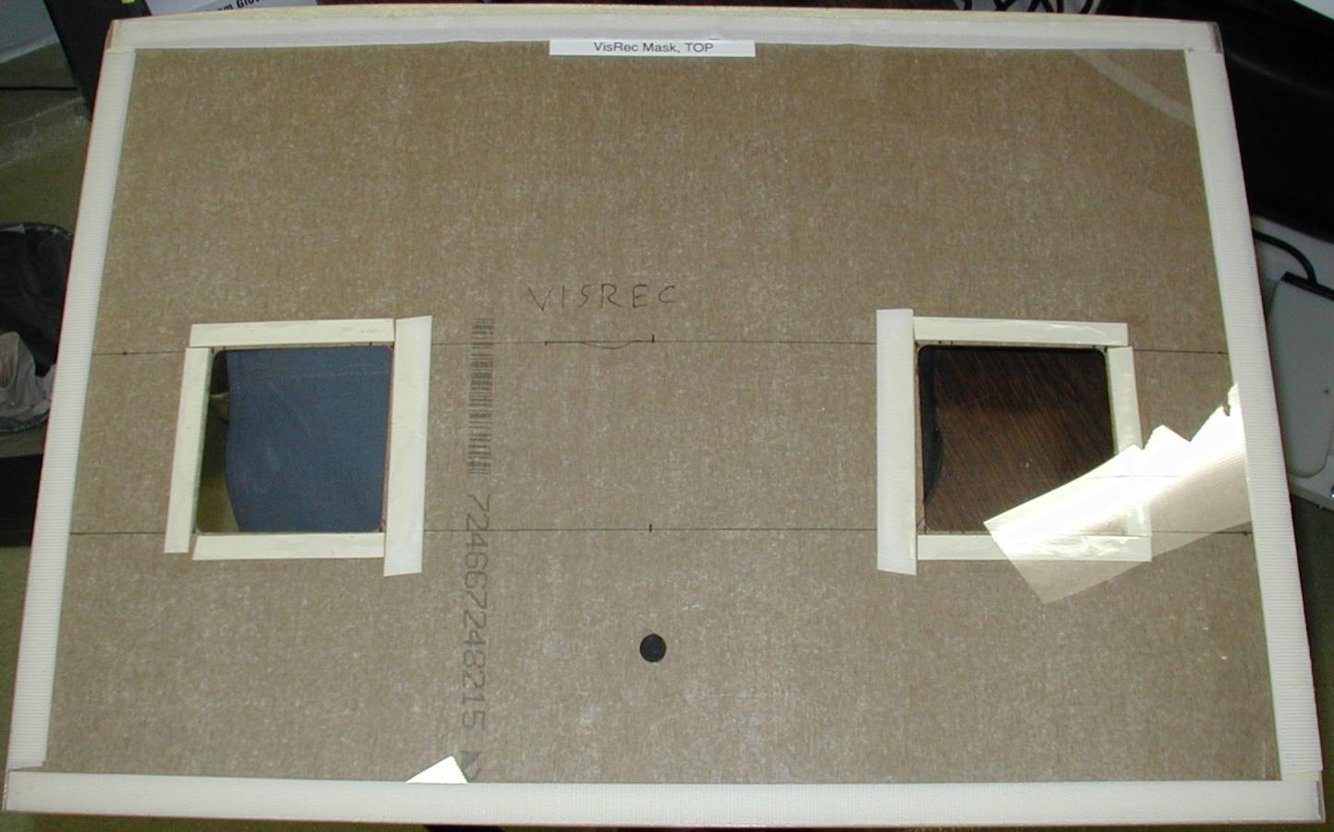
The stimuli masks are the same grey formica as that lining the stimulus chamber, layered on a sheet of 1/16" clear acrylic (to protect the monitor) with double-stick foam tape. For visual recognition tests, the holes in the formica are 4" squares, with 1/2" rounded corners, 5.75" from the bottom edge of the mask, and 3.5625" in from the outer edges. For visual acuity testing, the window is 6" high, 5.75" from the bottom edge, and extends to 3.625" from each side edge. The masks are 26.125" wide by 18.25" high overall, such that they fit snugly inside the formica-coated chamber walls. The masks mount with self-adhesive velcro strips to the aluminum angle frame defining the rear of the chamber. For this monitor, mount, and camera setup, a 1/2" diameter window centered 3.3125" up from the bottom of the center of the stimulus masks used aligned optimally with the optical axis of the camera.

A 2' length of 1" wide, 1/8" thick flat aluminum stock was bent in an "L" shape with a 90 degree bend 3" from one end. By feeding the long handle of this tool under the mask from the rear of the apparatus such that the bend hooks the lower edge of the mask, the mask can then be more easily pulled free of its velcro mounts from the front of the apparatus.

Computer

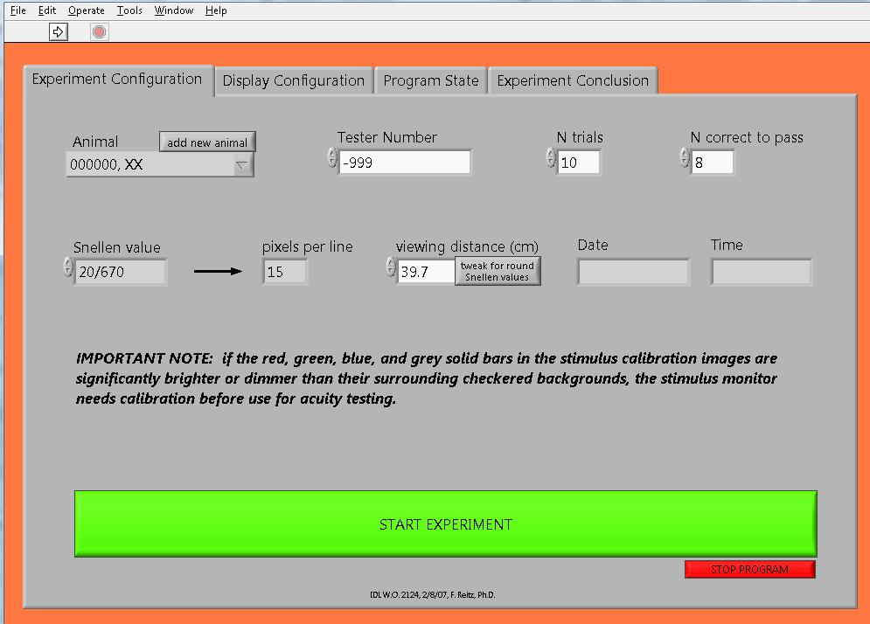
The computer used was a Dell Optiplex GX620. An LCD monitor besides that of the stimulus sits atop the apparatus for program configuration and experimenter feedback.

The progams controlling the visual recognition and visual acuity tests were written in LabVIEW. Test protocols are read by the software from a Microsoft Access database table, and acquired data are saved to this database automatically.

