Object Continuity Apparati Construction
10/19/09/F. Reitz, Ph.D.

There are 3 ObCon apparati: "the well", "A not B", and "the screen".

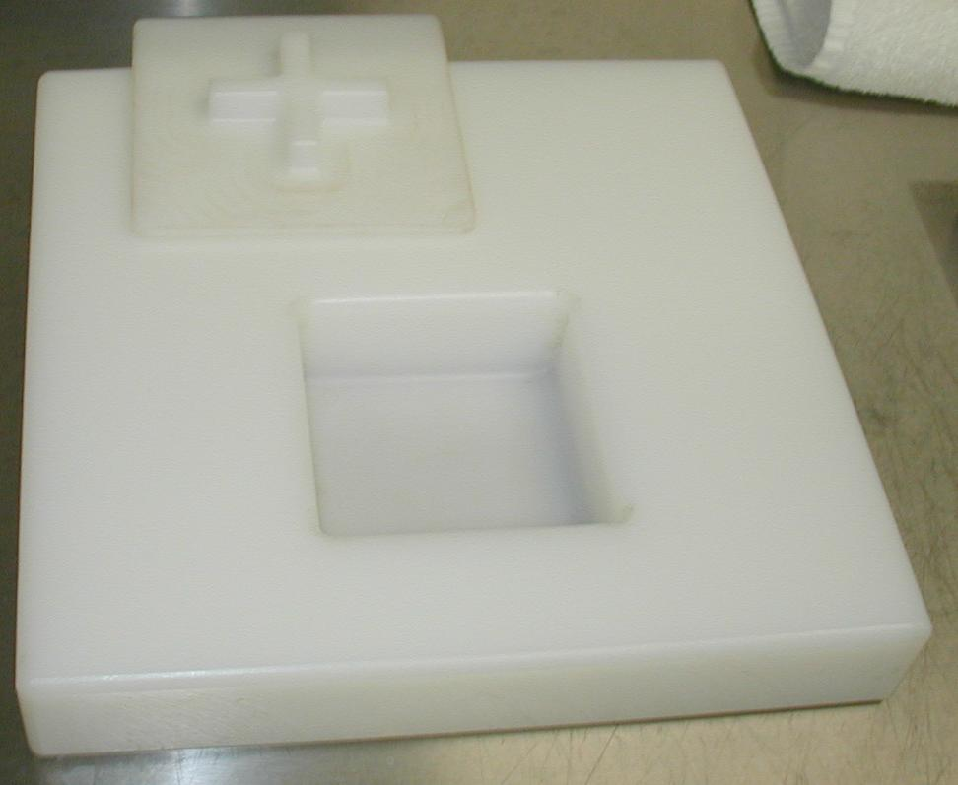
The single-welled "well" is 12.5" x 12.5" x 2" high. It has a 4.25" x 4.25" x 1.75" deep well milled 2.25" from one edge, and centered along that edge. Its lid is 5.5" x 5.5" x 1/4" thick, with a cross-shaped handle protruding from it. The two crossing segments composing the cross are each 0.5" wide, 3" long, and 0.6" high. The handle and lid are milled from a single block of plastic. All inside edges of the well and lid are milled with 1/4" radius curvature to facilitate cleaning. The 4 corners of the lid and the outer edges of the box are similarly rounded for safety.

"A not B" is 12.5" x 21" x 2" thick. Its construction, wells, and lids are identical to those of the single-welled box, except that there are two such wells, 2.25" in from the longer-dimension side, 4.25" apart from each other, and 4.125" from each end.

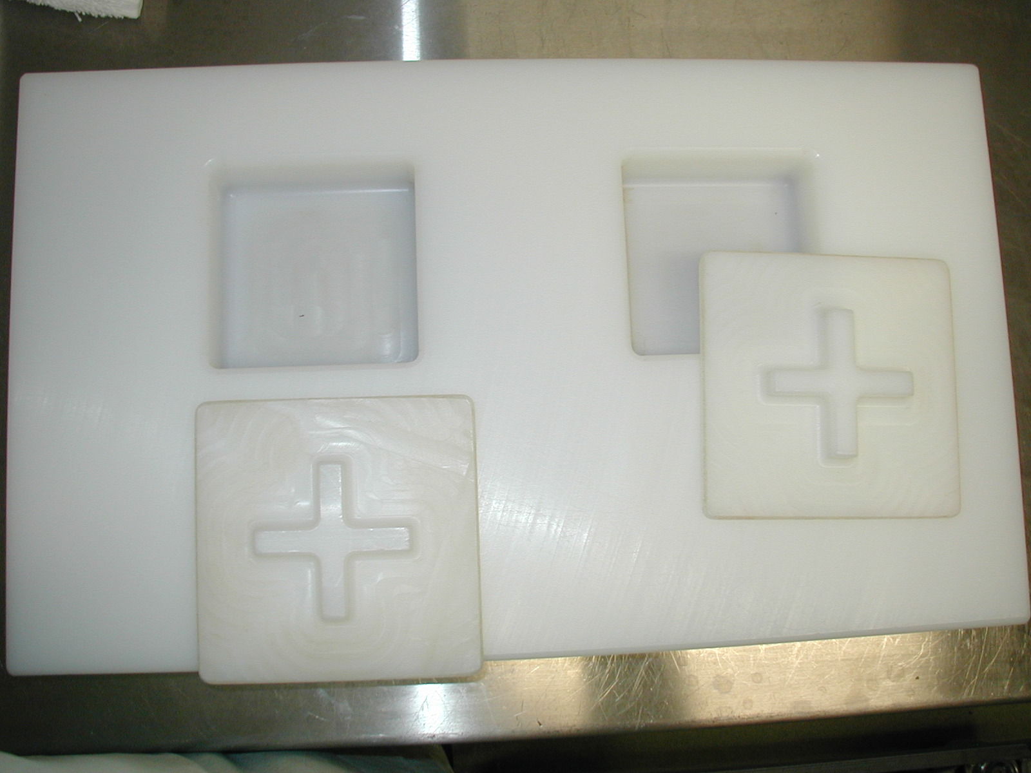

The base of the "screen" is 11" x 18" x 2" thick. A slot is milled in the slab 2.3125" in from the longer-dimension edge. Outside edges of the slab and screen are trimmed with an edger for safety.

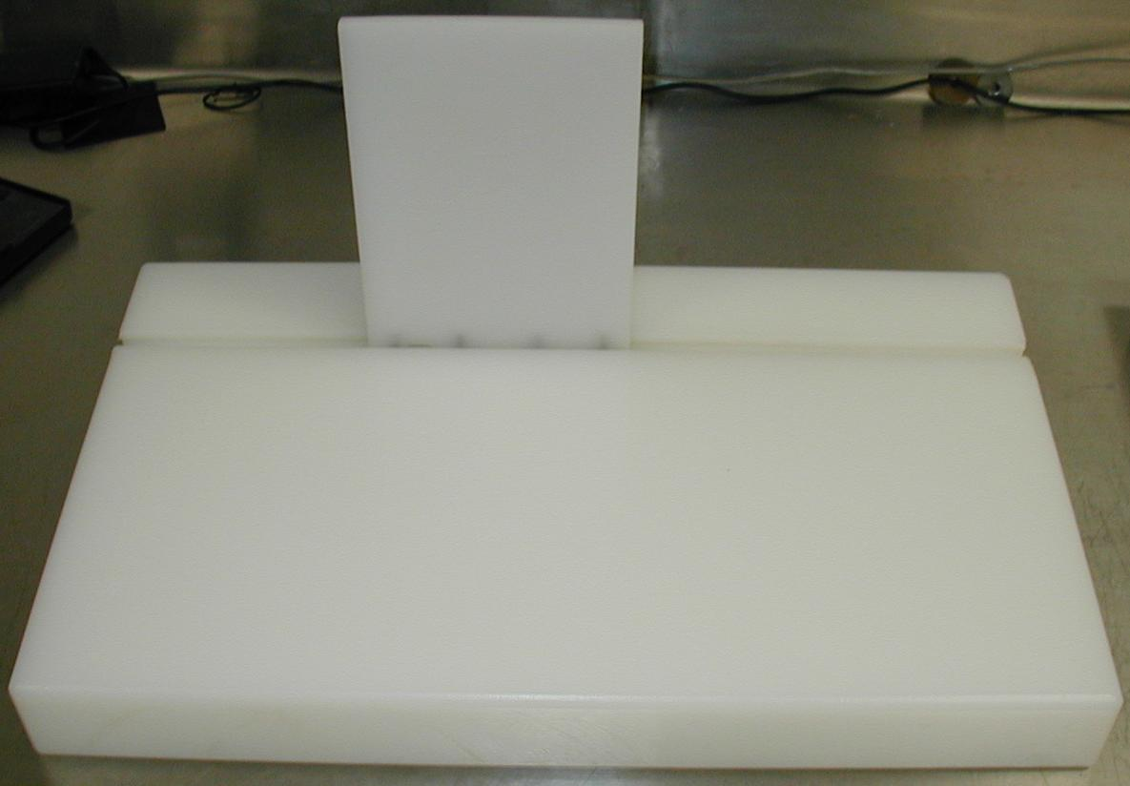
The screen itself is a 5" wide x 7" tall x 1/4" thick piece of UHMW attached to an acrylic sled with 4 recessed 0.825" long screws placed 0.5" and 1.75" in from both ends.

Bottom/oblique view of the sled:
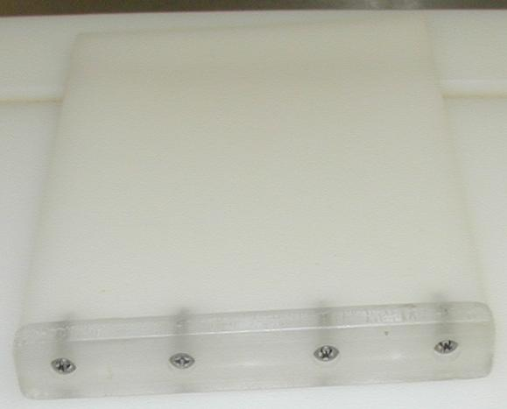
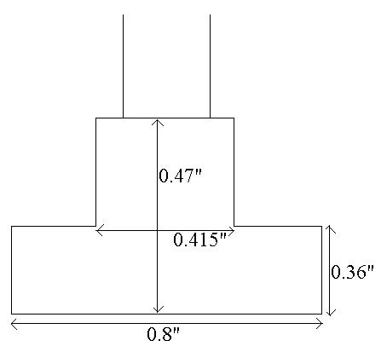

end-on view of the sled with measurements (not to scale):
end-on view of the slot:
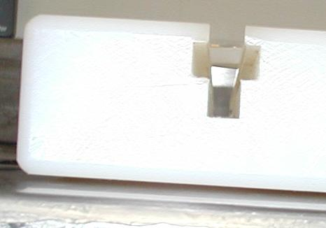

The lower portion of the slot was originally cut to accommodate an alternative sliding mechanism that is no longer used, and may not be necessary for the current scheme. Several design iterations were required to achieve smooth, quiet sliding of the screen.
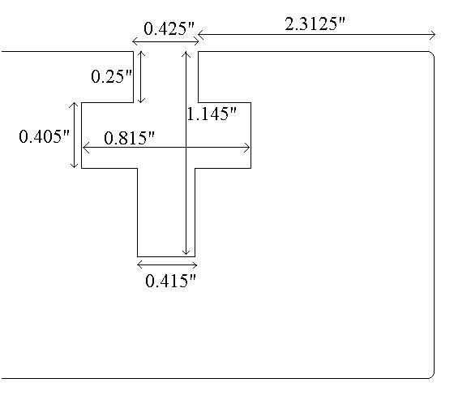

end-on diagram of the slot with measurements (not to scale):

