What is the IDL?
The Instrument Development Laboratory Core (IDL) meets the research instrumentation and engineering needs of CHDD Research Affiliates and other MRDDRC Core units. Our labor is free of charge to qualifying grants, only parts need be reimbursed.
What we do:
Design and construct research instrumentation, hardware and software systems, provide maintenance and repair services, install and test commercial instrumentation, consult on experiment design, data acquisition and reduction, commercially available instruments, security, safety, and grant and contract applications, and assist with resulting publications.
Example Projects:

- R/C and/or microcontrolled light-up toys for learning and behavioral research with children 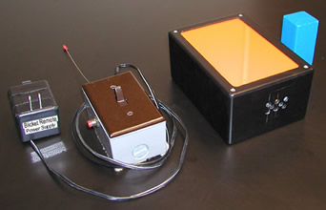
- data acquisition, from soldering the cable through signal analysis software!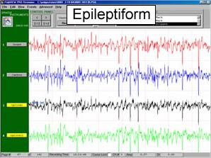
- repair/modification of existing equipment

- temperature control systems/enclosures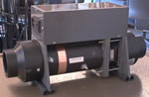
- video monitoring and coding systems, remote or otherwise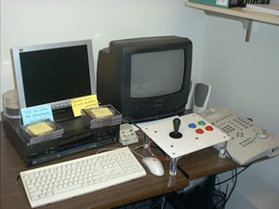
- computerized vision and cognitive testing systems with reward delivery, from the laminate cabinetry to the electronics, software, and automated calibration!
Who we are:

Thomas Lewis, Ph.D. (Mech Eng.), Director, has 8 years of academic & industrial research experience in acoustics, optics, fish hearing, ultrasound exposure and techniques, respiratory dynamics, diving physiology

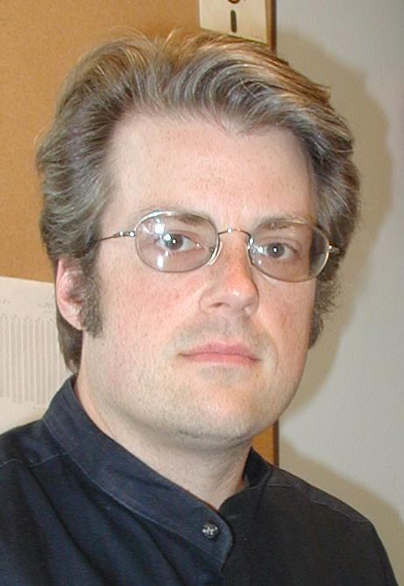
Fritz Reitz, B.S.E.E., Ph.D. (Bioeng.) has worked with scanning microscopies, cell biology and biochemistry, programming, molecular physics, and the development of mechanical, electronic, and optical systems



Kelvin Wu, B.S.BioE, B.S.E.E. is skilled with electronics and data aquisition systems for functional electrical stimulation and limb prosthetics
An Invitation:

- come walk through our lab to
  - meet your built-in employees!
  - see the physical tools and facilities at your disposal (electronics, wood/plastic/metal working tools, video/software development stations, etc.)
  - see what some have called the best view on campus!
- sit down with us sometime for an informal discussion of your research, and to explore ways in which the IDL might facilitate it (at our lab or yours -- we make housecalls!)
Center on Human Development and Disability
Instrument Development Laboratory

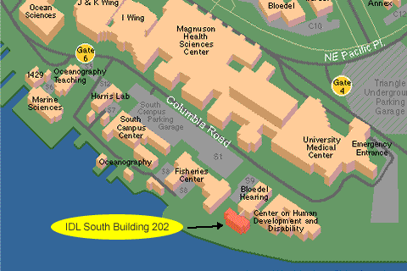

University of Washington
CHDD IDL SB-202
Seattle, WA 98195-7920
Mailstop 357920
(206) 543-9023

