Hood Canal Cruise
RV Robertson, 15-18 August 2017
(Captain Andy Reay-Ellers)

This is a combined cruise paid for by two separate projects (Project #1 and Project #2). Both cruises benefit from being in the low oxygen environment of Hood Canal during summer.

Schedule

Monday 14th
Loading and setup

Tuesday 15th
06:00 Meet at APL dock
06:30 Depart
12:00 Arrive at hotel, pickup Mark Altabet
13:00 Project #1 operations

Wednesday 16th
AM Project #1 operations
PM Project #1 operations

Thursday 17th
AM Project 2 operations
PM Project 2 operations

Friday 18th
AM Project #1 operations (and backup for Project #2?)
PM Transit, demob
12:00 Large APL passenger van available for transport of
people & samples going back to APL, or take boat back.

Small boat

We will carry a zodiac (small inflatable boat) on the Robertson in the event we need it for AUV operations.

Accomodations

There is a separate spreadsheet for where people are staying, either at the hotel or on the boat. Please bring a sleeping back if you are not staying in the hotel all the time as this will give us more flexibility.

The hotel is:

Pleasant Harbor Marina
308913 US Hwy 101,
Brinnon
WA 98320

Tel: 306-796-4611
Web: www.pleasantharbormarina.com

You do not need to do anything related to booking or reserving rooms, it is all taken care of. There are only 6 rooms and we have them all. The only group requirement we have (UW policy) is that we must fill all the rooms every night so that reimbursements work out.

Reimbursement

We each will claim per diem after the cruise through our travel coordinators. The grant will pay for your per diem which covers the hotel and breakfast/lunch/dinner. Because we will have early word day starts and be eating lunch on the boat, we pool some of the breakfast/lunch money in advance to stock the boat with supplies. Let’s plan on $15 per day from everyone receiving per diem for their time onboard so that we can buy the food on Monday as described below.

Food

Breakfast and Lunch: On Monday we will need to buy food supplies for breakfast and lunch, I’d appreciate some volunteer help to go shopping and make a list.

Dinner: There is a pub and restaurant at the hotel, if you have specific food requirements please make sure you have a backup plan:

http://www.pleasantharbormarina.com/pdf/pleasant-harbor-marina-menu.pdf

There is a second (bigger) restaurant 5-minutes drive down the road, and a few more beyond that.

General notes

Regarding gear and setup ideas for our cruise:

- AUV and gear (similar 'coffin' size box as the AUV is in), plus couple small pole mounted antennas (Iridium/GPS) that we strap to railing on upper deck if possible.
- CTD rosette and winch, plus sampling kits for inert gases and Winkler (several boxes of glassware sample bottles).
- Winkler titration kit, which will require a fair bit of setup during the trip to Hood Canal. This is wet chemistry with chemicals (sulfuric acid, sodium hydroxide, etc.). That will take up the largest available benchspace section ideally near a sink (freshwater rinse). We have chemical waste storage containers for titration waste (5 gallon during cruise?). I will get you a complete MSDS inventory. We will bring DI water in carbuoys.
- We will also need to setup an 'AUV control center' on a benchtop which is mostly a large screen and charging/data download area with Iridium/GPS feeds into the laptop. I wonder if the wheelhouse table could be used for the AUV laptop, it would provide you with all the realtime info on the vehicle from the overboard towfish. If so, are there an goosnecks to get cables into that region?
- At the CTD control station (deckbox in main lab) water samplers usually huddle at the whiteboard opposite it to plan the casts. Mark Altabet will have need of some mainlab benchtop to prepare/store his samples.
- there will be need for data processors with laptops analyzing data, maybe we can overspill into the galley area so as to clutter the main lab and have our laptops plugged and charging down stairs since there are lots scientists onboard who will be multitasking. ;)

Generally, it sounds like we will need to do most of the setups on route. I went to Hood on the Barnes couple months ago and we had a surprisingly rough turn (getting broadsided) into the canal which was due wind direction and fetch. I'll remind everyone to keep in mind that setup needs to be done right away, but we'll count on you to please keep us informed on sea conditions so we don't get caught especially with our chemistry focus in the main lab.

Project 1: Test new profiling Gas Tension Device (NOAA funding)

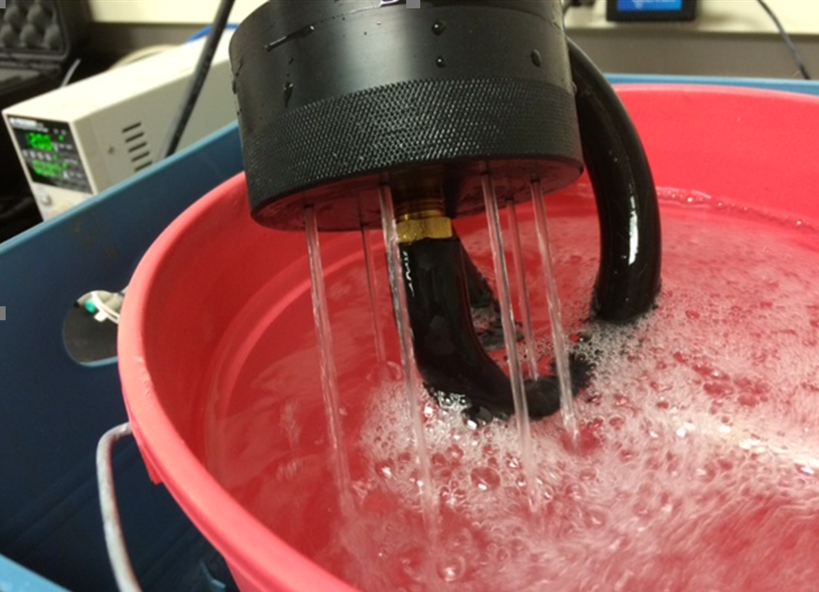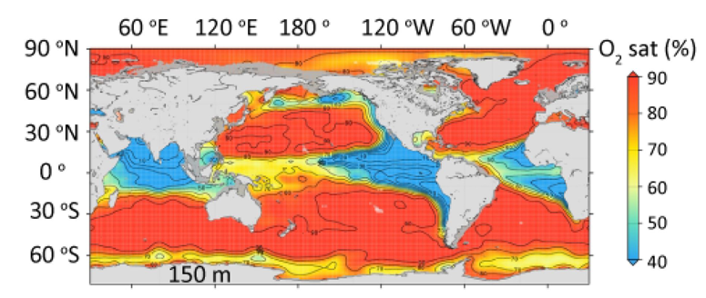

Goals:
- evaluate the performance of the new GTD on the ship’s CTD.
- determine and document best use practices
- perform inter-calibrations with mass spec determination of N2

Sampling: main sampling day is 16th. This will be mostly sitting in deep water running the rosette CTD. We will perform many very slow CTD casts to determine the equilibrium gas tension profile, evaluating various techniques (e.g., ‘hold-sample-move’, ‘density following on wire’, standard hydrocast, etc.). In more detail for ‘hold-then-sample’, for example, we will hold the CTD at various depths on the way up to trigger bottles for water samples and let the new sensor equilibrate at the Niskin trigger depth. Niskin samples will be analyzed for Winkler O2 on the ship, which involves wet chemistry in the main lab area. Some additional samples will be stored and transported back to the lab; these samples will be sent to UMass Dartmouth for mass spec determination of N2/Ar ratios.

People: McNeil, D’Asaro, Altabet, Reed, Anuscheh Nawaz (day guest)

HazMat: Winkler titration chemicals, nasty preservatives (?)

Notes:
-Altabet coming from east coast, leaving before Friday.
- Andrew Reed will run the Winkler kit.
-We might try profile along a section of the Canal after we figure out how the new sensor works and play with it for the first time.

Project 2: AUV water sampler for dissolved iron. (UW RRF funding)

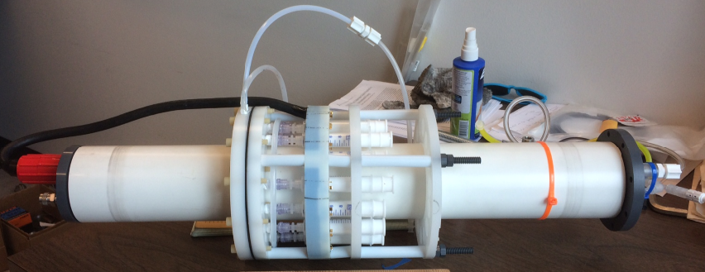

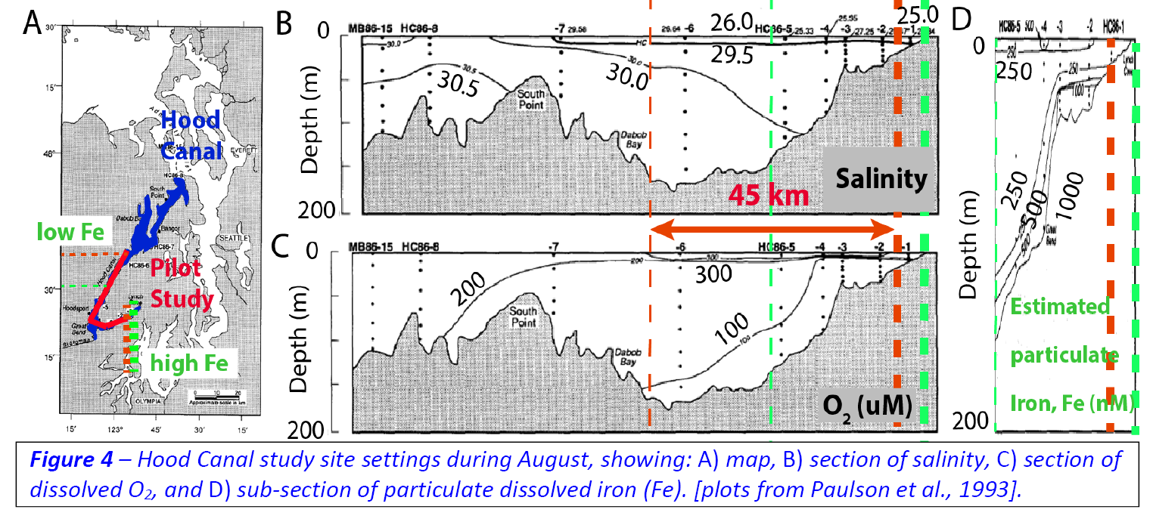

Goals:
- measure transect of dissolved iron along lower Hood Canal using the new water sampler on the AUV.

Sampling and tasks: Main sampling day is 17th. We may deploy several transponders for navigation and defined waypoints. We will run the AUV multiple (2-3?) times up and down the channel (see attached figure of planned route). The AUV will take water samples on-route. The sampler will be removed and syringes changed between missions. We will follow behind the AUV and take surface water samples using ‘clean techniques’ for inter-calibration.

People: McNeil, Shcherbina, Crusius, Mueller

HazMat: AUVs (large lithium ion batteries).

Notes:
- 8.5 kts for Robertson transit speed, about 5 hrs to Hood Canal from APL.
- Ray Hollingsworth will take an APL van up to the hotel on Thursday and ride back on the boat and Craig will drive to APL with any passengers and samples on Friday around noon.

