CHAPTER 13

THE HUMAN RESOURCES MANAGEMENT/PAYROLL CYCLE

SUGGESTED ANSWERS TO DISCUSSION QUESTIONS

13.1 Payroll and HRM systems are separate in many companies because integration was generally not feasible using early data processing technology. Also, different events generate data and two different professions were interested in using the data. As a result, many companies (and their employees) became accustomed to having payroll data processed by the accounting function and personnel data processed by the human relations function. Now that modern information technology makes integration more feasible, employees in some companies are still likely to resist suggestions for change because they are comfortable with the old way of doing things. In addition, employees within the accounting and personnel functions probably feel some degree of "ownership" of "their" data, and this is taken away when control of these data is transferred to a centralized data base function.

Reasons for integrating the personnel and HRM systems include the following:
- Integration will improve decision-making by providing access to more of the relevant data needed for monitoring employee development.
- It is logical, since both systems are organized around the same entity: the employee.
- By eliminating the perception that a specific organizational function has ownership of a particular set of data, it should provide improved data access.
- It should facilitate the retrieval and utilization of employee data when the data required would otherwise have to be obtained from both data bases.
- It should facilitate the process of updating employee data, since a single update process would replace two separate updating processes.
- It should simplify the development and implementation of more complex compensation schemes, such as flexible benefits or incentive pay.
- Centralizing the administration of employee data under the control of data base management software should enhance data security.
- It should minimize or eliminate the cost of storing identical data in two different databases.
- It should minimize or eliminate the confusion that might otherwise arise when two different databases use different data definitions, or report different values, for the same data item.

13.2 This question should generate some debate. The issue is the trade-off between “subjectivity” in measuring the value of a company’s investment in the knowledge and skills of its employees versus the usefulness of at least attempting to explicitly measure those assets. In the “information era” the value of a company’s employee knowledge base is increasingly important. Attempting to measure it should facilitate more effective management of this resource by focusing more attention on it.

13.3 Formal reports on employee performance are not intended to replace direct observation, but to supplement it. Direct observation is important, but a manager cannot observe all employees all the time. It is also difficult to accurately summarize detailed observations across time. Well-designed reports provide quantitative summary measures of aspects of employee performance that are believed to be important to achievement of the organization’s goals. Quantitative measures facilitate tracking performance trends over time. These benefits, however, will be difficult for many managers to understand until they have had experience in using such reports. There are also legal issues at stake. If an employee or former employee brings suit against the employer, supporting documentation may justify the employer’s position.

13.4 From an economic point of view, there is no question that direct deposit should become the norm. Some students might raise objections, however, on the basis of restricting employees’ freedom of choice or, for some groups of workers, on access to and comfort with dealing with banks.

13.5 Other threats are: not working or working less productively than if the employees were working onsite. Security risks such as the employee not proactively maintaining proper antivirus and patch management practices, in addition they may not protect and/or backup their data adequately. Software exists to enable companies to monitor employees, including what they do on the Internet. In addition, a company could require that telecommuting employees login their company’s network and store all work related files on the company’s network and not on their home machines. Employees would also be required to login so that their machines could be updated with the latest antivirus protection and patches. Most students should agree that companies have a right to expect their employees to not conduct a side business using company-provided resources. But, whether companies should try to prevent this through monitoring is certain to raise some lively discussion. Ask students if they have any first-hand knowledge of how their employers deal with this problem.

13.6 A separate payroll account limits the company’s exposure to only the amount of cash deposited into the payroll account. A separate account is also easier to reconcile and to detect any errors or irregularities.

SUGGESTED ANSWERS TO THE PROBLEMS

13.1 a. A hash total of employee wage rates should be maintained by the personnel department, and checked against the total on the payroll master file after each update of that file. Also, a reasonableness test of wage rate changes during data entry could detect this type of error if the dollar amount was large.

b. Access controls should be used to limit the ability to add new records to the payroll master file to only the HR department. A report of all changes to the payroll master file should be regularly run and all changes should be verified.

c. A limit check should be used during the data entry process to check the hours-worked field for each employee transaction record.

d. The computer operator's password should not allow access to the payroll master file, and a compatibility test should be performed on all transactions entered to verify that the operator's password indicates that he/she has the appropriate access and modification authority. A backup control would be a batch total of all salaries maintained by the personnel department and checked against a corresponding total generated during each payroll run.

e. Paychecks should be distributed by the payroll department, not the employee’s supervisor.

f. Job time data prepared or approved by factory supervisors, or captured using automated data collection equipment, should be reconciled with employee clock cards prior to payroll processing. Observation of time clock use might also uncover punching other people’s cards. The use of biometric controls to record time in and time out would also prevent this type of problem.

g. There should be control over access to payroll and other current master files, in the form of a file library function that restricts access to files to those who have appropriate authority. As in part (d), a backup control would be a batch total of all salaries maintained by the personnel department and checked against a corresponding total generated during each payroll run.

h. A record count of job time records could be prepared before the records are submitted for processing, and checked subsequent to data entry against the number of paychecks prepared. In addition, reconciliation of job time records to employee clock cards should detect this. Also, a report, such as the payroll register, should be printed along with paychecks. The total number of employees listed on the payroll register should match the number of employees in the payroll master file – any discrepancies should be promptly investigated.

i. All active files should have internal file labels identifying their contents and expiration date, and all programs should check the file labels prior to processing. In addition, backup copies of all current files should be maintained.

13.2

(CPA Exam, May 1993, Auditing Question Unofficial Answer, adapted)

Question | Y/N | Threat if control missing
1. Are payroll changes (hires, separations, salary changes, overtime, bonuses, promotions, etc.) properly authorized and approved? |  | 1. Unauthorized payraises and fictitious employees.
2. Are discretionary payroll deductions and withholdings authorized in writing by employees? |  | 2. Errors; lawsuits by employees; penalties if violate tax code.
3. Are the employees who perform each of the following payroll functions independent of the other five functions?  - personnel and approval of payroll changes  - preparation of payroll data  - approval of payroll  - signing of paychecks  - distribution of paychecks  - reconciliation of payroll account |  | 3. Fraud; theft of paychecks.
4. Are changes in standard data on which payroll is based (hires, separations, salary changes, promotions, deduction and withholding changes, etc.) promptly input to the system to process payroll? |  | 4. Errors in future payroll; possible fines and penalties.
5. Is gross pay determined by using authorized salary rates and time and attendance records? |  | 5. Over/under payment of employees.
6. Is there a suitable chart of accounts and/or established guidelines for determining salary account distribution and for recording payroll withholding abilities? |  | 6. Errors in cost analyses; fines and/or penalties if fail to withhold correct amounts.
7. Are clerical operations in payroll preparation verified? |  | 7. Errors not detected.
8. Is payroll preparation and recording reviewed by supervisors or internal audit personnel? |  | 8. Errors not detected and corrected.
9. Are payrolls approved by a responsible official before payroll checks are issued? |  | 9. Fraudulent payrolls.
10. Are payrolls disbursed through an interest account? |  | 10. Greater risk of paycheck forgery; harder to reconcile payroll.
11. Is the payroll bank account reconciled to the general ledger? |  | 11. Failure to detect errors
12. Are payroll bank reconciliations properly approved and differences promptly followed up? |  | 12. Failure to detect and correct problems.
13. Is the custody and follow-up of unclaimed salary checks assigned to a responsible official? |  | 13. Theft of paychecks.
14. Are differences reported by employees followed up on a timely basis by persons not involved in payroll preparation? |  | 14. Cover-up of fraud.
15. Are there procedures (e.g., tickler files) to assure proper and timely payment of withholdings to appropriate bodies and to file required information returns? |  | 15. Fines and/or penalties.
16. Are employee compensation records reconciled to control accounts? |  | 16. Inaccurate records; failure to detect and correct errors.
17. Is access to personnel and payroll records, checks, forms, signature plates, etc. limited? |  | 17. Fraudulent payroll.

13.3

The following changes may be made to improve the Kowal Manufacturing Company's system of internal control for payroll procedures:

a.

Weakness | Threat
1. Factory supervisor hires all job applicants and forwards their W-4 form to the payroll clerk. | The factory supervisor could hire fictitious employees and submit their W-4 form.
2. Factory supervisor verbally informs payroll of all employee pay raises. | No documentation on pay raises could lead to employee disputes and litigation. The factory supervisor could give the fictitious employees raises.
3. Blank time cards are readily available. | An employee could have another employee fill out a time card when they were late or not even at work.
4. Weekly time cards are not collected until the next Monday. | Time cards could be altered over the weekend with fictitious or false information in the case of a vendetta against another employee.
5. The factory supervisor distributes pay checks. | The supervisor can conveniently keep the pay checks of fictitious or fired employees.

b.

1. A system of advice forms should be installed so that new hires, terminations, rate changes, etc., are reported to the payroll department in writing. Such forms should be submitted by the employee and verified by the appropriate supervisor.

2. Before applicants are hired, their backgrounds should be investigated by contacting references to determine that they are not dishonest and have no other undesirable personal characteristics.

3. The supply of blank time cards should be removed. At the beginning of each week the payroll department should provide each worker with a time card stamped with his name.

4. The foreman should collect the time cards at the end of the week, approve them, and turn them over to the payroll clerk. All time cards should be accounted for and any missing cards investigated.

5. If the Company has a cost system that requires the workers to prepare production reports or to account for their time by work tickets, the time cards and the production reports or work tickets should be compared.

6. The payroll checks should be prenumbered to control their issuance.

7. The payroll checks should be distributed to the workers by a responsible person other than the foreman. Unclaimed checks should be sent to internal audit until claimed by the worker.

8. A responsible person other than the chief accountant and the payroll clerks should reconcile the payroll bank account.

9. From time to time an officer of the Company should witness a payroll distribution on a surprise basis.

(CPA Examination, adapted)

13.4

a. Five different areas in Arlington Industries' payroll processing system where the system controls are inadequate are as follows:
- The payroll processing system at Arlington Industries violates the principle of segregation of duties in several areas as the same individual verifies time cards, inputs payroll information into the master file, prints the checks, machine-signs the checks, distributes the checks, and prepares the payroll journal entry, which may lead to collusion.
- There is no authorization of employees' time cards by a supervisor or other objective party such as a timekeeper.
- The payroll checks are not prenumbered nor are they properly stored. As a result, there is no audit trail to verify check usage.
- There is no control over the machine signing of checks such as control of the signature plate by a second party or the use of a log to record activity.
- The data processing department appears to have full access to the payroll files and checks, which could lead to sensitive payroll information being leaked.

b. Two different areas in Arlington Industries' payroll processing system where the system controls are satisfactory are as follows:
- The personnel department determines the wage rate and initiates the setup of payroll records, which is a good example of segregation of duties.
- A backup of the master file is made after each weekly processing of the payroll.

(CMA Examination)

13.5

1. File changes are any additions, deletions, corrections, or other revisions of the payroll master records that do not occur on a regular basis. Examples would include:
- A name change
- An address change
- A change in salary
- A change in marital status
- A change in number of withholding exemptions
- A change in number or amount of authorized deductions
- An error correction in any field
- The addition of a new employee
- The deletion of a terminated employee

- Systems flowchart of payroll file update process:

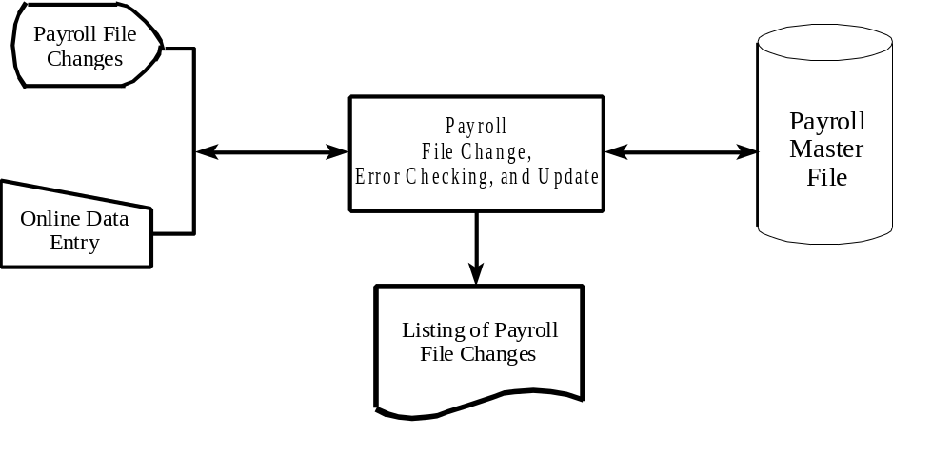
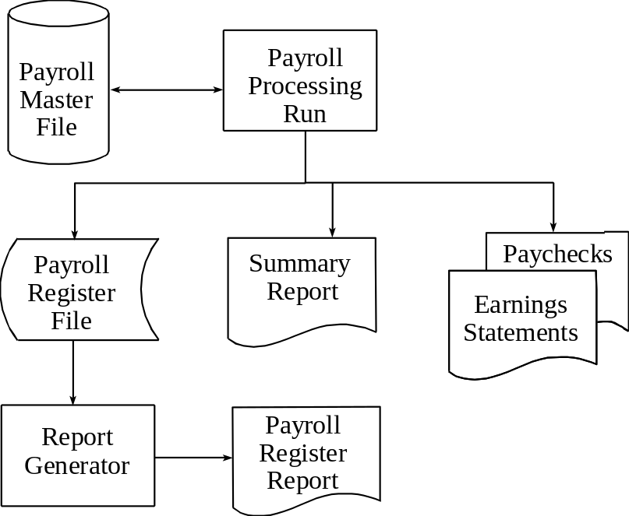
2. (Cont.) Systems flowchart of monthly payroll run:

3. The processing described in the problem is reflected by the following journal entries:
Salaries Expense $XX,XXX
Payroll Control $XX,XXX

Payroll Control $XX,XXX
Payroll Deductions (Various Accounts) $XX,XXX
Cash $XX,XXX

Payroll Tax Expense $XX,XXX
Payroll Taxes Payable (Various Accounts) $XX,XXX

While it is not clear from the case description, there might also be another journal entry debiting one or more expense accounts, and crediting corresponding liability accounts, for employee fringe benefits paid for by the employer, such as health insurance, life insurance, a pension plan, etc.

4. Control objectives and related control procedures:

Objective No. 1: Authorization of payroll transactions.
Computer Controls: Password access control.
Compatibility test of user passwords.
Supervisory review of list of payroll file changes.

Objective No. 2: Assignment of employees to productive work.
Computer Controls: Provide timely and complete reports on employee performance to supervisors.

Objective No. 3: Accurate processing of payroll transactions.
Computer Controls: Preformatting or prompting for data entry.
Transaction batch totals: record counts, hash totals, and financial totals.
Edit checks: validity checks, field checks, range checks completeness tests, etc.
Redundant data check of employee number and name.
Supervisory review of list of file changes.
Sequential numbering and logging of all payroll file change transactions entered.
Crossfooting of payroll register.

Objective No. 4: Accurate payroll master file records.
Computer Controls: Internal (header) and external file labels.
Backup copies of payroll master file, stored at an offsite location.
Payroll transaction log, stored at an offsite location.
Password access controls.
File library to maintain custody and log all payroll master file usage.
Batch totals of key payroll master file data values.
Objective No. 5: Proper disbursements for employee compensation.
Computer Controls: Sequentially numbered paychecks.
Reconciliation of payroll bank account.

More detailed explanation of the functioning of each control policy or procedure within the context of the payroll data processing application:
- Password access control: All persons authorized to access the payroll master file would be assigned a password which they would be required to enter onto the terminal for each access request. The system would not allow any operations to be performed on the payroll master file unless a proper password was given.
- Compatibility test of user passwords: Each password (see above) contains an internal code specifying certain functions (read, display, update, create, delete, etc.) that its user is authorized to perform on the payroll master file. Whenever any user requests that a function be performed on the payroll master, the system checks the compatibility of that function with the user's password.
- Supervisory review of list of file changes: Each departmental supervisor should receive a list of payroll file change transactions pertaining to employees in their departments, and should compare this list to their own records to verify that (1) only authorized transactions have been processed, and (2) the transactions have been processed accurately.
- Provide timely and complete reports on employee performance to supervisors: For each sales transaction, the identity of the salesperson should be recorded. The computer system can then easily prepare sales analysis reports by salesperson. These reports will help supervisors effectively evaluate the quality of each salesperson's work.
- Preformatting or prompting for data entry: For each type of payroll transaction, the user is prompted to enter the appropriate data items by displaying a document format or a list of required data on the input screen.
- Transaction batch totals: For example, for each batch of payroll file change transactions, record counts of the number of transactions by department, the number of new hires and terminations, and the number of salary increase transactions; hash totals of employee numbers; and financial totals of the total salary increases by department.
- Edit (input validation) checks: Validity checks of employee numbers and transaction-type codes, field checks of effective dates and dollar amounts, range checks on effective dates, reasonableness tests of salary increase amounts relative to the current salary, and a completeness test of each payroll transaction to verify that all required data items are included.
- Redundant data check of employee number and name: Each payroll transaction would include the employee number and name (or first five characters of the name). As a transaction is read, the system locates a payroll master file record having a matching employee number; failure to locate a record with a matching number indicates that the employee number on the transaction record is invalid (validity check). If a matching master record is found, the name on the transaction record is compared with the name on the master record (redundant data check). A match indicates that the employee number on the transaction is correct, while a nonmatch suggests that the employee number on the transaction, though valid, may not be the correct number for this transaction.
- Supervisory review of list of file changes. Discussed above.
- Sequential numbering and logging of all payroll file change transactions entered: Every transaction entered into the system should be assigned a sequential number and recorded on a transaction log. The system may be programmed to verify the sequence of transactions processed, thus providing assurance that all transactions are processed, and that no transaction is processed more than once.
- Crossfooting of payroll register: At the conclusion of the payroll run, checks whether the column totals of net pay and all deductions sum to the column total for gross pay. This should be done for each subsection of the payroll register (e.g., by page or by department) and for the report as a whole.
- Internal (header) and external file labels: The first record within the payroll master file should contain the name and expiration date of the file (internal label) and this should be checked against program and/or user specifications each time the file is used. Also, the file name and date should be written on a gummed label (external label) attached to the disk pack.
- Backup copy of payroll master file, stored at an offsite location: This should be prepared every time the payroll master file is updated, and immediately removed from the central data processing facility to be stored in a secure location elsewhere.
- Payroll transaction log, stored at an offsite location: This is prepared as described above under "Sequential numbering and logging of all payroll file change transactions entered." Ideally, a backup copy of the current transaction log will be maintained at the offsite location and updated through a data transmission network as each transaction is entered and processed. In that way, if a catastrophe strikes the central data processing facility and destroys all data and files maintained there, the backup master file and transaction log may be used to restore the payroll master file to a fully current status.
- Password access controls: Described above.
- File library to maintain custody and log all payroll master file usage: All copies of the payroll master file should be stored in a secure file library when not in use. When used or returned, the file should be checked in or out by a file librarian who records the date, time, and identity of the user.
- Batch totals of key payroll master file data values: The personnel department should maintain a number of batch totals of key payroll master file data values, including a record count of the number of employees, a hash total of employee numbers, and a financial total of employee salaries. These could be maintained for each department, as well as for the organization as a whole. It is important that these be maintained, and updated for payroll file change transactions, independently of the data processing function. Then, after each time that the payroll master file is updated or processed, the system can compute these same batch totals and print them on a report to be compared with those maintained by the Personnel Department.
- Sequentially numbered paychecks: These facilitate keeping track of all paychecks issued, and facilitate detection of any unauthorized use of blank paycheck forms.
- Reconciliation of payroll bank account: This should be done monthly, and can easily be done by the computer.

5. a. In addition to the employee's base salary, each employee's payroll master record would have to include (a) a code indicating whether or not the employee is a salesperson who is to receive a sales commission, and if so (b) a sales commission rate. In an REA system, commission rate data could be stored in a separate table. However, if the sales commission rate is to be the same for all employees, it could be incorporated into the payroll program as a constant, rather than stored in each employee's payroll master record.
b. The payroll run must process an input file that contains a record of sales for each salesperson. In addition, the payroll program must include a subroutine that calculates each salesperson's commission and adds it to their current period gross pay. Finally, the payroll register and employee earnings statement should include additional columns or fields listing the commission earned by each salesperson during the current pay period and year-to-date, and the summary report should list total sales commissions paid by the company during the current pay period and year-to-date.

c. The primary internal control objectives involve (a) the accuracy of the sales data entered into the payroll processing run as a basis for calculating the sales commission, and (b) the accuracy of the salesperson code and sales commission rate within the payroll master records. The issue of authorization of changes to the salesperson code and sales commission rate in the payroll master also arises, but this is dealt with by procedures explained below.

New internal control procedures to deal with these issues should include:
    - The sales data used as a basis for calculating sales commissions will undoubtedly be a by-product of sales transaction processing. Hence, it is important that good controls be in place within Darwin's sales transaction processing system. It would be useful to review these controls.
    - It is important that sales be credited to the proper employee. Since that was not essential when sales commissions were not paid, new procedures may be required to validate the salesperson identification number captured when a sale is made. Since the case tells us nothing about how sales data are collected, it is hard to make a specific recommendation. One possibility would be to give each salesperson a badge, which they can use to enter their identification number when they make a sale. A follow-up control is to provide every salesperson with a monthly report detailing all sales for which they received credit; this would provide an opportunity for each to verify the accuracy of these data.
    - Sales transaction processing should produce some type of batch total of dollar sales. Batch control over this figure should be maintained throughout the payroll-processing run.
A record count of the number of salespersons and a hash total of sales commission rates should be maintained by the Personnel Department. The "Listing of Payroll File Changes" report should detail all changes in these amounts within each pay period. Finally, the payroll run should recompute these values from the payroll master file and include them in the summary report, so that they can be checked against the values maintained by the Personnel Department.

13.6

See “Ferret Out Spreadsheet Errors,” (Journal of Accountancy, February 2004) by Mark G. Simkin and “Block That Spreadsheet Error,” by Theo Callahan (Journal of Accountancy, August 2002) at www.aicpa.org.

c.

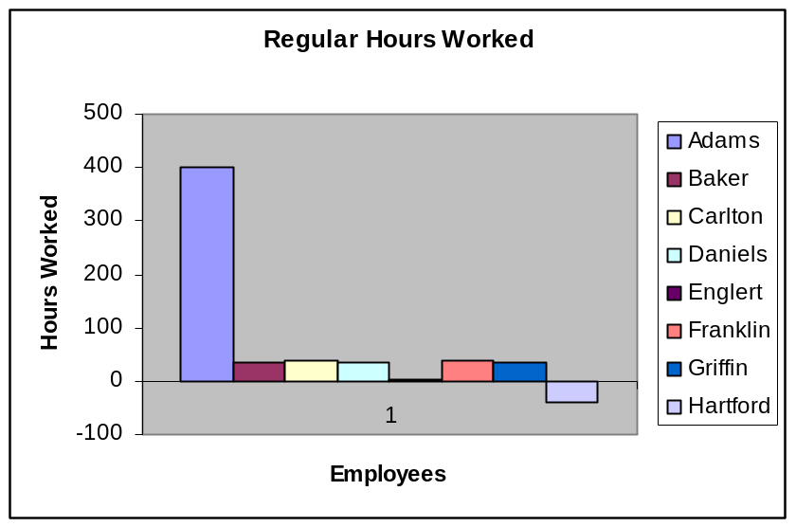

The errors on the time cards of Adams, Englert, and Hartfort are easily identified. The chart clearly identifies the employees whose reported hours are different from their fellow employees. The downside of the chart is that it would be difficult to identify less obvious errors, such as recording 41 hours instead of 40 hours may not be readily apparent.

Note: Disable data validation on the hours worked column in order to input erroneous data.

d.

Data Validation

Payrates between $6.75 and $14

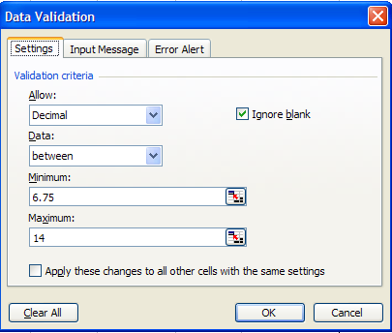

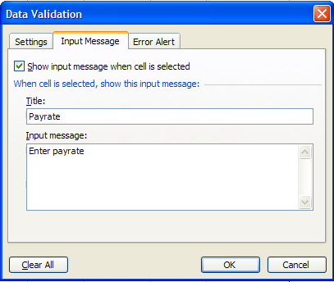

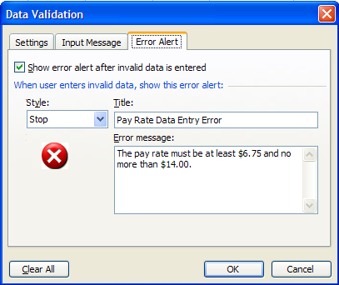

Regular hours worked between 0 and 40

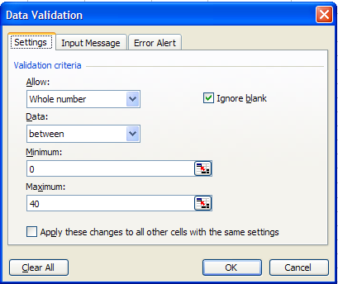

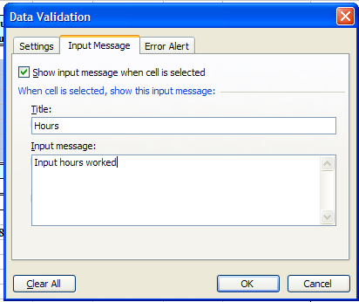

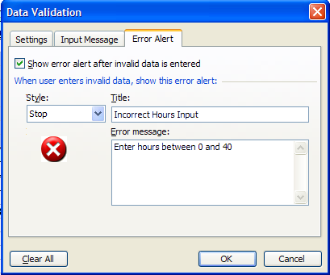

Overtime hours between 0 and 10

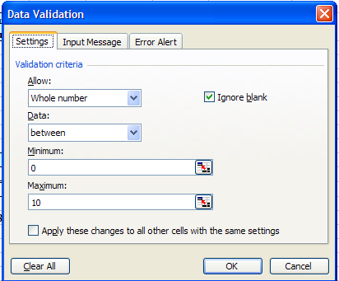

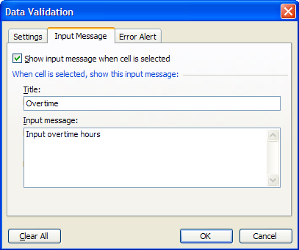

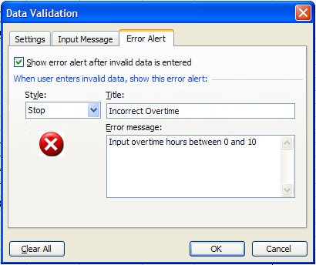

e.

Note: Change all validation rules from Stop to Warning on the Error Alert screen in order to input incorrect data (similar to the incorrect data in exhibit 9) to test the Formula Auditing Tool.

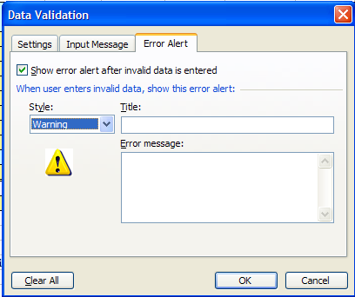
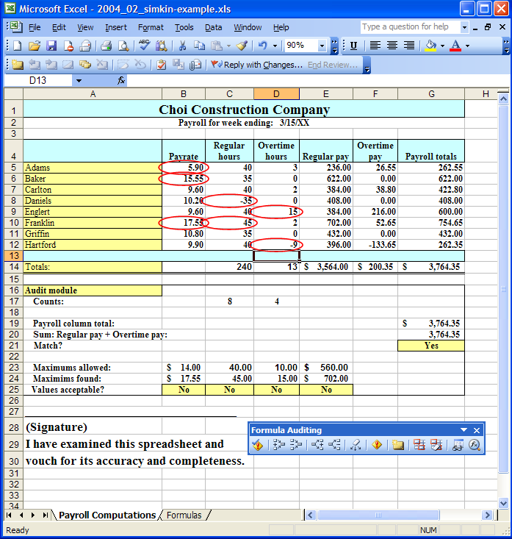

f. The Trace Precedents tools is especially useful in identifying the cells that are included in a formula. This allows the user to graphically identify any errors in formulas.

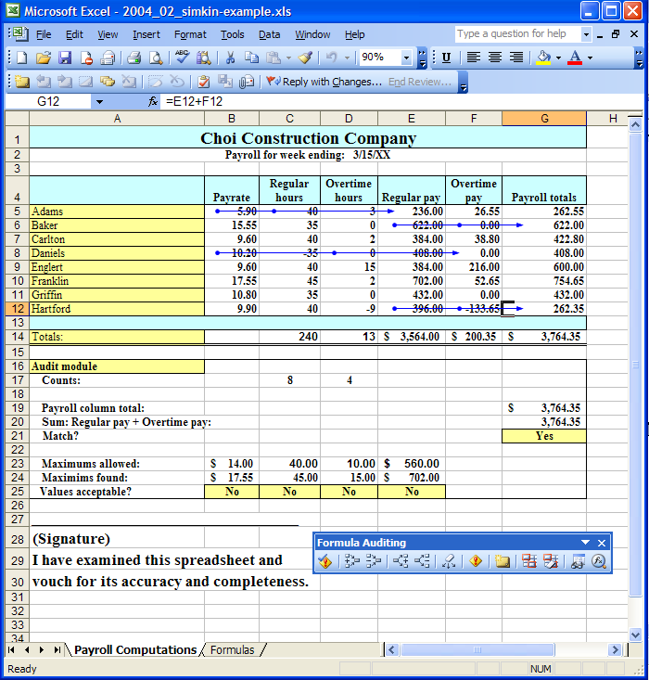

g.

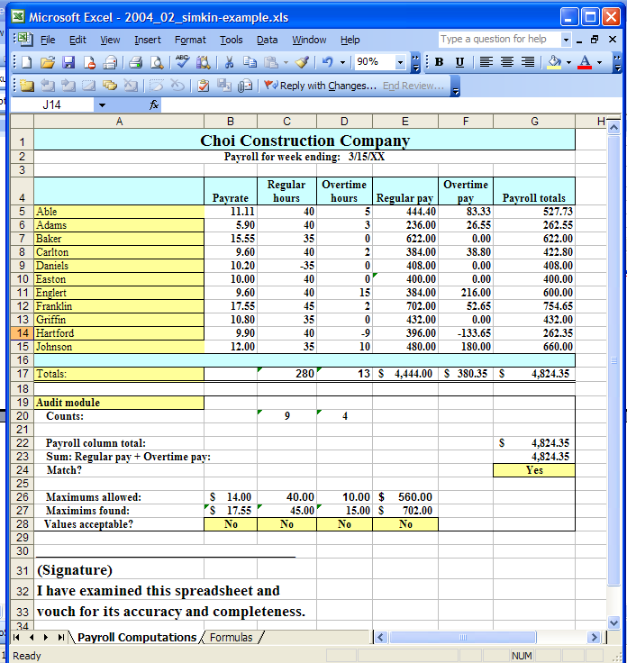

Several audit tests and validation rules changed because their parameters were established with the unadjusted cell references. The following audit tests and validation rules should be adjusted to include the new entries:

All input validation rules
All Control totals using the CountIf formula

13.7

See “Make Excel a Little Smarter,” (Journal of Accountancy, July 2003) by Lois S. Mahoney at www.aicpa.org.

b.

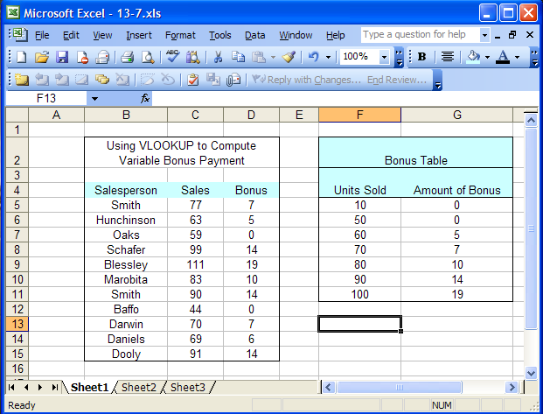

13.7 (cont.)

c.
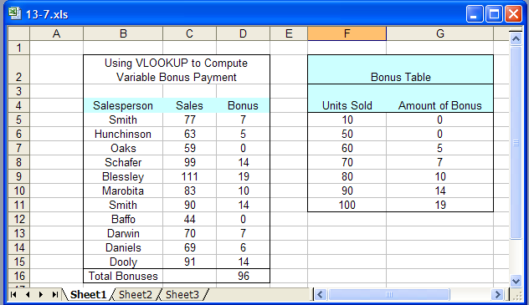

d.

Sales data validation
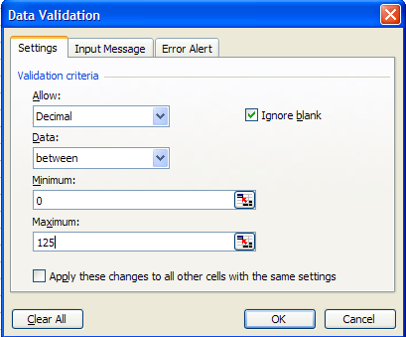
13.7d (cont.)

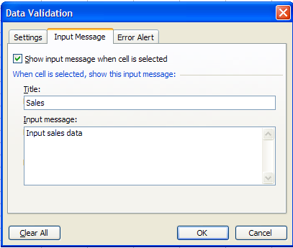

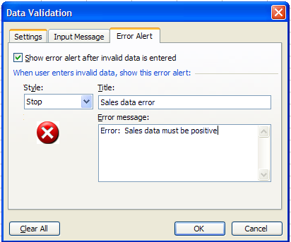

13.7d (cont.)

Bonus validation
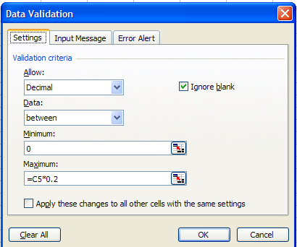

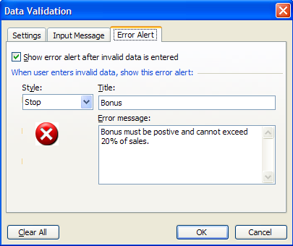

13.7d (cont.)

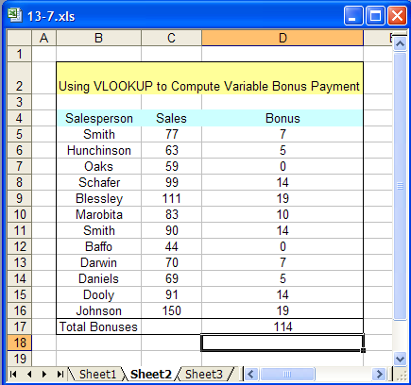

The formula for the vlookup (vertical look up function) for cell D16 is as follows:

=VLOOKUP(C16,Sheet1!$F$5:$G$11,2,TRUE)

13.8

See “Drilling for information,” (Journal of Accountancy, August 2000) by Jeff Lenning at www.aicpa.org

The article “Drilling for information” contains very detailed and explicit instructions for automating reports in Excel. As in all programming activities, if students follow the author’s instructions to the letter, students will likely have a positive experience and the programs will work. Every step is displayed in explicit screen shots published with the article. In assigning this problem, be aware the problem is quite extensive and will require a substantial amount of time on the part of the students to complete. Although the article’s instructions are detailed and explicit, students may still want additional instruction in MS Access, Excel Pivot Tables, Excel Macros, and Visual Basic programming if they are not familiar with these applications and programming tool. The article is written in such a way that a working knowledge of these software products is not necessary to complete the assignment. However, students may feel overwhelmed by the problem due to their lack of familiarity with the software.

- The article “Drilling for information” contains detailed instructions and illustrations for importing the text file into Access. However, there appears to be a Microsoft XP driver compatibility problem between the XP versions of MS Access and MS Excel in trying to import the Access file into an Excel pivot table. If a driver compatibility issue is encountered it is recommended that students simply create the pivot table part of this assignment from the plain text file instead of importing the file from MS Access.

- As in all programming, if students input the visual basic code exactly as prescribed in the article, the program will work perfectly. However, any misspellings, punctuation errors, mistakes in file names, or mistakes in column headings for the pivot table or access files, will cause this program to fail.

13.9 There is no one correct answer to this problem. The key is to assess the internal consistency of the student’s answers and the quality of the reasoning given to support their choices.

Students should answer parts b, c, d and e as if they were developing a payroll system, regardless of how they answer part a. Thus, in part b, the issues of verifying that students deserve the amount they will be paid need to be addressed. Who will have custody over records relating to student activity? Are controls in place to ensure that students actually receive their pay? These issues are all analogous to the payroll threats and recommended control procedures discussed in the chapter.

13.10

- To make sure former employees are no longer on the payroll register and still drawing a paycheck.
- To check for inaccurate or incomplete time data as well as errors in processing
- To control for the theft of paychecks
- To prevent the addition of fictitious employees to the payroll
- To check for inaccurate or incomplete payroll processing
- To control for inaccurate time data being input and processed
- To reduce errors in time data input, recording fictitious hours worked or fictitious overtime, and “clocking-in“ for an absent employee.
- To mitigate the threat that stolen payroll data could be analyzed and used against the company, to preserve employee privacy and to prevent employee identity theft,
- To check for inaccurate or incomplete payroll processing, prevent theft or fraudulent distribution of paychecks since an imprest account would make fraudulent checks easy to spot,
- To check for inaccurate or incomplete payroll processing
- To detect unauthorized changes to the payroll master file.

13.11

b.

 | Problem 13.11 Datafile
 | Time Card Data
 | A | B | D
 | Employee# | Hours Worked | Ghost Employee
1 | 100 | 40
2 | 101 | 39
3 | 102 | 38
4 | 103 | 37
5 | 104 | 36
6 | 105 | 35
7 | 106 | 34
8 | 107 | 33
9 | 108 | 32
10 | 109 | 31
11 | 110 | 30
12 | 111 | 29
13 | 112 | 28 | Employee not listed
14 | 113 | 27
15 | 114 | 26
16 | 115 | 25

Use the MATCH function to match the employee number on the Time Card worksheet exists on the Payroll Master worksheet.

Column C (hidden column) - =MATCH(E1,'Payroll Master'!$A$2:$A$34,0)
(Note: not all rows are presented in the Payroll Master file shown below)

Use the ISNA function in combination with an IF function to display whether or not a match exists.

Column D “Ghost Employee” - =IF(ISNA(C1)=TRUE, "Employee not listed","")

c.

Payroll Master File Data
 | A | B | C |  | D | E | F | G | H
1 | emp # | ssn# | Last Name |  | First Name | DOB | Gross Pay | Net Pay | Invalid SSN
2 | 100 | 101551234 | Smith |  | Steve | 1/11/76 | 4000 | 3040
3 | 101 | 555223333 | Jones |  | Brenda | 2/23/50 | 4000 | 3040
4 | 102 | 664889731 | Farly |  | Lonnie | 9/25/80 | 2000 | 1520
5 | 103 | 956889742 | Locken |  | Greg | 5/18/72 | 3000 | 2280 | Invalid SSN
6 | 104 | 213557894 | Johnson |  | Bill | 5/25/81 | 1500 | 1140
7 | 105 | 555006666 | Garbondi |  | Tanner | 6/4/52 | 4000 | 3120 | Invalid SSN
8 | 106 | 654546546 | Larker |  | Wes | 1/17/76 | 2500 | 1950
9 | 107 | 456789132 | Klass |  | Jay | 2/5/65 | 5600 | 4368
10 | 108 | 994563175 | Stevenson |  | Mary | 3/18/62 | 1890 | 1474.2 | Invalid SSN
11 | 109 | 456789123 | Alda |  | Chris | 2/28/66 | 1700 | 1377

Use the LEFT function to identify whether the social security number started with a “9”.

Use the MID function to identify whether the social security number contains the numbers 00 as the middle two numbers.

Use a nested IF function to display the message of whether the social security number is invalid because it starts with a 9 or contains the numbers 00 as the middle two numbers.

Column H - =IF(LEFT(B2)="9","Invalid SSN",IF(MID(B2,4,2)="00","Invalid SSN",""))

SUGGESTED ANSWERS TO THE CASES

13.1

Reports will of course vary from student to student, however, the following presents some points that should appear in a student’s report:

- CPA’s naturally have the necessary skills to provide payroll and human resource (HR) services.
- Although national payroll providers also provide the same services, CPA’s are in a better position to provide those services and recommend benefit consultants due to their detailed knowledge of their client’s business, operations, and internal needs.
- Even if a CPA does not offer payroll/HR services, they are in good position to help their client’s choose the consultant for the work that is required.
- Some of the payroll/HR services a CPA can offer are as follows:
  - Payroll administration
  - Benefits administration
  - Retirement plan administration
  - Human resource consulting
  - Regulatory compliance
  - Outsourcing
  - Management recruiting
  - CFO outsourcing/consulting
  - Labor relations
  - Acquisition/divestiture HR related consulting

13-2 (Adapted from the CMA Examination)

- Some kind of an integrated time and labor cost system could be developed and implemented. This system should include direct data entry, labor cost distribution by project as well as by department, on-line access to time and attendance data for verification, correction, updating, and individual employee work history files.
- The system could use uniquely encoded employee badges that could be used to electronically record entry and exit from the plant to the data system.
- Labor cost records should be maintained at the employee level, showing the time worked in the department. This way labor costs could be analyzed and responsibility for correct and timely data entry would reside with the departmental supervisors and be verified by project managers.
- On-line terminals should be available in each department for direct data entry. Access to the system should be limited to authorized users by user ID and password.
- Supervisors should be allowed to inspect, correct, verify, and update only time and attendance information for employees in their respective departments.
- Project managers should be allowed to access information recorded for their projects only and exceptions to such data must be certified outside the system and entered by the affected supervisor.
- Appropriate data should be maintained at the employee level to allow verification of employee personnel files and individual work-history by department and project.
- Access to employee master file data should be limited to the Personnel Department.
- Work-history data will be made available for analysis only at the project or departmental level, and only to departmental supervisors and project managers.

