CHAPTER 3
SYSTEMS DEVELOPMENT AND DOCUMENTATION TECHNIQUES
SUGGESTED ANSWERS TO DISCUSSION QUESTIONS
3.1 Data Flows: merchandise, payment, cash and register tape

Date Source: customer

Processes: capture sales and payment, give cash and register tape to manager

Storage: sales file (register tape), cash register

3.2 It is usually not sufficient to use just one documentation tool. Every tool documents a uniquely important aspect of a given information system. For example, system flowcharts are employed to understand physical system activities including inputs, outputs, and processing. In contrast, data flow diagrams provide a graphic picture of the logical flow of data within an organization.

Each alternative is appropriate for a given aspect of the system. As a result, they work together to fully document the nature and function of the information system.

3.3 Similar design concepts include the following:

- Both methods require an initial understanding of the system before actual documentation begins. This insures that the system is properly represented by the diagram.

- Both measures require the designer to identify the elements of the system and to identify the names and relations associated with the elements.

- Both methods encourage the designer to flowchart only the regular flows of information and not to be concerned with unique situations.

- Both approaches require more than one “pass” through the diagramming or flowcharting process to accurately capture the essence of the system.

The product of both methods is a model documenting the flow of information and/or documents in an information system. Both documentation methods are limited by the nature of the models they employ, as well as by the talents and abilities of the designer to represent reality.

- SUGGESTED ANSWERS TO THE PROBLEMS

3.1 Assorted Flowcharting Segments:

a.
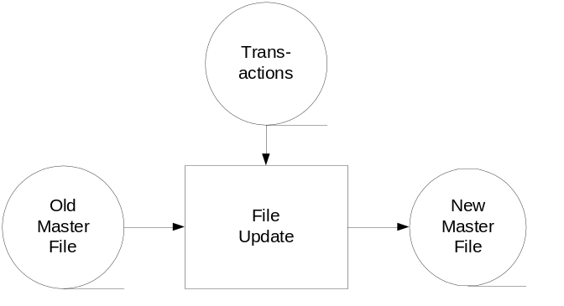

b.
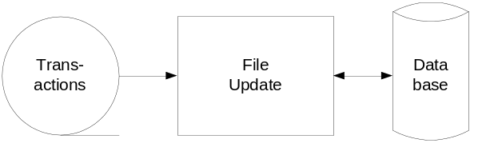

c.
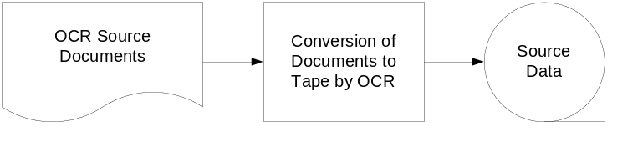

d.
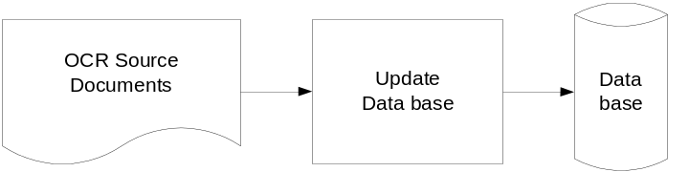

3.1 (continued) Assorted Flowcharting Segments

e.
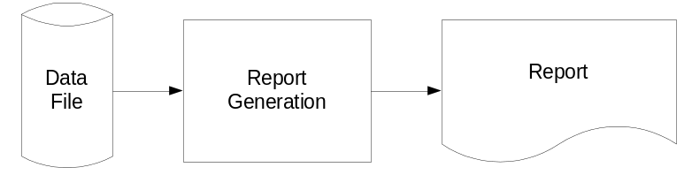

f.
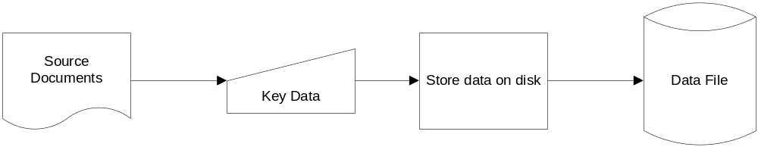

g.
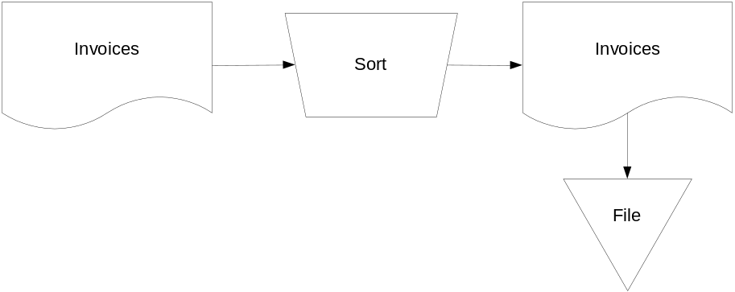

h.
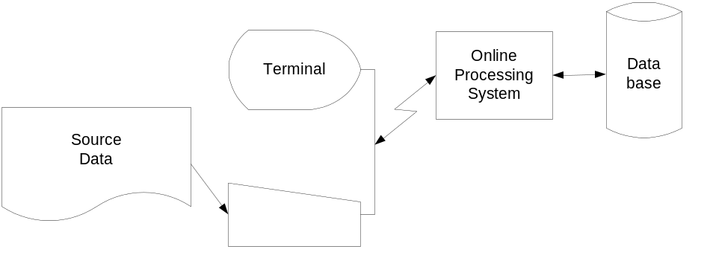

3.1 (continued) Assorted Flowcharting Segments

i.
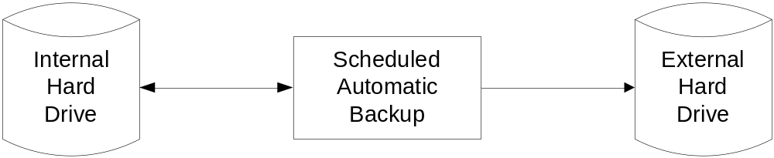

j.

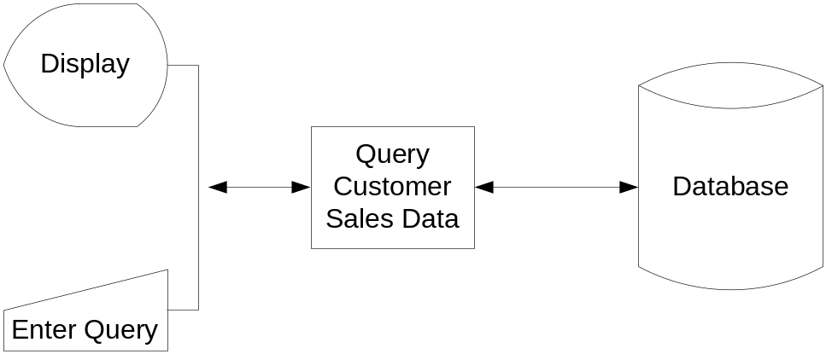

3.1 (continued) Assorted Flowcharting Segments

k.

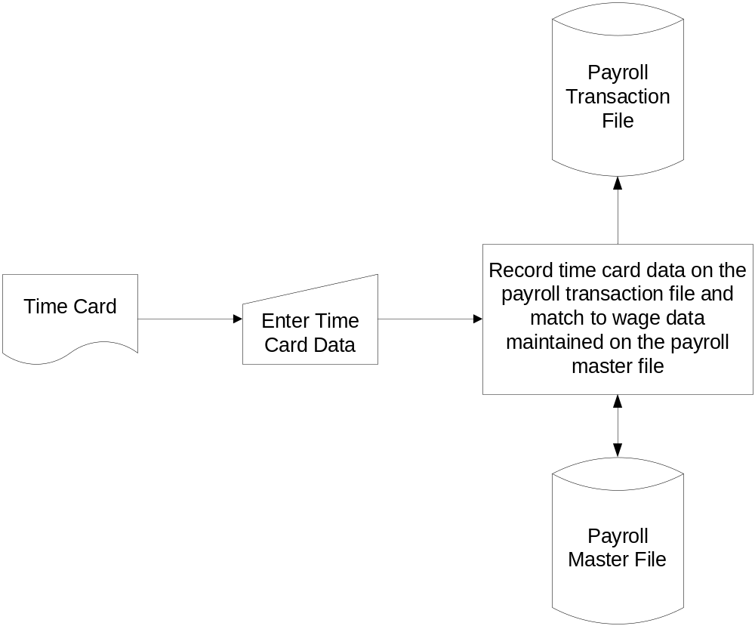

3.1 (continued) Assorted Flowcharting Segments

l.
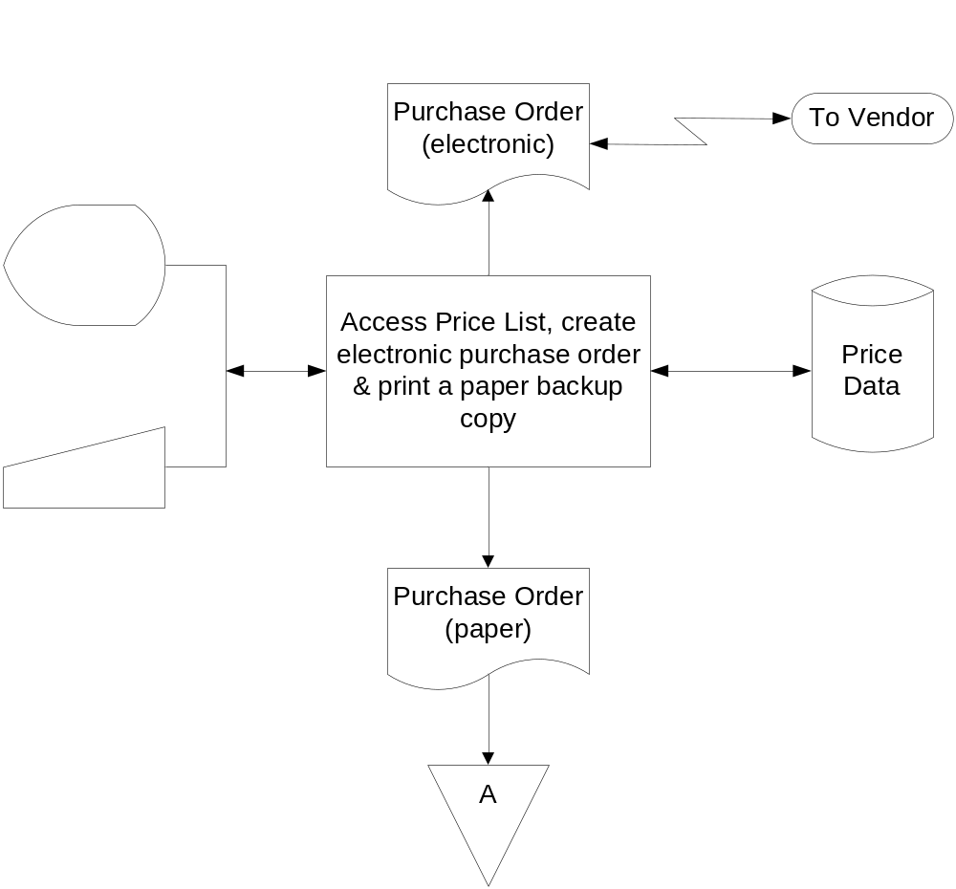

m.

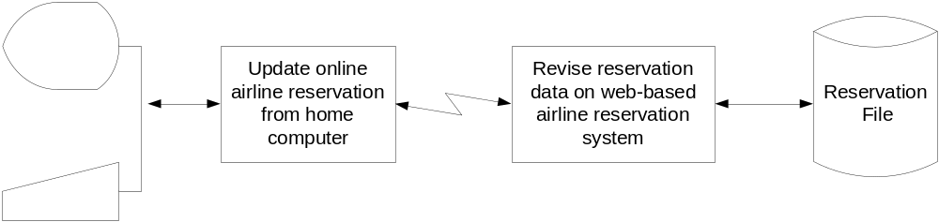
3.2 Happy Valley Utility Company

a. Billing operations

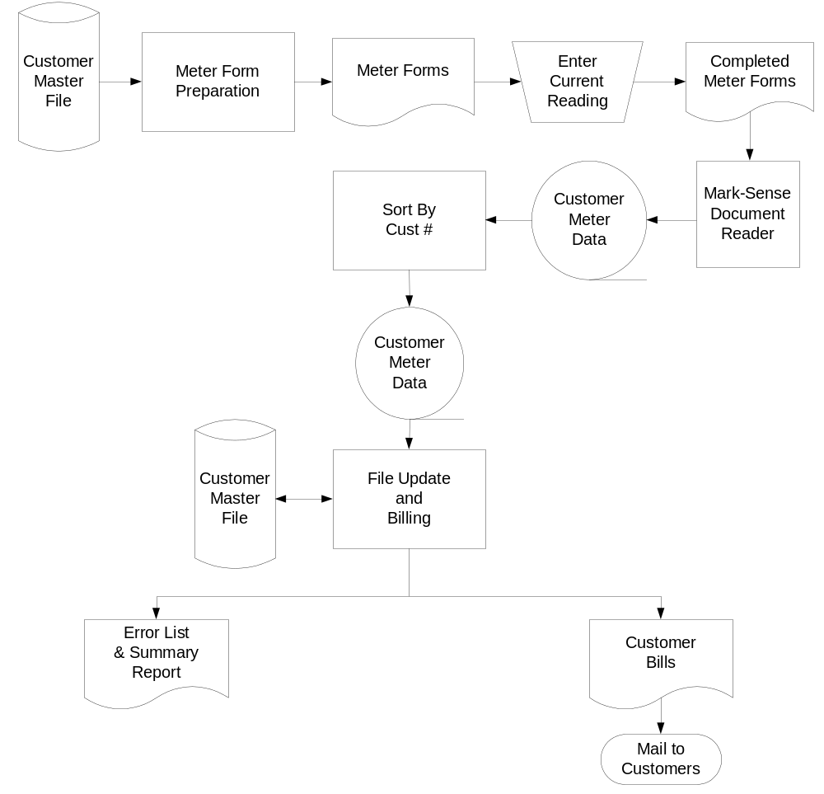
3.2 b. Customer payments processing

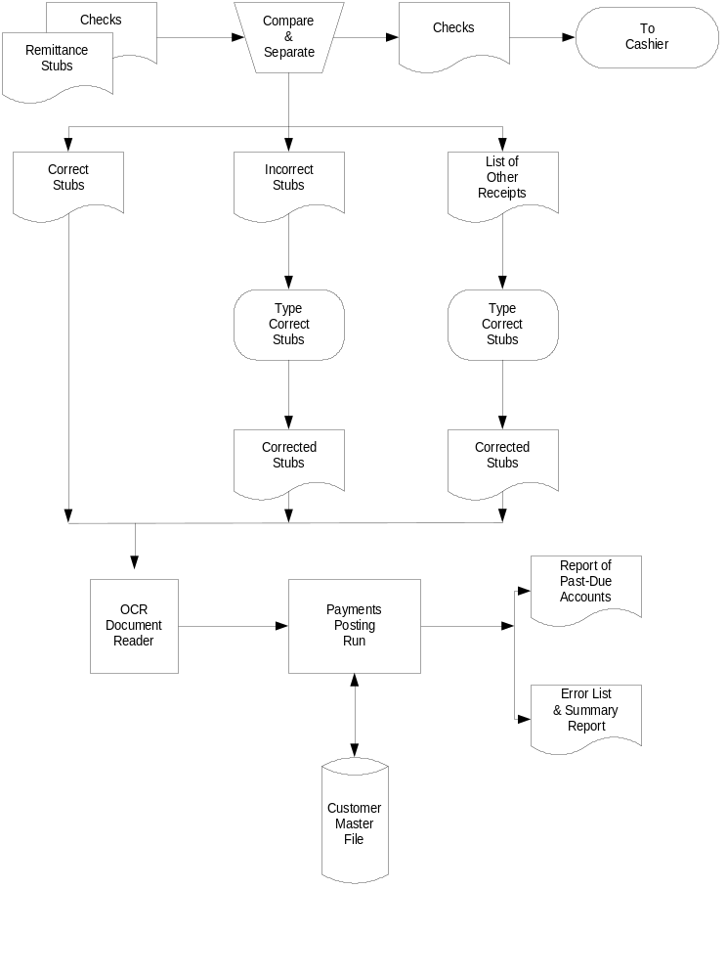
3.3 Payroll Processing for Dewey Construction Company:

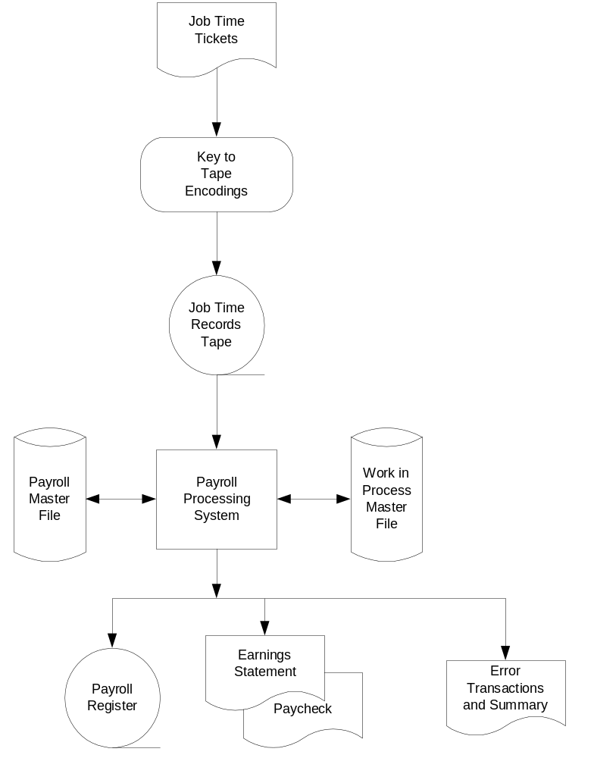

3.7 a. Context Diagram of S&S Accounts Payable

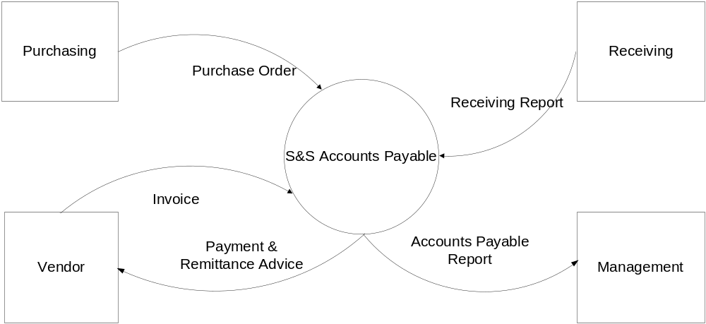

3.7 a. (continued.) Level 0 Data Flow Diagram of S&S Accounts Payable

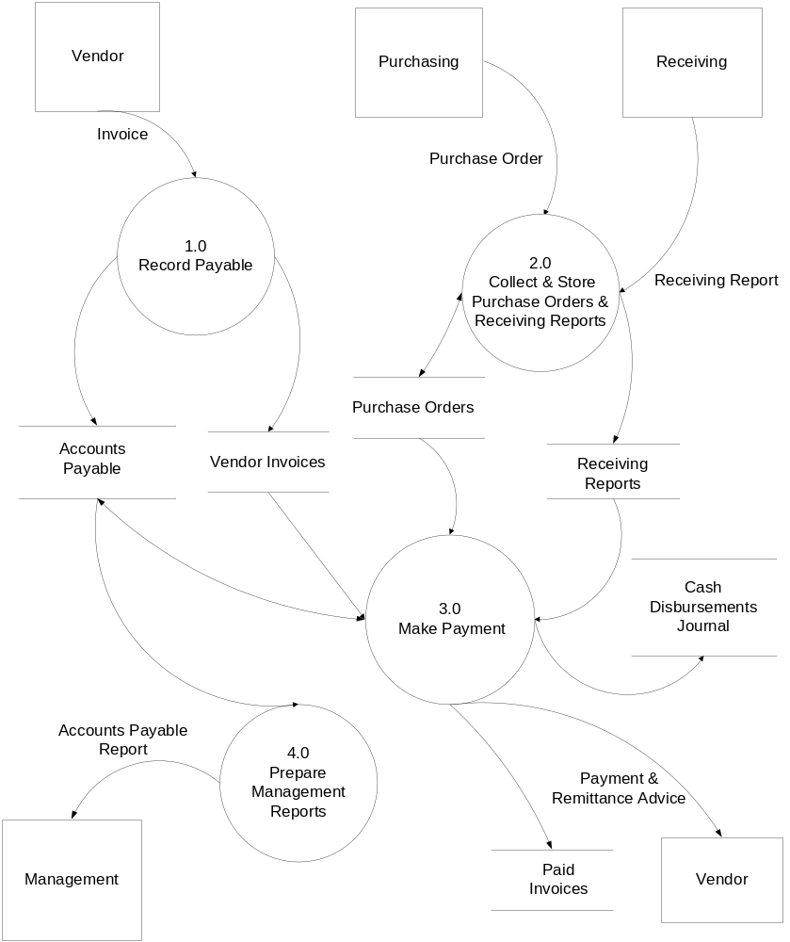

3.7 b. Document Flowchart of S&S Accounts Payable



