Lake Stevens Middle School
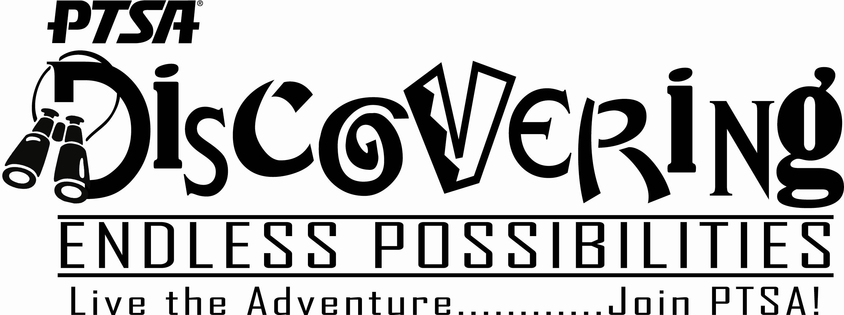
When you join PTSA, you join a community that encourages student achievement and enriches the learning environment. We believe in building partnerships between our families and our schools. Together we can make a difference!

* Join Today
* Family Programs
* Provide Shoes for ??School Bell
* Member Benefits
* Parent Involvement
* Sponsor Assemblies, ??Dances
*Parent Education ??Programs

Join us for our next meeting! Come early for refreshments.

Yes! I want to join.
Name: Child(ren):
Name: (for two adults)
Address:
Phone: E-mail:
My membership fees are enclosed with this form:
$12.00 Adult $8.00 Student
$20.00 Family (two adults in same household) $ Additional Donation
PTSA contacts for the 2007-2008 school year:
Kim Dailey President 334-6702 kbdaileys13@aol.com
Jodi Sander Vice president 334-9817 jjsander93@yahoo.com
Laurel Cheap Treasurer 335-1810 cheaps@earthlink.net
Sarah Ushler Secretary 931-6025 sarahlu23@msn.com

