Family Access Tutorial
A Guide for Parents



Northwest Regional Data Center
2121 W. Casino Road
Everett, WA 98204

Published by
Northwest Regional Data Center
2121 W. Casino Road
Everett, WA 98204

This document is printed in the United States of America. Information in this document is subject to change without notice. Registered trademarks for Skyward, Inc. are:

Skyward ®

PaC™; PaC School Management Systems™, PaC Student™; PaC Finance™; ERMA™; PaC Family Access™; PaC Educator Access™; PaC Educator GradeBook™; PaC Customer Access™; PaC Special Education™; PaC Food Service™

Table of Contents

FAMILY AND STUDENT ACCESS OVERVIEW 1
BASIC INFORMATION 2
Login Screen/Information 2
Account Information 3
GENERAL INFORMATION 4
Student Information 4
Grades/Gradebook 5
Message Center 7
Attendance 8
Schedule 11
Discipline 12
Test Scores 13
Food Service 14
Fee Management 16
Activities 17
Report Cards 18
Report Directory 18
Home Room 19
Health Information 20
LOGIN HISTORY 23

FAMILY AND STUDENT ACCESS OVERVIEW

Family Access is a Web module that allows family members to access student information over the Internet via a secured web connection in real-time. One of the great things about Family Access is that it’s available from your home, office or anywhere you have access to the Internet.

This tutorial provides information guardians can use to better understand and navigate more effectively within Family Access. Depending on how school districts configure it, guardians will have access to a wide variety of student information such as attendance, discipline, health and vaccination information, student and family demographics, food service information, fines and fees, and current grades, classroom assignments and classroom messages. Because schools differ from one another, just like children, not all Family Access features will be available at all schools.

Family Access makes attendance tracking and absence notifications easier for guardians. Guardians can view their student’s attendance history in real-time, submit absence notifications to the school through Family Access and subscribe to receive real-time email notifications when their student is marked absent in a class.

Family Access allows guardians to become more involved in their student’s education. Families can take an active role in assisting students and improving their educational experience. The technology raises awareness in the community of the school district’s educational efforts by opening additional lines of communications between the guardians and the school.

Family Access can be a tool for guardians and schools to communicate with each other. Good school to guardian communication prevents surprises at parent/teacher conferences or when guardians are contacted by the school with student’s attendance or discipline issues. School districts can provide via Family Access, teacher/staff email addresses to further improve communication access and opportunities.

BASIC INFORMATION

Login Screen/Information
Figure 1: Family Access Login Screen
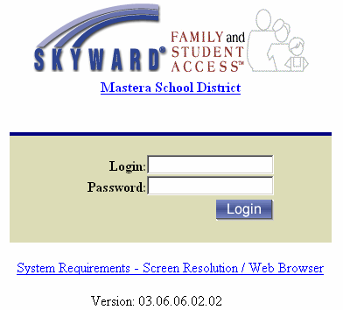
Enter the Login Name and Password supplied by your student’s school and select the login button (If you have not received your information please contact your child’s school to receive it). This single login and password will allow you to view information for each child for whom you are listed as a guardian.

About your login: The login supplied to you is comprised of the first five characters of your last name, the first three characters of your first name and a system generated three-digit-number. If your last name has less than five characters, then you will need to include the appropriate number of spaces to fill the void. For example: Last Name = DOE, First Name = JOHN, the login will be: DOE JOH006 note that there are two spaces between DOE and JOH to complete the entire name key. Logins and Passwords are NOT case sensitive in this system. When you log in for the first time, you will see your account information page (see Fig. 2). You have an opportunity to update the student information system with your email address. After entering your email address, make sure to input your current password (for validation purposes), and select the “Save” button. You may also choose to “Record no Address”. If your school district allows, you may also be able to change your account password.

Important Note: Please use a VALID email address; teachers can use it within the system to communicate directly with guardians via email regarding their child.

Account Information

Figure 2: Account Info Screen, General Information Menu and Course Requests Menu.
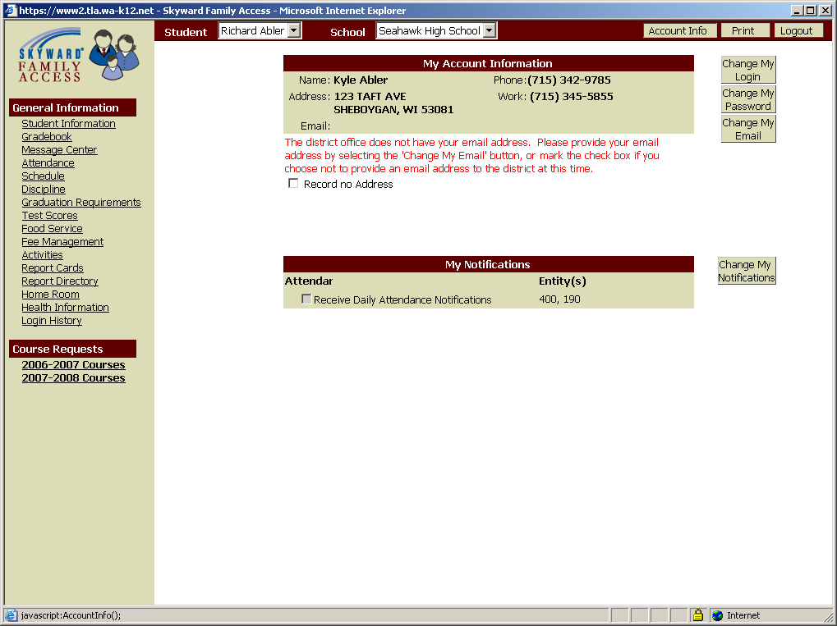
Each underlined item is a hyperlink. Select the appropriate hyperlink to display pertinent information regarding your children.
Select Change My Login, Change My Password or Change My Email, to change your current login name, your current password or enter your email address.

You may also choose to record no email address.

Select the drop-down to select another student in your family.
Select Change My Notifications to receive email notification messages from each Entity (school building) in which you have a student enrolled.

On the general information menu (see Fig. 2), you will have hyperlinks to display the different types of information your school district has made available to you. These hyperlinks may include: Student Information (Demographics, Family, and Emergency Contacts), Grades or Gradebook, Message Center, Attendance, Schedule, Discipline, Food Service, Fee Management, Activities, Report Directory, Health Information and Login History. If you have multiple students, you can use the drop-down student selector to switch students. In addition, there are three buttons near the top right-hand side of every screen in Family Access. Select the “Account Info” button to return to this screen to view or make changes to your login, password, and email address or email notifications that you receive. In addition, select the “Print” button to print information from each screen you view. Family Access will automatically log you off after 5 - 10 minutes of inactivity or you may select the Logout button at any time to exit the system.

NOTE: Creating a password greater than 8 characters can cause system issues.

“Course Requests” and “Arena Scheduling” are two additional menus your student’s school may make available to you. If activated they will allow you and/or your student to make online course requests and/or create class schedules for the current or future school years.

GENERAL INFORMATION

Student Information

Select the Student Information hyperlink on the general information menu to see your student’s demographic, family and emergency contact information (see Fig.3-4).

Figure 3: Student Information.
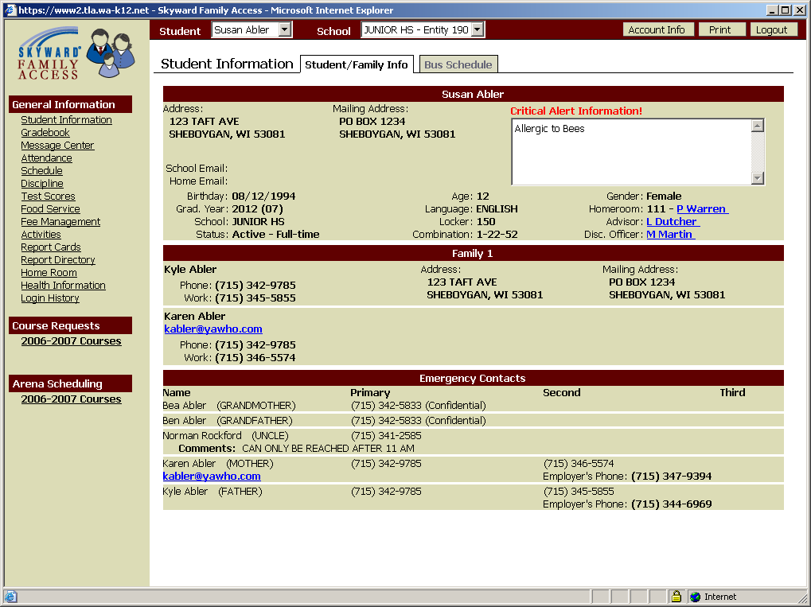
Please be aware that Emergency Contact information may be different for each of your students. Verify each child’s information for accuracy by using the student drop-down.

Figure 4: Bus Schedule.
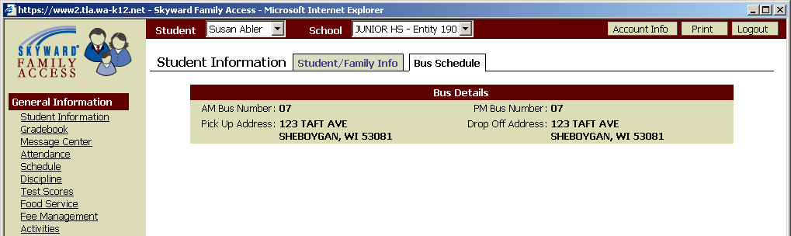

Grades/Gradebook

Select the Grades/Gradebook hyperlink on the general information menu to see your student’s Term or Semester grades, missing assignments and comments posted to your student’s report card for the current school year (see Fig.5-8).

Figure 5: Grades/Gradebook, view by Progress Report.
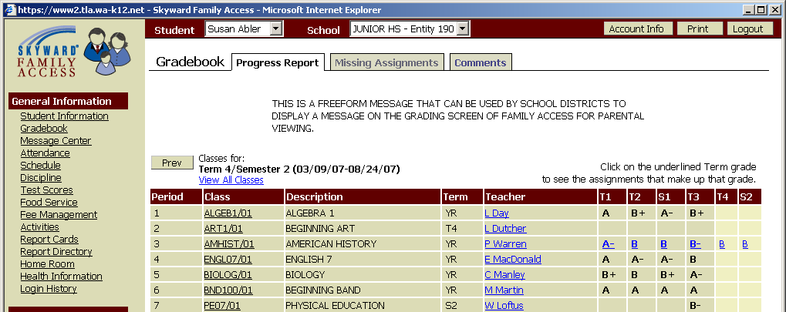
Select the Term/Semester grade hyperlink to view assignment details that make up the grade.

Figure 6: Grades/Gradebook, view by Term/Semester Grade hyperlink, Assignment details.
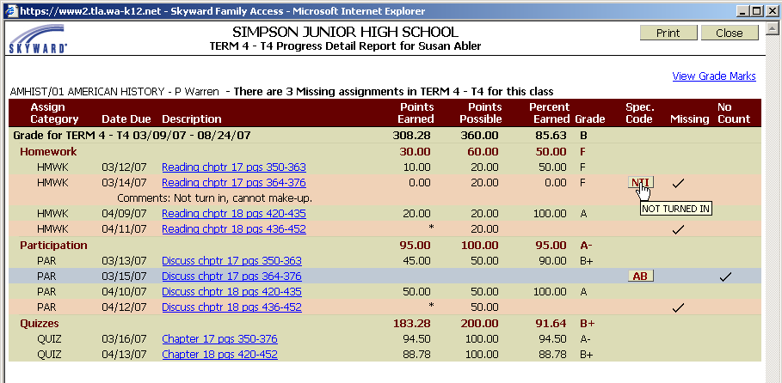
Detail term and grade information and are displayed near the top of the screen.
Detail of each assignment is displayed: assign category, date due, description, points earned, points possible, percent earned, grade, special code, missing and no count.
Assignments marked with an asterisk are un-graded at this time and do not factor into the grade that is currently being calculated for the course.

The “missing” and “no count” columns may have check marks associated to them:
A “missing” check mark means the assignment is missing and most likely not turned in.
A “no count” check mark means any points earned or points possible are not factored into the grade that is currently being calculated for the course.

Select the assignment description hyperlink to see the details of the assignment and a class score summary.
Select the view grade marks hyperlink to see the grading scale used for this class.
Hover the cursor over spec code to see the description. (Example above NTI = Not Turned In).
Figure 7: Grades/Gradebook, view by Missing Assignments.
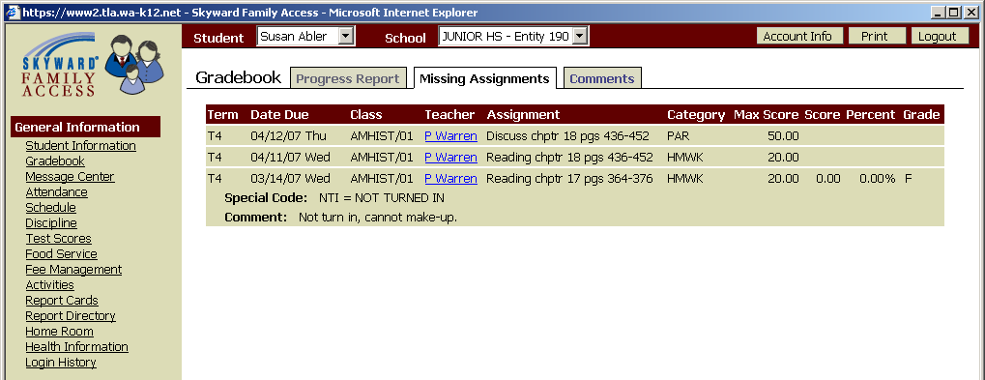
View missing assignments for all of your student’s classes from current or previous terms/semesters.

Figure 8: Grades/Gradebook, view by Comments.
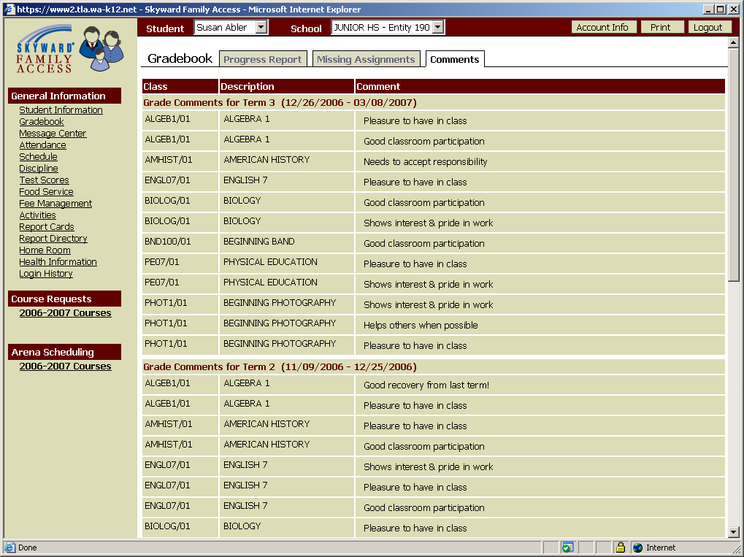
View report card comments for each of your student’s classes from current or previous terms/semesters.

Message Center

Select the Message Center hyperlink on the general information menu to see class messages posted by your student’s teachers. You may display current messages or expired (see Fig.9-10). Teachers determine if guardians will be able to reply to a message or if they will allow them to reply via email. If a teacher’s name is a hyperlink it is linked to their email address so you can easily send a quick email back to that individual if you need to.

Figure 9: Message Center, view by Current.
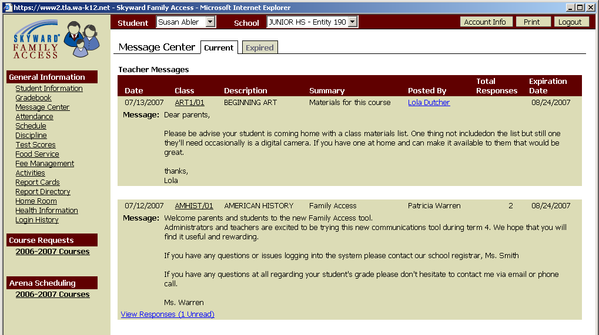
View details of current class messages for each of your student’s classes.

This example allows guardians to post a reply to the teacher via family access.

Select the view responses hyperlink to read responses from the teacher or to add a response for the teacher.

Figure 10: Message Center, view By Expired.
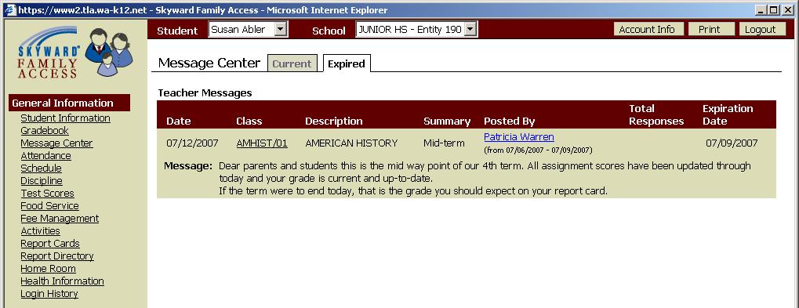
View details of expired class messages for each of your student’s classes.

This example allows guardians to reply to the teacher via email but not to post a reply to the message.

Attendance

Select the Attendance hyperlink on the general information menu to see your student’s attendance record for the current school year. Selecting the tabs will change the display from “Calendar” view to “By Day” or “Totals” (see Fig.11-14). In calendar view if your student has an absence or tardy record, it will be hyperlinked on the date and color coded for easy cross reference. Selecting on the hyperlinked date will result in a separate pop-up window that displays the period by period breakdown along with absence type and reason.

Figure 11: Attendance, view By Calendar.
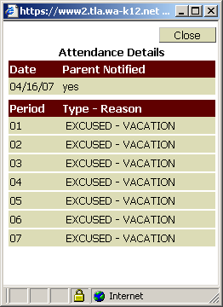
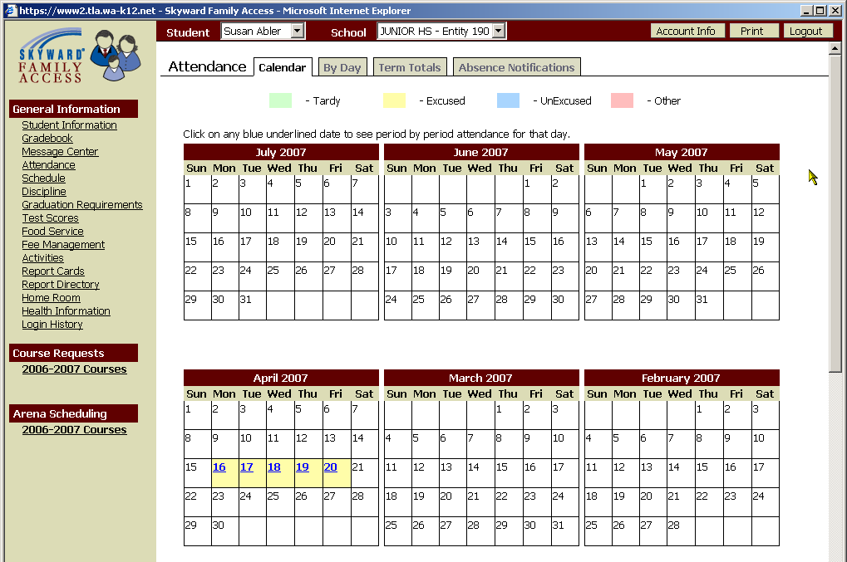
Select the hyperlinked date to view period by period details regarding the absence.
Figure 12: Attendance, view By Day.
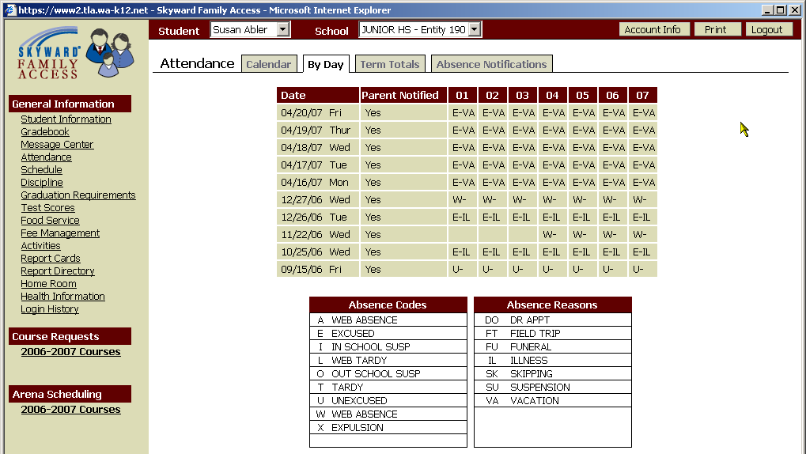
View absence information by date for your student.

There are two tables included that give descriptions of the absence type code and the absence reason codes.

Figure 13: Attendance, view by Term Totals.
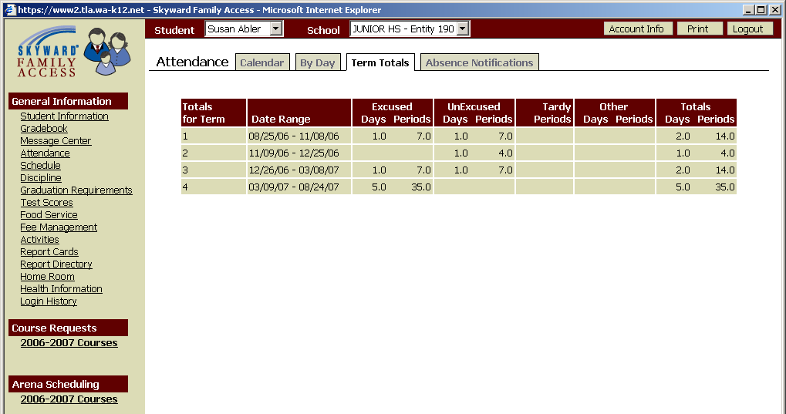
View absence totals by term for your student.
Figure 14: Attendance, view by Absence Notifications.
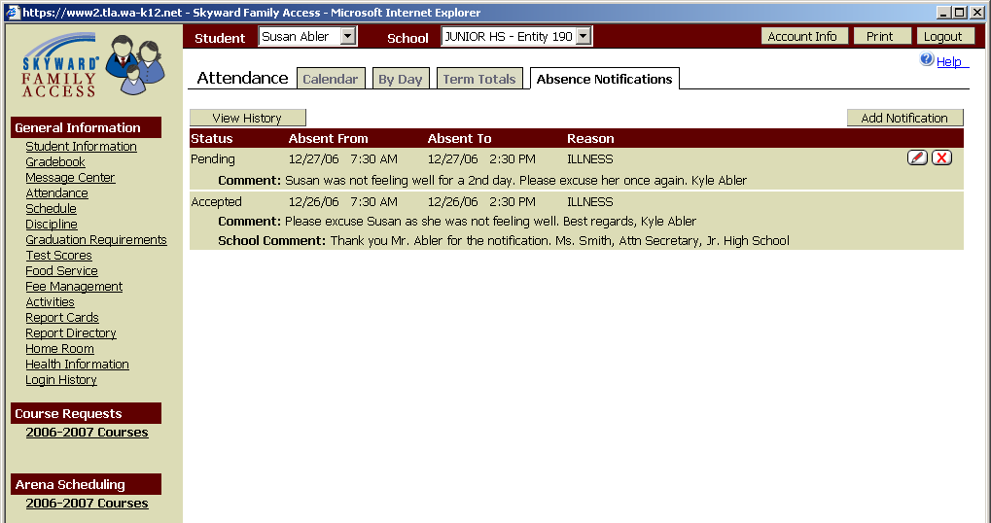
If configured by your school district, view, add, change or delete an absence notification explaining the reason your child was absent on a specific day.

If the school building has accepted the absence notification, it can no longer be changed or deleted.

Schedule

Select the Schedule hyperlink on the general information menu to see your student’s class schedule for the current term (see Fig.15-16). The Current Year tab allows you to view your student’s class schedule for the entire school year.

Figure 15: Schedule, view by Current Term.
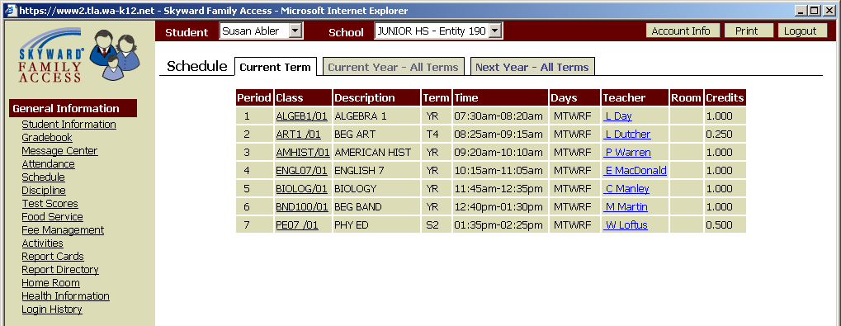
View your student’s schedule for the current term.

Figure 16: Schedule, view by Current Term.
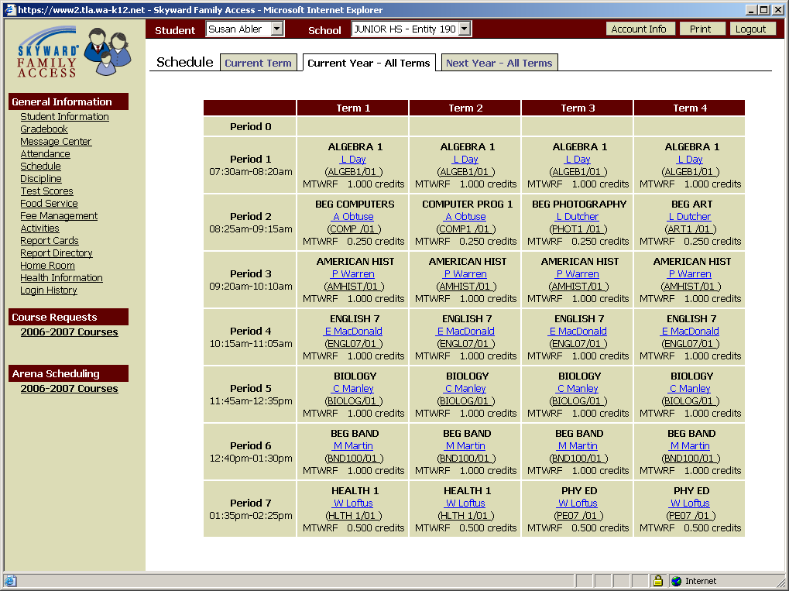
View your student’s schedule for all terms during the current school year.

If your student’s school has the schedule created for the next school year, it may be possible to view that information.

Discipline

Select the Discipline hyperlink on the general information menu to see your student’s discipline referrals/offences for the current school year (see Fig.17-18).

Figure 17: Discipline, Offense Information.
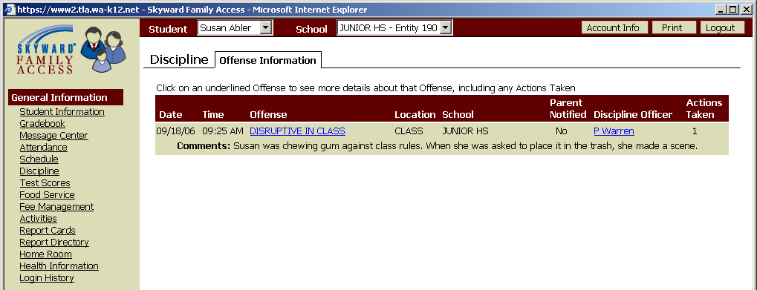
View your student’s discipline offense (wrongdoing) information.

Select the offense hyperlink to view the actions (consequence) your student’s school has taken.

Figure 18: Discipline, Actions Taken Information.
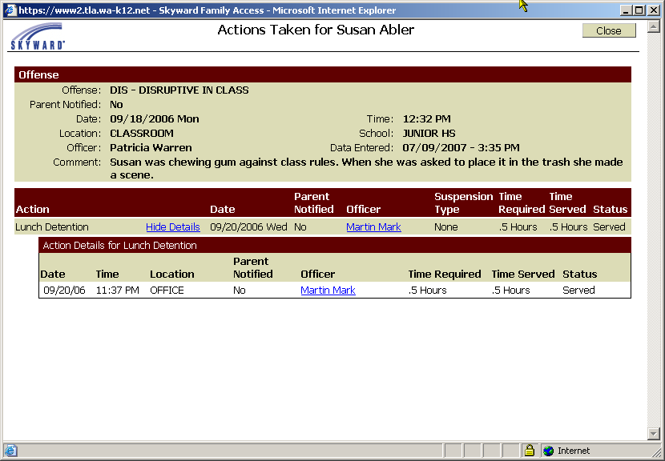
View your student’s discipline action (consequence) information.

Select the show/hide details hyperlink to view additional action details your student’s school has taken.

Test Scores

Select the Test Scores hyperlink on the general information menu to see your student’s standardized test score information (see Fig.19).

Figure 19: Test Score, view by Account Information.
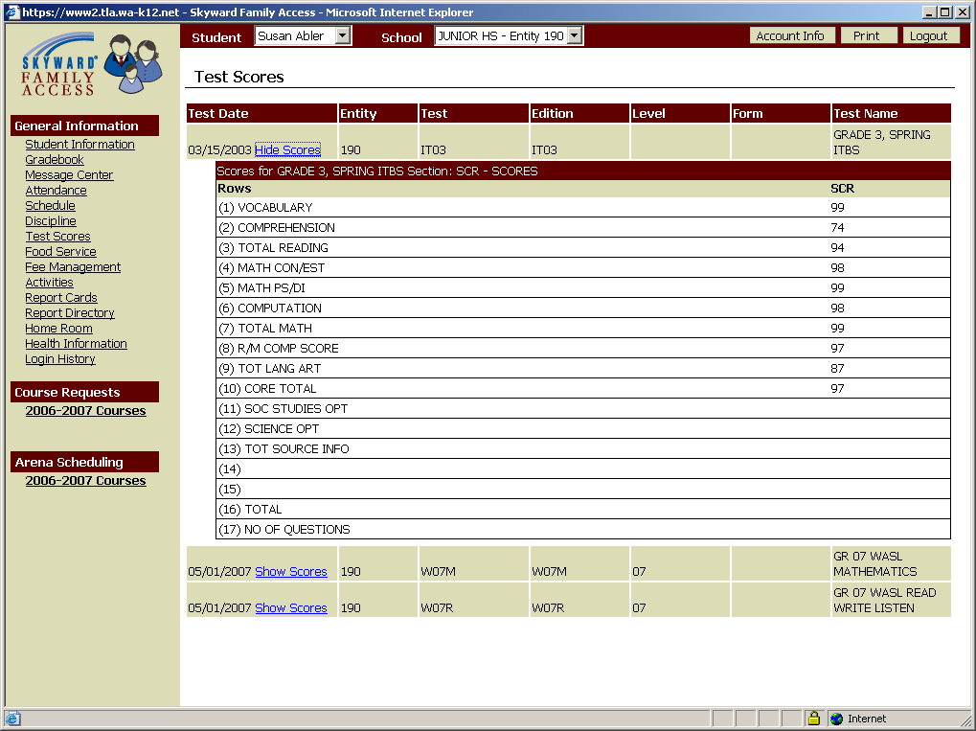
View your student’s test score information.

Select the show/hide scores hyperlink to view additional details about the test.

Food Service

Select the Food Service hyperlink on the general information menu to see your student’s food service information for the current school year (see Fig.20-23).

Figure 20: Food service, view by Account Information.
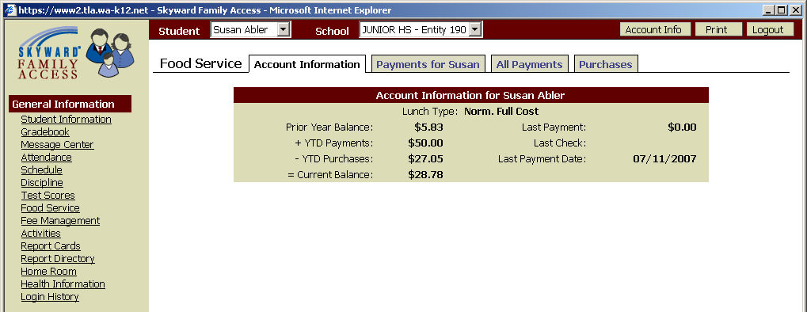
View your student’s food service account information.

Figure 21: Food service, view by Payments for <Student FN>.
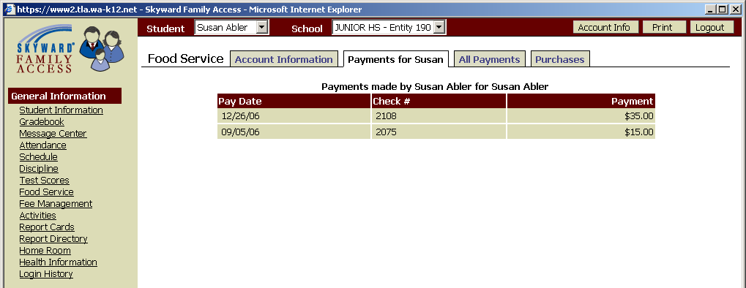
View your student’s food service payment information.

Figure 22: Food service, view by All Payments.
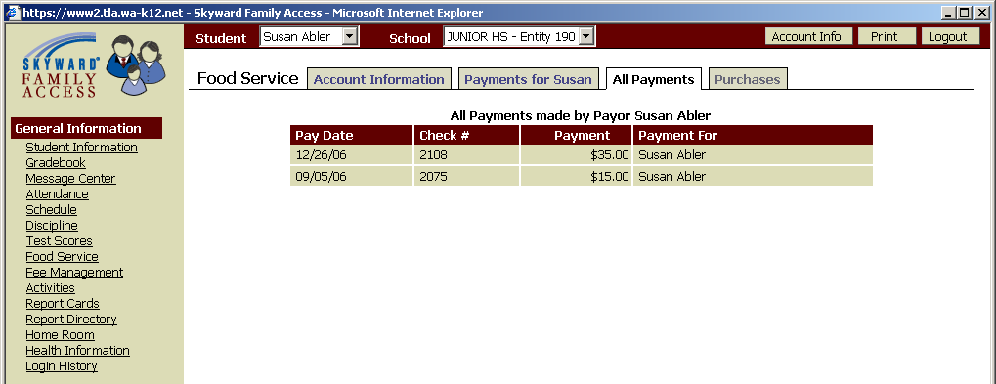
View your student’s food service payment history for the current school year.

Figure 23: Food service, view by Purchases.
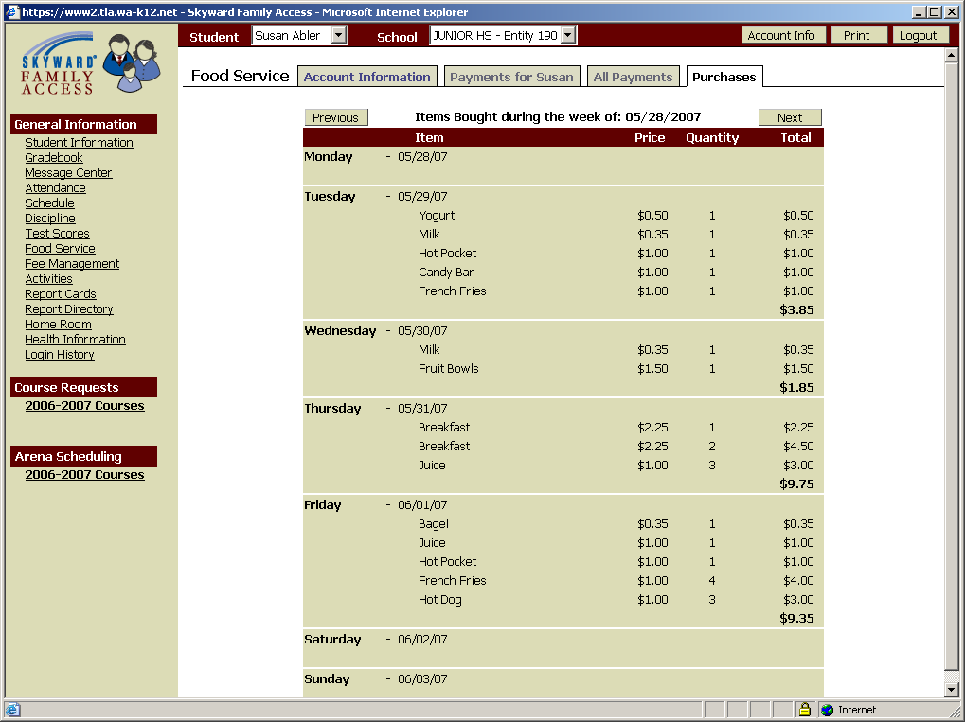
View all of your student’s food service purchases during a one week timeframe.

Select the previous and next buttons to change which week you’re viewing.

Fee Management

Select the Fee Management hyperlink on the general information menu to see your student’s current and past due fines, fees and payments excluding lunchroom payments (see Fig.24-25).

Figure 24: Fee Management, view by Fee Activity.
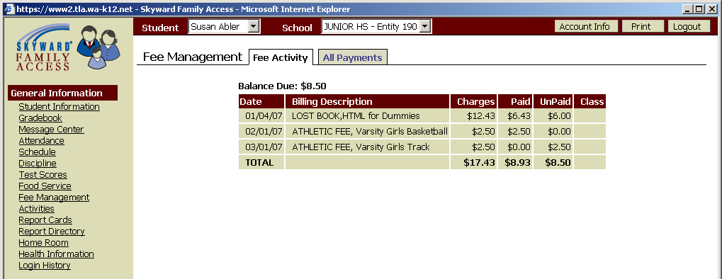
View your student’s fee management information for the current school year.

Figure 25: Fee Management, view by All Payments.
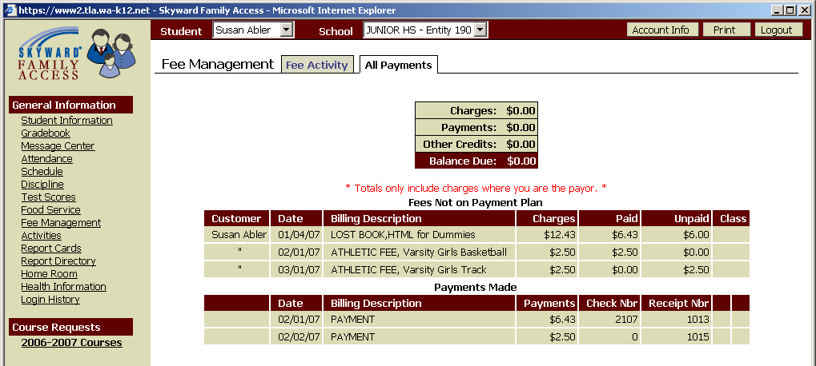
View your student’s payment history for the current school year.

Activities

Select the Activities hyperlink on the general information menu to see your student’s activities (see Fig.26-27). The Current Year tab allows you to view your student’s activities for the entire school year.

Figure 26: Activities, view by Current Year.
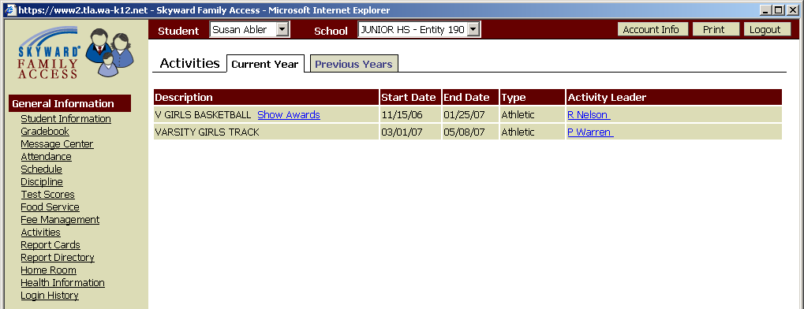
View your student’s activities for the current year.

Select the show/hide awards hyperlink to view awards earned by your student

Figure 27: Activities, view by Show/Hide Awards hyperlink, Awards details.
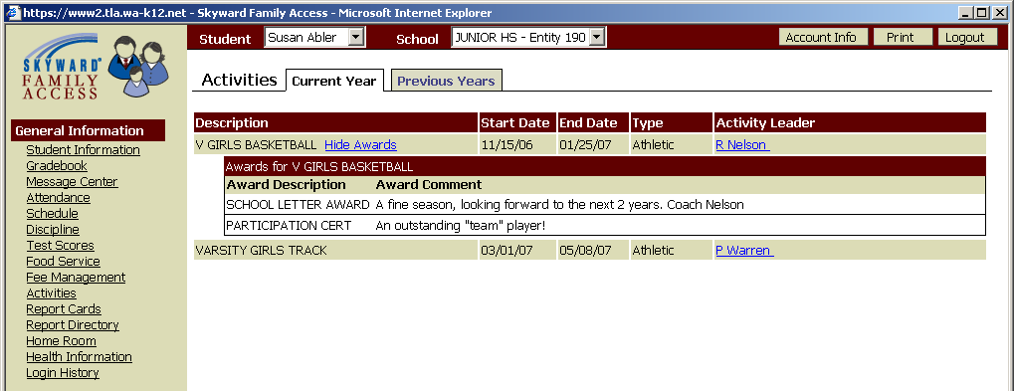
View awards earned by your student.

If your student was involved in activities during a previous school year, you will be able to view that information.

Report Cards

This feature is not currently available in the State of Washington.

Report Directory

Select the Report Directory hyperlink on the general information menu to view reports that contain information regarding your student (see Fig.28-29).

Figure 28: Report Directory.
View reports that contain information regarding your student.

Select the report name hyperlink to view the report details

Figure 29: Report Directory, view by <Report Name> hyperlink, Report details.

Home Room

Select the Home Room hyperlink on the general information menu to see information including addresses and phone numbers for all students in your student’s homeroom (see Fig.30).

NOTE: Northwest Regional Data Center (NWRDC) recommends school districts use caution if initializing this access. To do so may infringe on a family’s right to privacy. Should a school district decide to make this information available, marking a family phone number as “confidential” and home address as “do not distribute” will maintain “some” privacy of the family’s personal information. Please discuss this feature of Family Access with appropriate School District personnel.

Figure 30: Home Room.
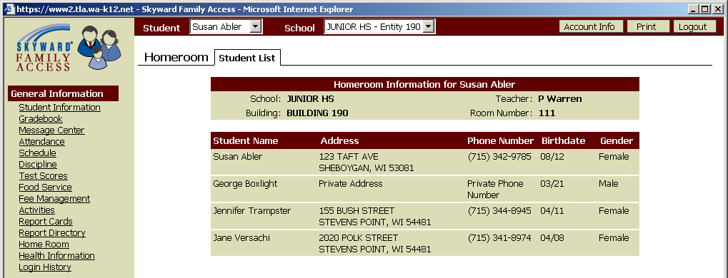
This is an example of a District being able to better secure a family’s personal information.

Health Information

Select the Health Information hyperlink on the general information menu to see information kept regarding your student’s vaccinations, childhood illnesses, health tests and health conditions
(see Fig.31-35).

NOTE: Northwest Regional Data Center (NWRDC) recommends school districts use caution when initializing this access. It may infringe on a family’s right to privacy. The four areas listed below as examples are the more common ones. Please discuss this feature of Family Access with appropriate School District personnel.

Figure 31: Health Information, view by Condition.
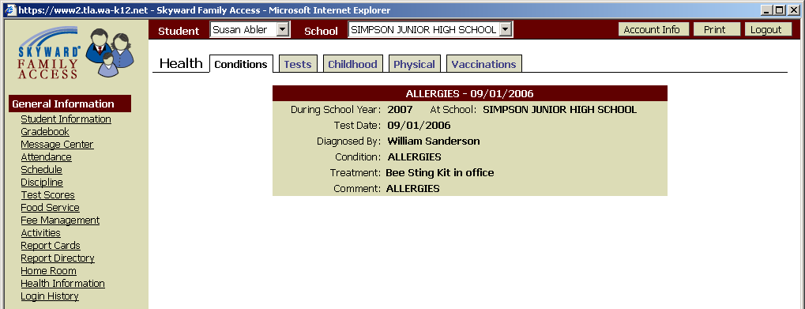

Figure 32: Health Information, view by Tests.
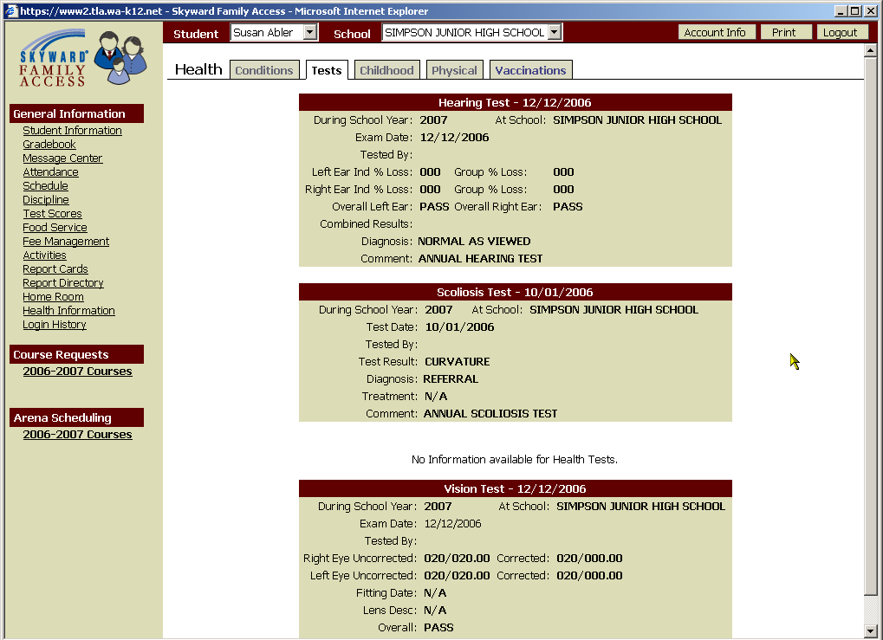

Figure 33: Health Information, view by Childhood.
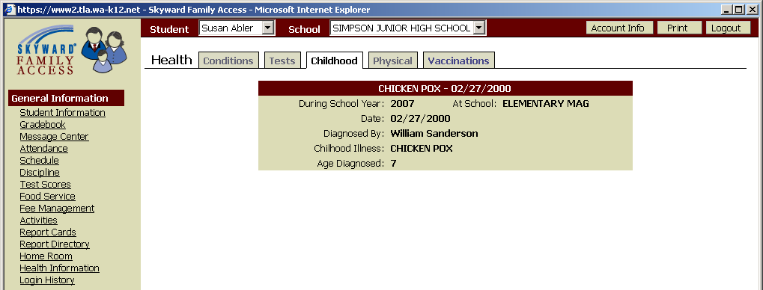

Figure 34 Health Information, view by Physical.
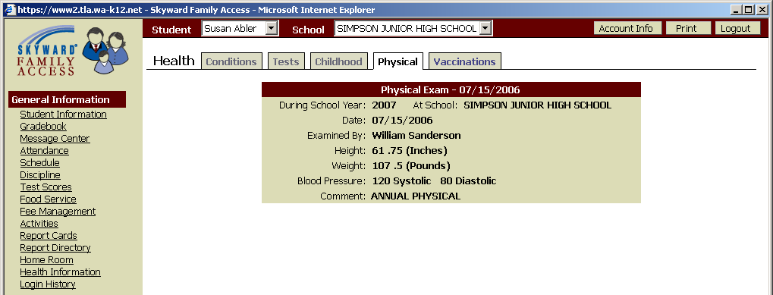

Figure 35 Health Information, view by Vaccinations.
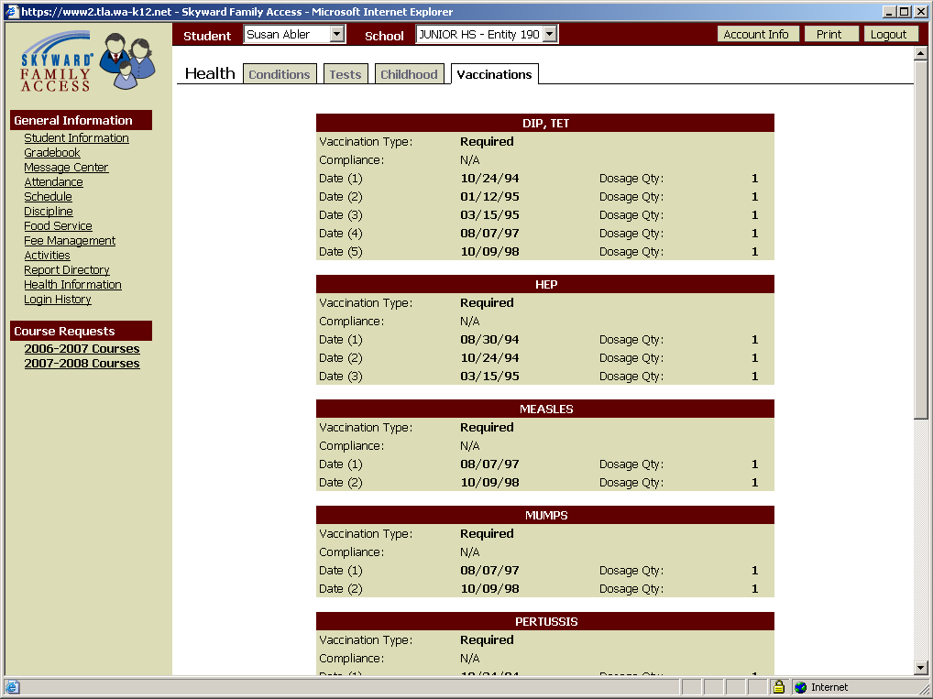

LOGIN HISTORY

Select the Login History hyperlink on the general information menu to see information regarding your login history/usage of Family Access. It will allow you to view historically the date, time and IP Address of your login. In addition you can view the specific areas of the system and for what student you inquired upon (see Fig.36-37).

Figure 36: Login History.
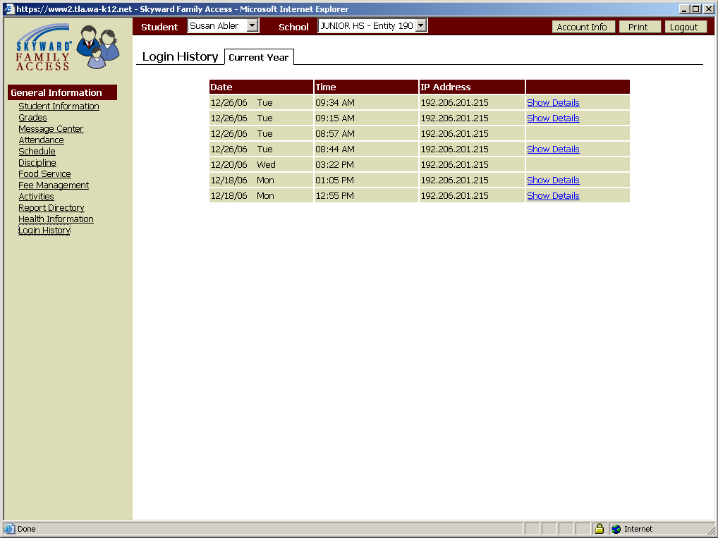
View your login history.

Select the show/hide details hyperlink to view details of the login date.

Figure 37: Login History, view by show/hide details hyperlink, history details.
