INTRODUCING PRT TO THE SUSTAINABLE CITY

Robbert Lohmann* and Luca Guala**

* Commercial Director, 2getthere, Proostwetering 16a, 3543 AE Utrecht, the Netherlands; PH +31 30 2387203; robbert@2getthere.eu
** Luca Guala, Area Manager, Systematica SpA, Via Marengo 34 – Cagliari 09131 Italy; PH +39 070 275939 guala@systematica.net

Abstract

The zero carbon, zero emission city of the future will require a high-level-of-service passenger transit system to accommodate the trips that in cities are typically performed by automobile. Mass transit, or group transit, is badly suited for this purpose as it can’t replicate the service as supplied by the automobile. Also from the energy use point of view, with the exception of peak hours, mass transit is extremely inefficient as it requires that large vehicles travel nearly empty to respect a schedule. The sustainable city requires an on-demand, door-to-door, personal, zero emissions, energy efficient transport service that can be obtained by means of automated, electric powered taxis.

The sustainable city will employ Personal Rapid Transit, the solution that provides on-demand, private transit directly from origin to destination. The city will feature a network of guide-ways with a large station density ensuring short walking distances (maximum 150 meters). The stations are off-line, since the vehicles will make no intermediate stops, the guide-ways are located at grade, while the pedestrian level is elevated to create a new street level (the podium). The guide-way allows for multiple lanes, incorporating acceleration and deceleration lanes to allow vehicles to speed up and slow down for stations away from the main through-lane.

The entire network has been modeled using both static (macro-scale) and dynamic (micro-scale) simulation software. The simulation has been extended to pedestrian traffic and the interaction and mode split between walking and use of PRT has been modeled as well. The extensive use of simulation models is a fundamental step to the assessment of a novel transport system such as the PRT. The modeling allowed a precise assessment of the traffic volume in all branches and nodes, and the determination of parameters of exercise such as headway, trip time, wait time, energy use etc.

The network will also accommodate the movement of a variety of freight and waste services. As the PRT replaces automobiles, dedicated (automated) vehicles are required to replace delivery vans and trucks. The freight and waste vehicles will feature similar driving characteristics (acceleration, deceleration and top speed) to ensure mixing of traffic on the network is not made more complex. A generic freight vehicle will accommodated different types of loads; creating flexibility in the operations. Most loads will be transported in standardized containers, adopting an existing standard. It is essential that the freight system takes into account the supply chain to and from the city, ensuring seamless connections while taking into account liability issues.
Introduction

How would you build a city if you could start from scratch? Would a city look different form the cities of today? How would you accommodate the accessibility? With sustainability in the back of your mind, would you still allow access to cars? If not, how would you accommodate mobility of people and goods? Would you be able to with today’s technology? Today’s Concepts? Or do we need to introduce a new transit concept to allow the city of the future to be build differently, taking into account our natural environment – changing the focus to sustainability without it being at the expense of accessibility and comfort? A ‘dream’? No, certainly not: a vision for the future, yes. And being realized now!

The City of the Future Today

The city of the future is carbon neutral, zero waste; a sustainable dwelling place acting as an example for future urban developments. The city features green buildings, waste management and reusage and natural energy taken from the sun or the wind. A sustainable city can’t feature fossil fueled cars; it can’t even feature cars at all! A truly sustainable city ensures accessibility but not at the expense of space or living comfort.
For the city of the future, a modern and reliable system of transport is needed to replace the private car. It relies entirely on the energy produced within the city from renewable and carbon-free sources, be free from congestion and significantly safer than any transport system based on private cars.

Personal Rapid Transit (PRT), an automated taxi-like service concept, has the qualities to provide the mobility desired, meeting the requirements of the sustainable city, without having to compromise on any other aspect of the development of the dwelling. It features the car’s privacy guaranteed by the fact that only the individual, or group of individuals that board a vehicle at the first starting station will occupy it: each vehicle, once a person or group has boarded it and planned the route, will not stop until the chosen destination has been reached. PRT is a combination of the characteristics of the personal automobile, the advantages of public transportation (congestion, parking) and clean technologies to ensure a sustainable transit system.

PRT vehicles run on electricity, with a significantly lower energy consumption than other means of transport. The level of energy saving is significant also compared to mass-transit systems as the vehicles only run on-demand, so they never run empty, with the exception of the vehicles that are automatically routed to pick a passenger, and their ride is uninterrupted, so they do not have to expend extra energy to accelerate after an intermediate stop.

When compared to proper public transport systems, the PRT may have a lower capacity, since a public transport vehicle can increase its occupancy during peak hour. From the user’s point of view, compared with public transport, the PRT offers better comfort, lower wait time, higher travel speed, no need to plan routes or transfer from one vehicle to another. From the community point of view the PRT offers very low energy consumption, high reliability and safety, non intrusive infrastructures and the possibility to build a thick network, capable to cover an urban area thoroughly and requiring very short walking distances from and to any point.

The PRT system functions as a local area network, connecting the locations within its network, and a feeder system to both other means of public transit as well as parking locations where access to more traditional private transit systems is provided.

Considering PRT

Personal Rapid Transit is selected as one of the transit options for the city of the future on the bases of several distinct characteristics in comparison to other options such as cars, taxis and public transport. Summarized the advantages are:
1. Shared usage: one PRT car can perform the task of 30 to 40 private cars.
2. Through automation congestion on the network is avoided through dynamic rerouting.
3. Automation leads to predictability, creating safety by avoiding human error.
4. The minimal footprint through a reduced guideway width and not requiring parking ensures only 13% of the surface is dedicated to transport (1/3 of the surface required for a traditional city).
5. PRT provides direct travel and on-demand service, ensuring trips are quicker, seamless and energy consumption is less.
6. Off-line stations warrants the level of service is not reduced if the number of stations is increased. The density of stations in the urban area is limited only by the space available and the cost.
7. PRT guarantees the privacy of the passengers; users can allow other passengers with the same destination to board the PRT vehicle with them, but only at their choice.
9. At off peak times the level of service increases as typically a car will be waiting at the station already.

Although PRT has significant advantages, there are several aspects that need to be addressed to be able to properly configure the system for the city of the future.

One clear aspect needing to be addressed in the accessibility of the stations. Where cars (and bikes) provide door-to-door transit (if parking is available at both origin and destination), the best effort for PRT requires a network with a high station density. Within extreme climates the maximum acceptable walking distances are relatively small (100meters or 1,5 minutes), ensuring the transit system remains attractive to use. This does impact the costs of the network significantly, as stations are not located at grade.

The PRT system will be public transportation. As a result it is not possible to leave objects in the car and the wear-and-tear faced is associated with public transit rather than personal ownership (where people tend to be more careful with personal possessions).

Traditional transportation system by the sheer size of the vehicles provide better capacity during peak hours, allowing the seats and standing places to be used to and over the maximum. However uncomfortable, this contributes to increasing the capacity of the line. PRT still allows for private usage, but ride sharing could be encouraged. The psychology is comparable to airports of larger cities with a shortage of taxis available; people will resort to ride sharing rather than waiting longer being able to travel by themselves.

The capacity of a lane for manual vehicles is based on a headway of 2 seconds or less, although at times, through human error, this will result in accidents paralyzing the system and its capacity. As PRT needs to comply with the current legislations imposing brickwall stop requirement, a headway of 2 seconds is not yet achievable. PRT’s lane capacity might be lower, but when relating it to the space consumed, it is actually much better (as the required lanes are smaller).

Based on these considerations PRT is determined to be a useful supplement to the transit network of the city of the future. It supplements public transit (an LRT and metro line guaranteeing external connections), slow traffic (bikes, pedestrians and segways) and car traffic (at the city perimeter).

PRT Blueprint

Mobility, and accessibility in particular, is an important element for people in the selection of their housing or place of work. Hence the transit system in the city of the future is an integral part of the urban planning. The network needs to be planned to provide the required capacity, while also minimizing its footprint to ensure space can be used for value adding (money making) activities.

Urban Planning

To be able to ensure the throughput of any transit system, avoiding the congestion on ‘normal’ roads and leaving the space at grade for other activities (such as walking), systems require a dedicated, grade-separated infrastructure (guideway). For Personal Rapid Transit the popular choice is an elevated infrastructure, a result of the costs of underground installation and working within existing spatial planning in build-up areas. In the city of the future, as a green field development, these drawbacks were less constraining.

After analyzing the impact of an elevated network of PRT guideways on the dense built fabric of the city, especially considering the required thickness of the network (in order to minimize the walking distances and optimize the accessibility) and its visual impact, alternative possibilities were researched. The analysis clearly showed that a raised pedestrian level with an ‘undercroft’ created at-grade (a basement at grade level), would allow to exploit the entire available road surface, without disturbing the image of the city and minimizes the extreme weather impact contributing to the energy efficiency of the system; although at the sacrifice of the view of passengers during the trip.

This solution is not new, although, clearly, it has never been implemented with PRT. The township of Louvain la neuve in Belgium, and the district of la Défense in Paris, France, are built like this but in those cases, it’s car and truck traffic and parking which take place under the elevated pedestrian free circulation space.

This concept also allows quick and direct access to any location in the city for special vehicles (emergency, maintenance, exceptional freight), providing the infrastructure of the system also allows access to these types of vehicles. The running surface hence has to be flat and free of obstacles, while featuring a bearing capacity to support a large freight vehicle for a width of at least 3.5 m.

Network Design

The transit system is one of many elements of the city of the future, which means the characteristics of its network design are influenced by all of the other elements. In the city of the future, the PRT network needs to take into account that:
- Stations need to be featured near main attractors of traffic;
- Stations need to be spaced such that the walking distance is minimized;
- The exact location for a station is based on the space available at each location;
- The corridors must follow the boundaries of the plots in which the city is divided
- The PRT running surface must be accessible to other vehicles in case of need;
- PRT tracks can’t cross each other (no intersections);
- PRT tracks must preferably be one way;
- The junctions of the PRT network allow only merge/diverge maneuvers;
- maneuver lanes are required along most of the network (as acceleration and deceleration on through lines constrains the network capacity).

The complexity in the design is matching the architectural needs of the city with the attraction of traffic to the characteristics of the PRT system. In order to optimize the transport network and its efficiency in serving the needs of the city of the future, a model was designed to allow a dynamic interaction between the use of the land in the city of the future and the PRT network. Use of the land and network were defined in successive iterations in order to reach a satisfactory distribution of functions and a good network with the least number of stations and lines that allow to prevent congestion in any foreseeable situation. The first iteration was done on the initial land use and population data; a first PRT network was tested and the feedback used to modify the land use pattern. Several iterations were performed until a satisfactory combined solution of land use and transport was obtained.

In the final layout, the main attractors were positioned along the “spine”, that runs diagonally through the city. This contains the LRT line as well as the main PRT connections. A Business District expands in the other direction, along which the roads are straighter and therefore better connections can be provided. A Light Industry area is positioned mostly along the edge of the city, so that it can receive its prime matter and deliver its finished goods with the least disturbance to the inner road network. The network was tested for robustness with the flow of passengers assumed for the two morning peak hours (7AM to 7AM) and a final network and station layout were defined

In the creation of the PRT network in the undercroft, the creation of a grid compound of outer and inner loops and transversal connections entering and exiting the spine proofed most effective. This design process follows the layout of the pedestrian-level inner roads , which are twistier in the SE-NW direction and straighter in the SW-NE direction. Therefore, the fastest and most direct PRT connections were designed in SW-NE direction. Designing the network is an iterative process during which several different networks are designed and verified against the geometrical constraints, architectural and environmental requirements.

All the transport levels were specified with their main features, using several geometric and functional attributes, and properly connecting the LRT line, Metro train line, PRT system and the pedestrian network. All the transport systems are connected to the pedestrian network and are connected each other using the pedestrian network (i.e. walking to the PRT stop or LRT station); the PRT lines are all one way except the connection to the external car parks.

The design of the network also required an analysis of the connections between the two separate built districts which make up the city of the future. Since these connections could become a bottleneck for the whole network, the main aim was to design as many connections as possible between these districts to let the PRT flows spread across them toward their destinations instead of having all the traffic between the two districts over one or few links.

Without reference in literature or field data, all hypotheses made have a significant level of uncertainty, even though they have been defined as accurately as possible. The results of the simulation have therefore been considered “safe” only when they yielded a flow of less than 60% of the saturation flow in every branch and node.

The least number of roads were used to connect all the PRT stations required to guarantee the accessibility level needed. The resulting transport system is composed of:
• Walk network: ~104.7km
• PRT network: ~45.0km, all one way except ~10.0km
• LRT network: ~40.1km (including connection with parking lots)
• Metro train network: ~6.7km
• 103 PRT stops (including external parking lots),
• 154 merge/diverge nodes
• 6 LRT stops inside the city

In parallel with the design of the route network, the locations of the PRT stations was analysed, based on the requirement to ensure the maximum walk distance from any point to the nearest PRT stop is no greater than 150 meter. The design constraints are basically generated by a compromise between opposite goals: achieving maximum coverage and not having an excessive number of stops, which leads to an uniform land coverage.

Since the roads of the city are arranged in a square angle grid layout, the walk distance from the PRT stops has been evaluated along a right-angled path and not along a radius; The theoretical scheme that arises from these considerations is a triangular, or staggered grid of stations. This layout allows the minimum overlap between areas of influence and the minimum number of stations to cover the whole city area. The actual network follows the plot division and is not as regular as the theoretical scheme, so some areas of influence have a higher overlap and the number of stops is slightly greater. Punctual attractors (LRT stations, main office building, hotels, shopping areas, Places of Worship, Schools, etc.) were considered as fixed points in the station scheme.

About 1/3 of the whole area has 2 PRT stations within a distance of 150m. The best coverage has been obtained on the busiest areas (BD, spine, special buildings, etc.). If a uniform distribution of population is assumed over the territory, then at least 50% of PRT users will have a station less then 100m away, and often they will have more than one station within 100m.

Only some very small areas fall beyond the 150m walking distance goal from the nearest station; part of these are included in the “green finger” linear parks that cross the city, other small areas lie within the light industry built up area. Since the population is not uniform, but more concentrated in the areas where also the PRT stations have also been located, it can be assumed that more than 50% of the PRT users will walk less then 100m to the nearest station. This result is consistent with the goal of providing a near-door-to-door transport service throughout the built area.

Transit System Modelling

The estimation of demand is the process that produces the number of trips from each zone of the area analyzed to every other zone. To be used in a traffic model, these trips must be arranged in a matrix format (matrix estimation process). The final result of the process was a matrix of 283 zones based on the plot subdivision of the built area of The city of the future, with about 62,400 trips over 2 hours (7AM-9AM).

The analysis performed is based on:
• The attraction and generation rates for each land use, as well as the inbound/outbound traffic rates and the AM traffic rates (when trips rates are referred to the whole day) are those found on literature Trip Generation Manuals (TG).
• It has been assumed that 70% of the commuters that reach the city of the future for work/study purpose will travel in the peak 2 hours between 7AM and 9AM. this assumption is purposely cautionary.
• Trip rates represent the number of trips generated and attracted for each unit of reference and for each land use category. The values in the TG manuals are referred to different types of units of measurement: areas (typically, 100 sqm GFA in TG Manuals), number of students for University and School, dwelling units for Housing, keys for Hotels, and employees for Light Industry.
• The zoning system represents the 280 plots inside the two built districts, plus three external zones, one zone by mode used by the commuter to reach the city, that is Light Rail Train, Regional Metro Train line underground, Car+Bus+Hov (those using the external Roads and car parks).
• For each land use the inbound/ outbound ratio were taken from the TG manuals. As an example, for residents this is equal to 83% outbound, 17% inbound.
• Every land use and activity inside a single plot was examined individually and its specific data were used in the trip generation process, then the trips generated and attracted were handled as uniformly spread over the whole plot.
• Total trips generated and attracted by each plot were calculated multiplying the trip rates by the value of the relevant parameter per each land use per plot (for example, area, population, no. of students etc.).
• For what concerns the University, only the employees and 10% of the students were considered in the trips generation process, as potential inbound travellers, because 90% of the students were considered as resident inside the University quarters (and not travelling towards the city during peak hour).
• Since trip rates from the manuals are expressed in vehicle trips, a vehicular occupation coefficient equal to 1.2 was used to convert vehicular trips in passenger trips where appropriate. This is equal to the average occupancy of cars and is cautionary because the occupation coefficient will probably be closer to 1.5 if a HOV promotion strategy is implemented (Single Origin, Multiple Destinations - SOMD).
• Trips attracted by each plot have been estimated allocating the number of commuters entering in the city on the base of the “power of attraction” of each plot compared to the others. “Power of attraction” has been calculated applying attraction trip rates to each plot on the base of the different types of activities localized in it.
• Trips generated by each plot have been distributed among destination on the base of their “power of attraction”. For each type of trips a set of possible destinations have been selected. For example, it was assumed that destinations allowed for commuters are the work and leisure locations but not the places of residence.
• The mode split between the external transport means, and the occupancy of the vehicles have been defined in a trip generation scenario.
• It has been assumed that car and HOV passengers will board the PRT vehicles with the same occupancy as the car they traveled into, while bus passengers will fill up the PRT vehicles to almost their capacity. Other travelers (LRT users and residents) will board the PRT cars with an average occupancy of 1.2 passengers per car. This too is a cautionary assumption, since it can be assumed that LRT users will accept higher occupancy levels of the PRT vehicles (SOMD).

The biggest generators are three zones that represent the virtual points of origin of the trips by private transport, LRT and Metro. Since the plots are all mixed use areas, the relation between land use and the number of trips generated is not as clearly visible but, as a general rule, the residential area is a shallow but vast generator. The main attractors during the peak hours are all the offices and business areas where people usually work. The residential area has a low attraction level, during the morning peak hour, mainly related to the community activities.

The traffic model based on the multi-level network and the matrix obtained from the demand analysis was drawn, employed an equilibrium iterative model to evaluate the traffic flow on each link. Specific BPR flow curves were used to fit the sharp PRT network capacity drop off.

For what concerns the commuters who use the light rail, no assumption is made about their distribution over the rail way stations inside the city of the future: they are assumed to be free to choose the best railway station (the nearest) to reach their destination. This also applies for commuters using cars, buses and HOV: no assumption is made about their distribution over the external car parks and their use of the LRT to enter the city: they are assumed to be free to choose the most suitable car park to reach their destination and to choose between PRT and LRT where available. The “best path choice” and the “path-finding” algorithms handled these processes (with the parking lot capacity serving as a constraint). The capacity of the network was defined based on a PRT system which allows a 3 seconds headway to the vehicles. This is a baseline number, and not a precise estimation of the performance of any specific PRT system.

The network resulted to be almost everywhere within capacity although over 60% of capacity in about half of the network. The model also showed some locations in the network close to 100% capacity, which requires further analysis to determine how capacity can be increased; a shorter headway being one of the options. This means the PRT system implemented will need to accommodate for a reduction of the headway once the build out of the city and the increase of demand on the network show this to be required.

PRT (and FRT) Systems

Besides the PRT system the network will also need to accommodate the FRT (Freight Rapid Transit) system to allow for the delivery of goods and the removal of waste. For deliveries the FRT system will operate during the same period as the passenger vehicles, although avoiding the absolute peaks, while for transport of waste will be scheduled for the low demand hours of the passenger transit system.

In normal operations the priority is the passenger transport. The graph below is an indication of the time interval assigned to the different vehicles. The PRT system will be operational 24/7. During the peak hours of the system, no other system will be operational in the undercroft. The undercroft will be accessible at all times for emergency vehicles. During the night it is also possible for exceptional loads (using manually controlled vehicles) to be transported. Exceptional loads in other hours of the day should be avoided, but if it can’t be avoided these would be scheduled before and after the lunch period.
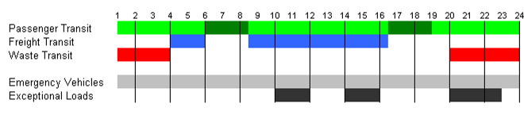

As the PRT and FRT vehicles operate at the same time intervals and on the same infrastructure, their driving characteristics should be similar to avoid disruptions of the system and network. This means that characteristics such as the maximum speed, turning radius, acceleration and deceleration capabilities and profiles should be equal. This is most easily achieved by means of a shared platform. The build-up on the platform and the body would differ considerably. The shared platform greatly facilitates the planning issues of the supervisory control system.

Supervisory Control System

Although vehicles are the most visible aspect of a PRT system, the (supervisory) controls are the most critical factor for the success of the system. Personal Rapid Transit is all about network (and vehicle) controls.

The supervisory system TOMS (Transit Operations Monitoring and Supervision) will co-ordinate the different vehicles and the scheduling, but will also be expandable towards the future to allow for expansions and/or phased introduction. The supervisor should allow for ‘easy’ expansion, allowing the network the be extended and the fleet size to be increased. Hence the control system will feature a distributed network architecture, making it more flexible and allowing for easy expansion while also ensuring the system’s robustness. Local control and autonomous decision making are essential to the success of the network and the application.

The extensive experience of 2getthere with automated vehicle systems results in a 4th generation supervisory control system based on object-oriented Holonics software architecture. The objects (holons) within the framework are identifiable, self-organizing units that both comprise subordinate parts and constitute part of a large system. The interactions between these objects (each object influences and is influenced by both subordinate and superior objects) enhance the ability to respond locally while maintaining a global goal – ensuring the system is flexible, robust and scalable. The strength of the architecture is that it enables the construction of a (very) complex system that ensures efficient use of resources, is highly resilient to disturbances (both internal and external), and is adaptable to changes in the environment in which it operates. The supervisory software is platform independent.

An important element of the supervisory control system is the newly developed Graphical User Interface, allowing the operators of the system to monitor the process real-time in either 2D or 3D, selecting the track sections, stations or individual vehicles of interest at any time. The GUI is developed in-house, incorporating previous applications experience.

Vehicle Guidance

The transit system is a free ranging system, operating on rubber tyres. The most notable shared characteristics vehicles are the controls and the obstacle detection system.
The vehicle control software operates based on the patented FROG (Free Ranging On Grid) technology; creating intelligent vehicles that can operate in any environment. The on-board computer controls the vehicle based on electronic maps (route planning). While driving, the vehicles measure distance and direction traveled by counting the number of wheel revolutions and measuring the steering angle (odometry). External reference points (magnets embedded in the road surface) are used to correct possible small inaccuracies in reference to the planned route (calibration). The system has continuous longitudinal and lateral position calculations, ensuring external influences, such as wind, are automatically corrected. The passive reference points merely serve to improve the accuracy even further. The patented Magnet Measurement System has tested and proven up to speeds of 100km/ph, showing only marginal deviations from the planned path. For PRT applications the maximum speed will be restricted to 40km/hr in light of the applicable safety regulations.

The navigation system is not dependent on any physical infrastructure. It does not require any physical guidance (rail) or guiding infrastructure elements (curbs and/or walls), ensuring complete liberty in design. Dependency on infrastructure elements is avoided as it entails a higher vulnerability and increased inspection and maintenance costs of the infrastructure. The guidance system is inherently safe and can not be ‘derailed’ by placement of additional magnets taking the vehicle of the planned path.

Although the vehicles operate on a dedicated guideway, each vehicle features an advanced obstacle detection system. The obstacle detection system functions as a safety measure both related to people in the immediate environment (in the unlikely case that there are any), as well as in respect to other vehicles operating in the same environment. The obstacle detection system (ODS) uses sensors to scan the base-hull and extended hull in front of the vehicle. The base-hull (the vehicle envelope plus a small safety margin) is specific for each track section and calculated based its’ characteristics (straight, curve, etc.). The extended hull is wider and incorporates space adjacent to the base hull where objects might be present that could move into the base hull. The vehicle would slow down and ultimately stop for obstacles (objects present in the base hull), while it would only slow down to pass at a lower speed for objects in the extended hull. In case the object would move into the base hull from the extended hull, thus becoming an obstacle, the lower speed ensures that it is still possible to stop in time. Both hulls are divided into a large number of detection cells. Each detection cell is scanned several times per second. The measurements of the scans are repeated and based on them a probability factor of an object being present (in that detection cell) is determined. The probability factor is among others determined based on object size (presence in multiple adjacent detection cells) and its’ presence in continuous repeating scans. Based on the object probability number the reaction requirement is computed, which in its’ turn is translated to an adapted speed profile taking into account the obstacle. The new speed profile takes into account acceleration, deceleration and jerk constraints as defined for the application.

PRT Vehicle

2getthere’s PRT vehicle has been developed in co-operation with Zagato (design) and Duvedec (realization). Based on stringent customer requirements and reviews the vehicle design was developed in several design cycles. It reflects the appeal and characteristics of the personal car, while being resistant to the wear and tear associated with public transit. The design is in-line with the design of the city of the future, appealing to energy efficiency and innovation.

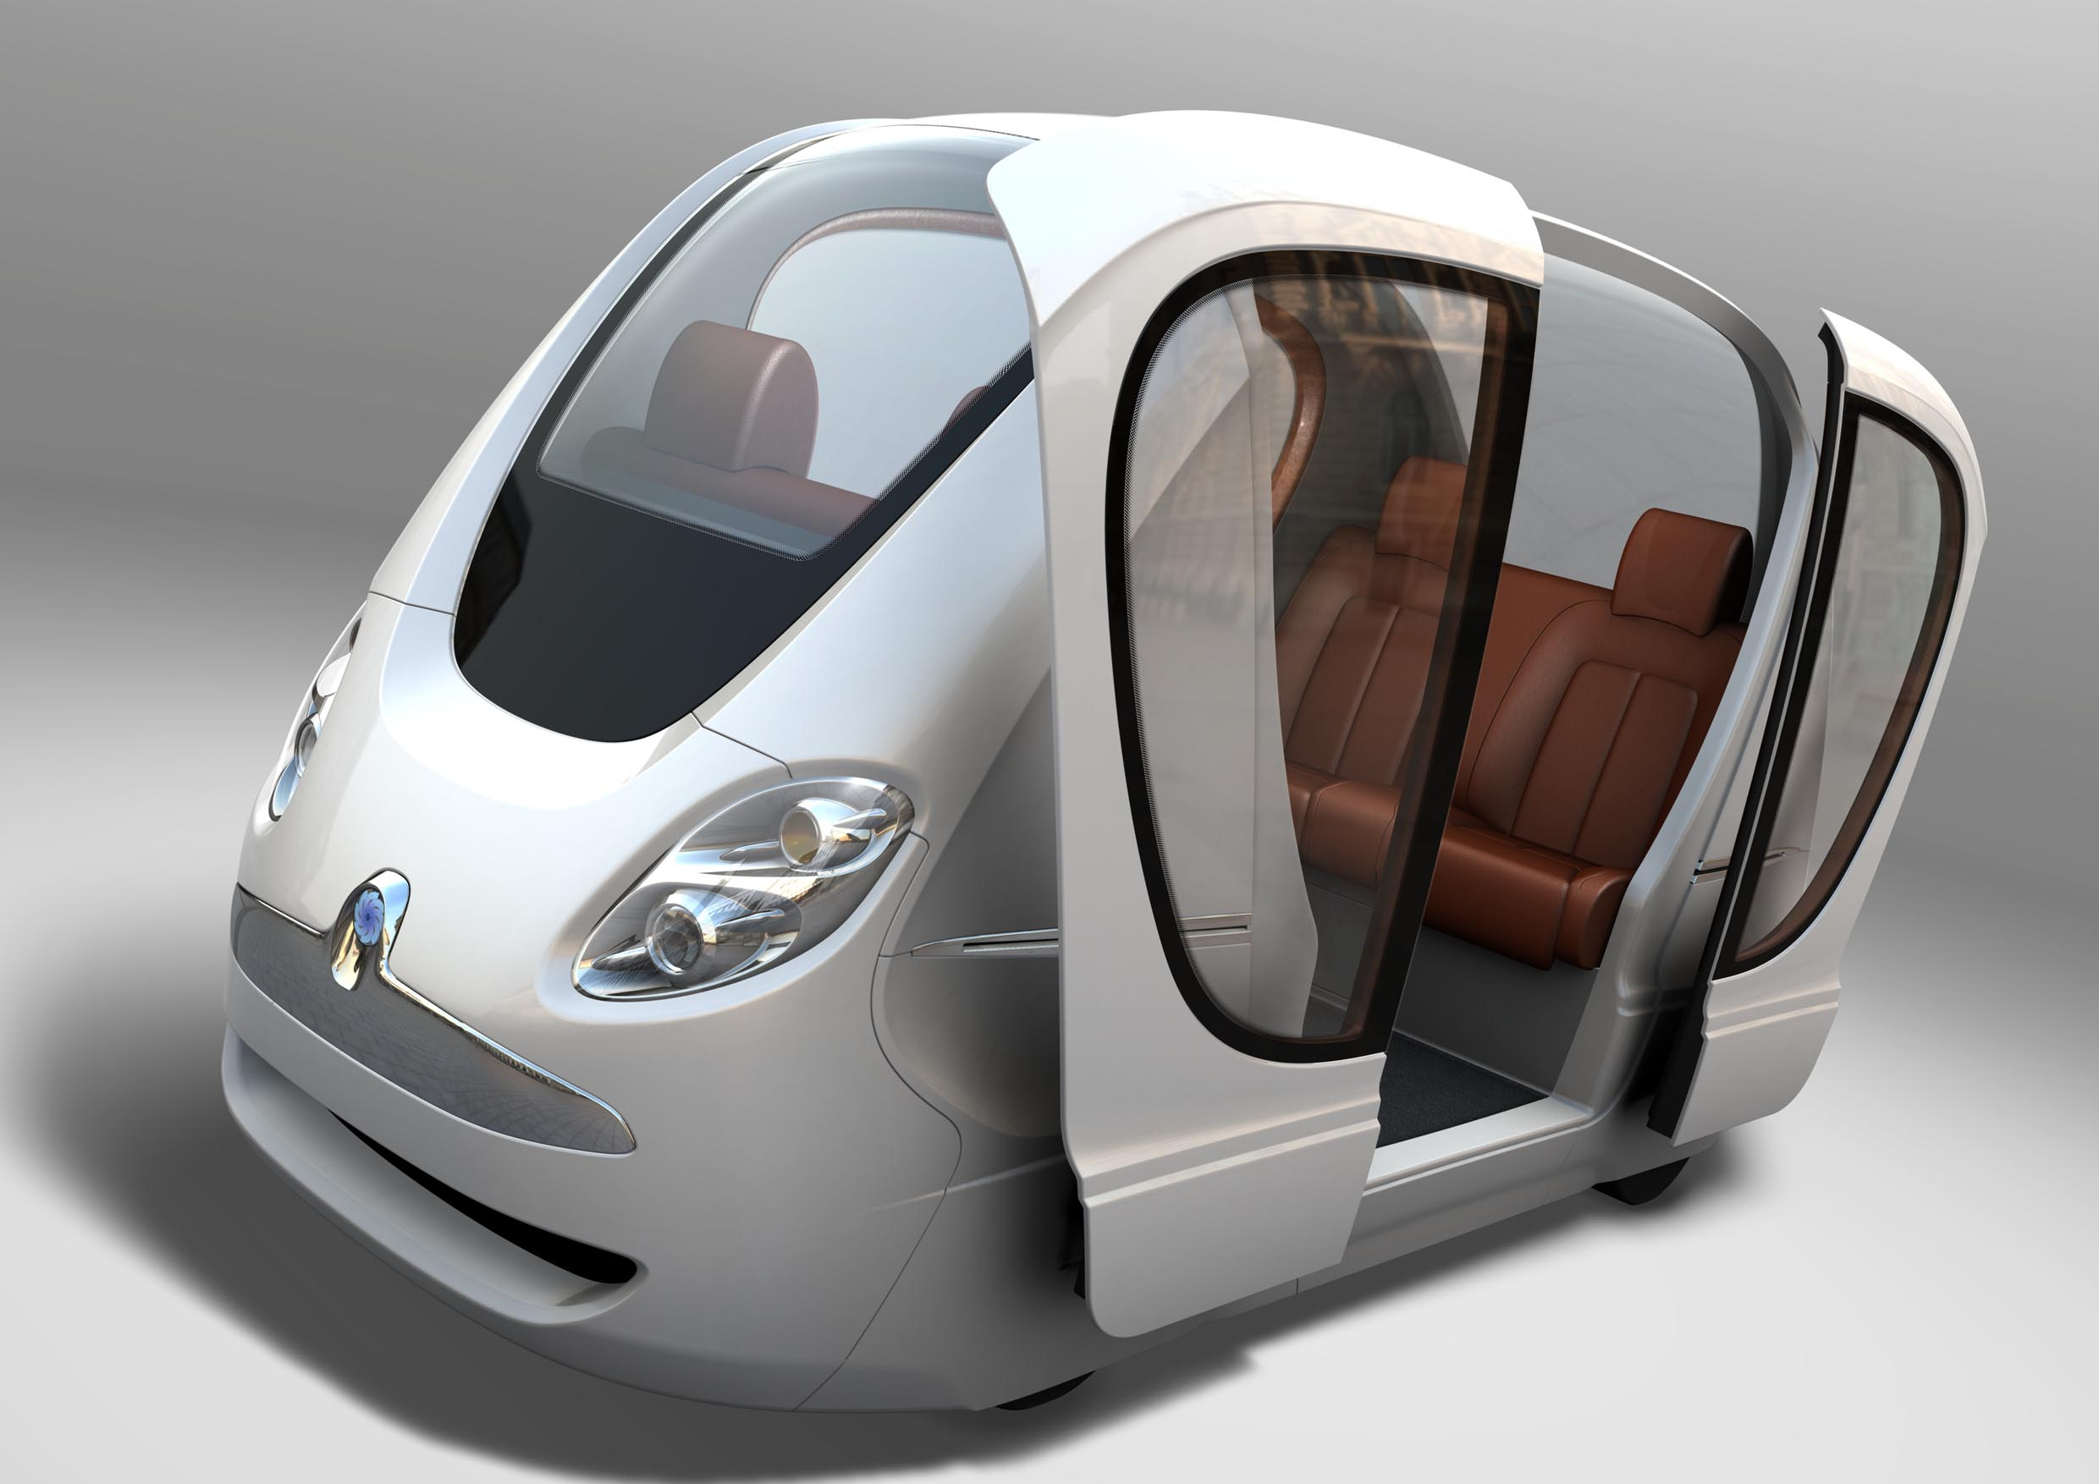
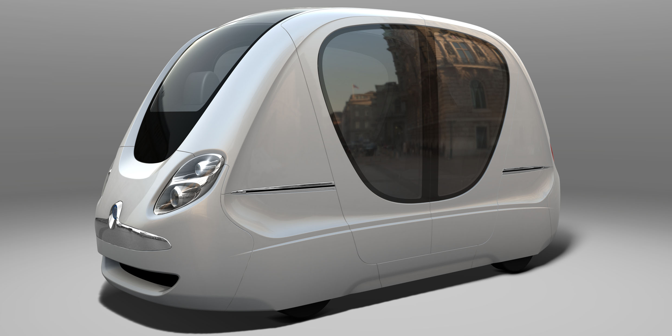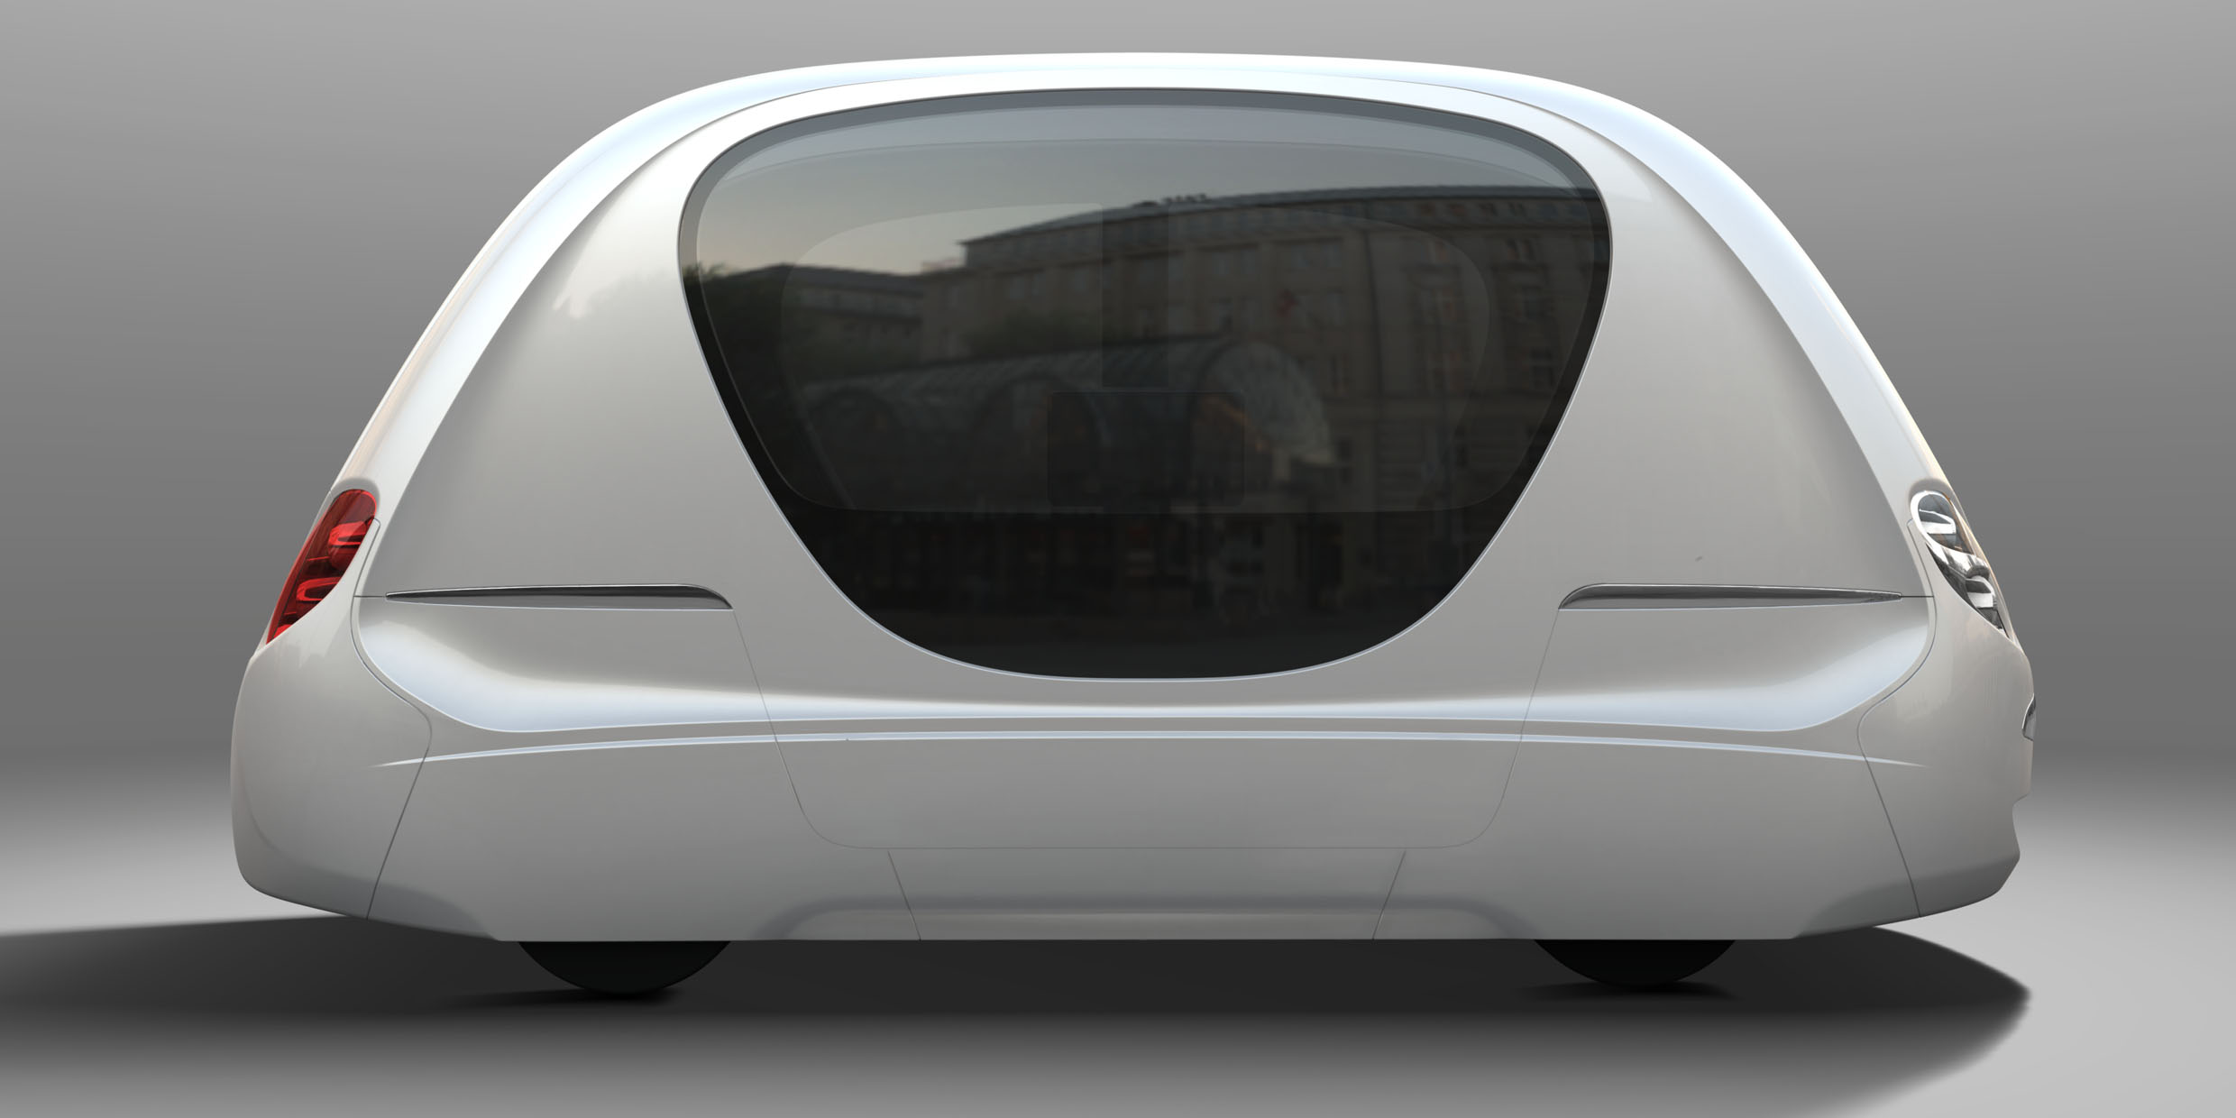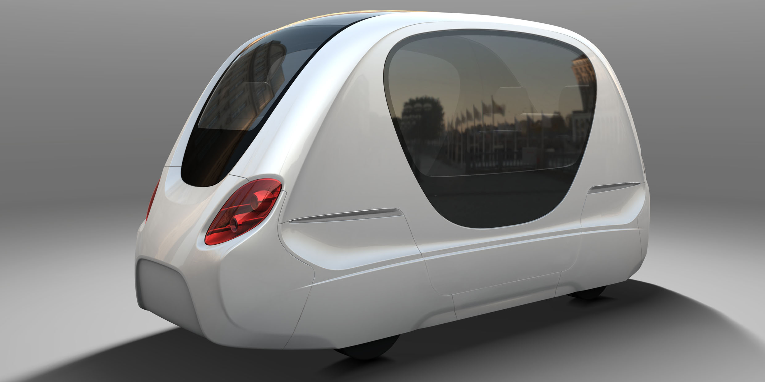
The exterior is compact with optimal interior space. Ease of access is provided by large, automatically operated, sliding doors. Although stations might be featured on both sides of the tack, the vehicle will only feature sliding doors on one side. Access to the vehicle will be ensured from the platform in adaptation of the platform design. The opening width of the doors allows for wheelchair or pram access from the platform which is flush with the vehicle floor.

The cabin is spacious and light. The height of the cabin is such that passengers will not be able to stand during transit and passengers will be notified to seat their children. Large, heat reflective, glass surfaces give good all round vision and add to the security feeling of the passengers. The cabin is well illuminated when driving at night. It accommodates 4 to 6 passengers (maximum 4 adults, 2 children). The seating is configured in the form of two benches, placed opposite of each other and located over the wheels. The benches feature two seats sunken-in each. The space in between the seats accommodates a child. Seating is comfortable with space clearly exceeding normal public transport standards.

The vehicle’s user interface consists of an information screen and interfaces for the vehicle activation, intercom, doors, medical assistance and emergency stop. Ease of use and ample travel information are important prerequisites for People Mover systems. Therefore layout and design of the controls are inviting and simple in such a way that passengers intuitively find their way. This process is supported by a display for guidance and feedback. It also provides further travel information. The display can be upgraded for commercial messages.

It is important for passenger comfort to know there is human support instantly available at all times. Passengers can communicate directly with the operator via the intercom. A voice module is available for (automatically generated) messages. An interior video surveillance adds to the security (feeling) of the passengers. The images of the interior camera are displayed on screen when the operator is contacted via the intercom.

In the application actually two types of PRT vehicles are featured: standard and VIP. The VIP vehicle can be used by indentified individuals only and feature several luxurious features not present in the standard vehicle (such as leather seating and privacy glass).

FRT (Freight Rapid Transit)

To optimize the operations and ensure maximum flexibility, while minimizing the fleet size, a common platform was developed for both freight and waste transit. The platform is a flatbed vehicle capable of carrying containers. The type of container determines whether the vehicles are being used for freight (multiple variants such as refrigerated, valuables, flammable/dangerous) or waste.

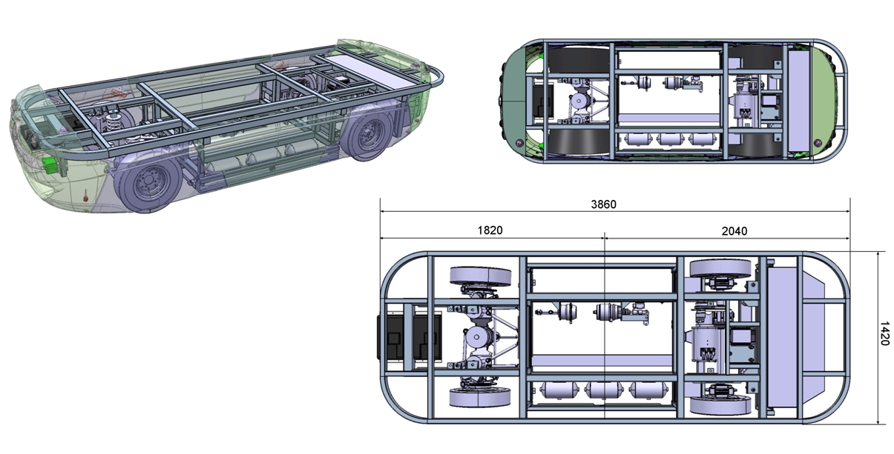
The containers are designed specifically, color-coded based on the purpose they serve:
- Blue: freight containers
- White (reefers): refrigerated containers
- Black: waste containers
- Yellow: valuables (including key-pad with security code to be able to open the container but also to release clamp mechanism of PRT vehicle)

The containers allow for 2 pallets per container. Roll containers would also fit, although the size of the roll container platform would have to be adapted specifically to the width of the containers. With the interior dimensions being approximately 1050mm, the base should be 500mm wide (allowing for two roll containers to be placed adjacent to each other). All the containers would feature fork-pockets at the base, allowing them to be handled manually by means of a fork-lift truck. At the same time the pockets could also be used of automated handling (e.g. by a miniature stacking-crane).

Furthermore the pockets would allow for securitization of the freight during transit. The vehicles will feature automatic clamps which will lock the container after it is loaded onto the vehicle. These clamps will be automatically released once the container reaches its destination, with the exception of the containers carrying valuables – in this case it will be required to enter a security code first before the clamps will be released from the vehicle. Entering the security code would either be done through the interface on the container (same panel as required for opening the doors to these containers, but a different code), or via a terminal of the supervisory control system.

By using the color-coded containers and flatbed vehicles, the vehicles can serve any kind of transport without any risk to hygiene. The vehicles will feature a load handling mechanism similar to airplane-freight. This would mean that the pallets, once the clamps are released, can be pushed off by hand.

Energy Management Concept

The vehicles are powered by an on-board energy source. As there are many parallels with other applications (e.g. cars) the development of these type of energy sources is rapidly progressing.

In light of the various application characteristics, including the climate and the sustainable nature of the project, it is essential the (battery) technology applied ensures the best fit. Opportunity charging using regular car batteries is an option, but is certainly not the most sophisticated or sustainable solution. The city of the future application will feature Lithium-Phosphate batteries, which, although considerably more expensive, offer the same capacity at a lower weight in comparison to lead-acid batteries. To optimize the life-cycle of the battery deep-charging (with a full charge within 2 hours) is preferred over opportunity charging, although this is possible. The range of the vehicles is approximately 60 kilometers per charge.

A battery management system is available to ensure all cells are discharged equally and an indicator for the remaining energy is provided. The chargers are actually located inside the vehicles based on the requirement to be able to recharge at the stations and the fact that direct current (DC) energy is provided. This allows for the sensitive process of charging to be checked immediately. Otherwise each possible parking location would also need to be connected to a dedicated charger.

Headway and Throughput

The minimum headway (distance) between vehicles is a safety factor, which also influences the maximum capacity of the infrastructure. The headway will largely depend on the requirement for a brick-wall stop. When a brick-wall stop requirement is imposed, the CyberCab PRT system will feature a 3 second headway. NOTE: this is calculated according to the requirements of safety certification procedures, with the leading vehicle braking at the technical maximum, with the trailing vehicle decelerating at the (fail-safe) minimum emergency deceleration speed while taking into account sensory, communication and activation time delays. When the brick-wall stop requirement would be lifted, a shorter headway would be possible.

The capacity of a track lane is determined by the length of a vehicle moving block (headway + vehicle length). At lower speeds the vehicle moving block is longer (as each section of the track is occupied longer by a vehicle). At lower speeds, the throughput will decrease. Hence the infrastructure design (especially the curves) will determine the maximum throughput of each track-section. The throughput will be as high as applicable for the lowest speed in that section. The curve radii are vital in establishing the throughput of a track section) are thus vital in determining the potential throughput per hour; which is why close co-operation with the design of the network is required to ensure the PRT system is able to make true on its capacity to the largest degree possible.

Infrastructure

For a network with a high-station density and a large number of vehicles, acceleration and deceleration lanes become a pre-requisite. As a metaphor please use the resemblance with highways. When vehicles would need to slow down on the main guide way before being able to turn into a curve or into a station, all the trailing traffic would need to slow down as well; seriously impacting the capacity of the network.

For this reason the sustainable city will feature multiple lanes, consisting of one or more highways and one or more deceleration lanes. From this perspective a lack of physical separation between lanes is a great advantage as it allows the system to switch lanes at any point along the trajectory. In addition the lack of physical guidance ensures the infrastructure costs are minimized (both in construction and maintenance).

Surface

The infrastructure surface of the guideway is an important factor often neglected; it impacts comfort (noise, vibration) and the passenger experience very directly! Although the weight of both the PRT and FRT vehicles is limited, the consistency in driving (maximum normal lateral deviation of 1cm) ensures rutting is a serious issue. A concrete infrastructure would solve this issue, but the longitudinal evenness (or roughness) could be a point of concern, especially as it directly impacts the ride comfort. In addition concrete provides less comfort and more noise hindrance, as well as it is more difficult and expensive to maintain.

From these perspectives there is a preference for asphalt, which, however, is more suspect to rutting. An asphalt surfaced pavement for the underlying infrastructure will provide a smoother surface. Furthermore in case of incidental surface defects it will be easier and more economical to provide local resurfacing. With modern asphalt mixes and polymer modification of bitumen it is possible to provide tough and rut resistant asphalt pavements.

A surface water drainage collection system is required to drain tracks and all non-permeable areas within the APM structures. The surface drainage design includes the design of the gravity sewers, road gullies and connection to a main drainage connection point at the property boundary. For the magnets to be embedded in the road surface it is important to take into account a 10 centimeter clearance underneath the magnet (15 centimeters below surface level) for the steel reinforced grid. This to avoid any potential disturbance of the magnetic field to be measured by the vehicles sensors.

Stations

All stations feature all the necessary amenities and security measures to ensure the comfort and safety of the passengers. The stations are ADA compliant ensuring easy access for less able bodied passengers. 2getthere opts for a station with angled berths (avoiding the gas-station queuing problem), with the design allowing for independent entry and exit of all berths (optimizing capacity) while ensuring passenger do not need to cross tracks (minimizing costs) and remaining intuitive in usage (minimizing the signage required).

Please note that the operations at angled berth stations are more complex as a result of the maneuvering required; vehicles reversing out of berths need to be coordinated with vehicles coming into the station. To enable these operations the distributed network architecture of the supervisory system is important as the maneuvering can be controlled locally rather than centrally. It should also be taken into account that reversing out of the berths does increase the driving time slightly. However, the average trip time is reduced as delays will not build up for all vehicles. The independent exit and entry ensures the system is more robust, less vulnerable to disturbances and single point of failures.

Amenities that are a requirement are passenger information consoles and a PA-system. The station lay-out should make usage intuitive and easy to use for all passengers – both young and old. Despite the fact that there is minimum waiting time, and is most cases a vehicle will be present in the station already, it is still important to provide passenger information. The information concerns the operations of the system, especially if there are exceptions, but also e.g. if there is no vehicle present the possibility to indicate a transport request and the waiting time for the vehicle to arrive. The transport consoles at the stations will also feature a possibility to contact the operator via an intercom. The PA-system will allow general messages to be broadcasted at all stations simultaneously.

From the perspective of security each station needs to feature the possibility to contact the operator (via intercom) and have camera surveillance. The transportation request modules at the stations all feature an intercom facility. The operator can be contacted directly. Once the operator is contacted the images of the CCTV cameras will be displayed on screen immediately; in this way the supervisor can actually observe the surroundings of the person contacting him. Each station will feature camera surveillance. The cameras cover all areas of the station (avoiding blind spots). Stations will feature multiple cameras with overlap, to avoid a non-functional camera creating blind-spots.

Wrap Up

The city of the future will allow for door-to-door transportation, but not by car. Personal Rapid Transit can become a part of the transport mix offered to residents and workers of the city. The most prolific advantages are the savings in energy, its’ environmentally friendly nature and the huge reduction of the space required for transit systems – allowing this space to be used for other purposes.

PRT is a concept that can only now be realized with the developments of numerous technologies contributing to it. More and more applications will be realized in future years; in niche markets first, but in complete city applications thereafter. On what term will become evident based on the success of the first applications…

