HandyByte, Inc.

Functional Specification Documentation

Product: HandyByte I/StatPac 1.0
Date: 6/3/02
Version: 0.1
Author: G. Mobus
Emp. No.: 987654

Functional Requirements:

Module: 1.0 StatPac Main Menu

Description:

Menu Selections:
Enter data
Read data from internal file
Edit data
Delete data
Save data to internal file
Compute/Display statistics
Exit

Menu choice prompt:
Enter a selection: _

User input on input line – 25. Check selection number for proper range and prompt user if an incorrect number has been entered.

Error prompt:
Incorrect item chosen. Press [ENTER] to continue.

Sub-modules:

The following sub-modules have been identified.
  - Enter
  - Read
  - Edit
  - Delete
  - Save
  - Compute-Display

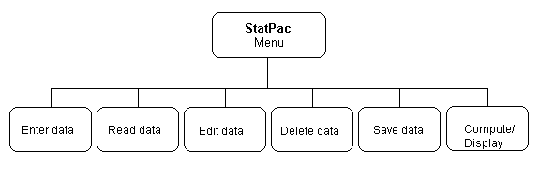Figure 1.1. StatPac sub-modules.

Data Structures:
This application will require an array or list of double precision floating point numbers.

Constraints:
The number of menu items is limited to 10 due to screen space.
Menu title should be shown centered on line 5.
There should be 3 blank lines between the title and the first menu item.
Initial analysis of memory requirements indicate that a data array of no more than 100 double precision floating point numbers

Process Description:
Input:
User types a number selection from the menu.

Process:
The program loops, first printing the menu on the screen and then waits for user
selection input.
Entered number is checked for correct range. If in error, the user is alerted and
promted for another selection. Upon correct selection, the program calls the
appropriate module for further processing.

Output:
Formatted menu, user prompt/alert.

Termination:
When the user selects the Exit option, the program terminates returning control to
the operating system.

© Copyright, 2002. HandyByte, Inc. – All Rights Reserved

