FROM WEB SITE:
http://www.impactpt.net/index.html

(See add’l info on web site)

Impact Physical Therapy - Run by and Owned by a Physical Therapist
The mission of Impact Physical Therapy is to provide one on one patient care by Licensed Physical Therapists only. We do not use any ancillary personnel to assist with our treatments, and every patient is assigned to a Physical Therapist for the duration of his/her care. We believe that consistency in care and treatment is not only important for the patient but for the therapist as well. The clinic is set up with several individualized treatment rooms to assure patient confidentiality and privacy.
The staff is highly qualified in manual therapy and continue to further their expertise by attending monthly round robin sessions, a monthly study group held on Saturday mornings, and monthly guest speaker sessions held by various professionals in our field.
Physical Therapy Referral Prescription
Most insurance companies require a physician's prescription for reimbursement. Download one here.
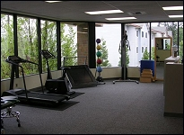 |  | 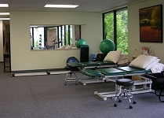 |  | 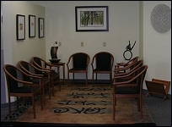
About Impact Physical Therapy
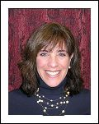
Nancy Mitrano, MS, PT is the owner of our clinic. She has been in the field of physical therapy since 1990. She graduated from the University of Washington and specializes in manual therapy, orthopedics, gait training analysis, and the spine. Her background has consisted of medical management, a behaviorist for the morbidly obese, and a masters degree in exercise physiology. She opened Impact Physical Therapy with the vision of it being a multidisciplinary clinic. One that focuses on one-on-one patient care, as well as various specialties by each individual therapist. She wanted to provide an environment for physical therapists to progress their skills by providing a weekly mentor/round robin session, guest speakers, and combined course work to be shared by th e entire staff. Her side interests include a passion for animals and athleticism.
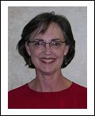
Mary Lee Snorteland, PT Mary Lee Snorteland,PT,LLC has been in private practice for twenty years on First Hill in Seattle relocating to Impact PT in 2005 as an independent practitioner. She shares their vision of one to one quality care, a multidisciplinary approach and superb service. Her areas of expertise are manual therapy, orthopedics and the physicial> therapy management of imflammatory diseases. She has received extensive continuing education since graduating from the University of Colorado.
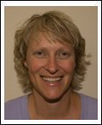
Sarah Patton, MSPT, Feldenkrais® Practitioner
Sarah’s lifelong interest in movement leads her first to a career in dance and then to the profession of Physical Therapy. She received her MSPT degree from Boston University and has been practicing in the Seattle area since 1990. Sarah has worked in both hospital and clinic settings and her patient–care experience includes orthopedics, neurology, pool therapy and vocational rehab. In the early 2000’s, Sarah discovered the Feldenkrais Method® while recovering from a back injury herself. She became so fascinated by this gentle method of movement education; she enrolled in a four year professional training program and in 2006 became a certified Feldenkrais® Practitioner. Sarah is happy to join Impact PT and to share her enthusiasm for movement with her clients
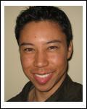
Jafari Jackson, PT graduated from the University of Southern California in 2001, completing his degree, doctor in physical therapy. After practicing for three years, in California, he relocated to Seattle in 2004. Jafari's core approach in treating patients, is to identify movement dysfunctions and then determine treatment through manual techniques, exercises or a combination of both, in order to correct the impairments thereby maximizing normal movement and function. He also expands his skill set by attending continuing eduation courses in order to incorporate current and relevant techniques. Jafari enjoys playing his guitar and participating in a variety of recreational activities including soccer and volleyball.
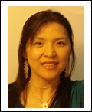
Tun-Yuan (Jessie) Chao, MPT graduated in 2006 with a master degree in physical therapy from Wichita State University, Kansas. Her treatment style is greatly influenced by her knowledge of oriental traditional bodywork ¡§Tuina¡¨. She is interested in manual physical therapy and is passionate in combining eastern and western techniques in treating her patients. In her free time, she enjoys cooking, singing, and playing piano.
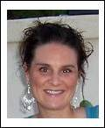
Kim Kuzara LMP graduated from Ashmead college with a certificate in massage therapy in 2003 and recieved a Washington State License in 2003. Kim's training is in Swedish, sports, pregnancy, seated and treatment massage. Kim has been working at a spa in West Seattle for over a year and frequently attends continuing education courses to further her knowledge and to better help her clients/patients. She also enjoys yoga, gardening and cooking
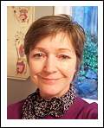
Lael Catherine Evans LMP
Lael has been licensed in Washington since 1984, taking initial training at Acadia School of Healing Arts in Seattle. She served on the Board of the Washington Chapter of the American Massage Therapy Association as the sports massage committee chair for two years. She enjoys learning new massage applications to combine with relaxation, deep tissue, muscle energy and other modalities that address injury treatment and wellness requirements
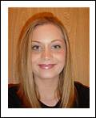
Sarah Fritz, Business Manager
Sarah began working for a Radiology company in Silverdale, Washington. Worked in the mammography department doing data entry and transcription. Moved to Europe in 2001 due to husband's military orders. Returned to Washington in 2004. Began working at Impact Physical Therapy in April. When not working, Sarah enjoys spending time with her husband and daughter.
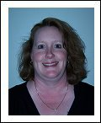
Julie Hanley, Billing
Julie has been working in the medical field for over 17 years. Julie first worked in Skilled Nursing Facilities then onto more, one on one Physical Therapy billing in a private practice setting. Julie spends her free time with her husband, they love to travel and spend their time seeing the sights of the Pacific Northwest.
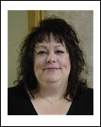
Colene Corbin Bowser
After 14 years in banking, I decided I needed a change. I am a recent graduate of Bryman College with a Certificate Degree in Medical Insurance Billing and Coding and love being in the medical profession. In my off time I enjoy shopping and old movies and being with my cats and family.
Directions to Impact Physical Therapy Lynnwood
Impact Physical Therapy
6101 200th Street SW Suite 208
Lynnwood, WA 98036
#425-778-2325
Directions to Lynnwood Office
I-5 Southbound:
Take I-5 south, take main Lynnwood exit (196th street)
Turn right off the freeway and get in to the left lane.
Follow 196th St. until you come to a Bank of America on the right.
Get in left turn lane, turn left.
Follow Scriber Lake Road until you come to 200th St. (traffic light).
Turn right. You are on 200th street heading west.
You will make almost an immediate right into our drive way - a two story cream color building with turquoise trim .
I-5 Northbound:
Take I-5 north
Take Lynnwood/44th Ave. W (exit #181 A)
Turn left off freeway, go under freeway and get in to the left turn lane
Turn left at light (200th street) go through 3 stop lights (you are on 200th street heading west now), Cross Scriber Lake road (3rd stop light on 200th)
Turn right in to office building, a two story cream color building with turquoise trim.
Northbound 405:
Take the Southbound I-5 exit (Lynnwood-Seattle).
Take main Lynnwood exit (196th street), turn right off the freeway and get in to the left lane.
Follow 196th St. until you come to a Bank of America on the right.
Get in left turn lane, turn left.
Follow Scriber Lake Road until you come to 200th St. (traffic light).
Turn right. You are on 200th street heading west.
You will make almost an immediate right into our drive way - a two story cream color building with turquoise trim .
